**MOLECULES AND SOLIDS**

**Exercises**

**Section 37.2 Molecular Energy Levels**

**16. Interpret** We are to find the energies of the first four rotational states of an HCl molecule.

**Develop** The energies of rotational states (above the *j* = 0 state) are given by Equation 37.2, where for the HCl molecule, 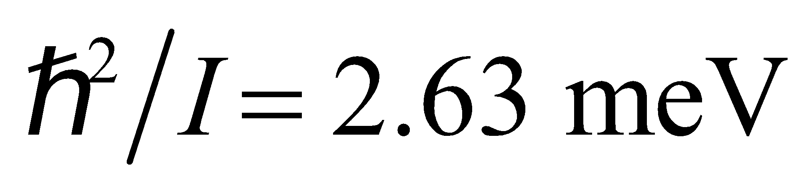 (from Example 37.1).

**Evaluate** Thus, 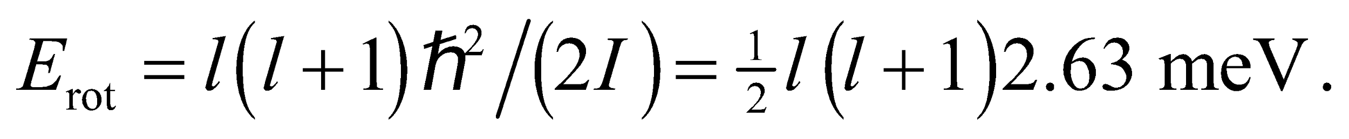 For *l* = 0, 1, 2, and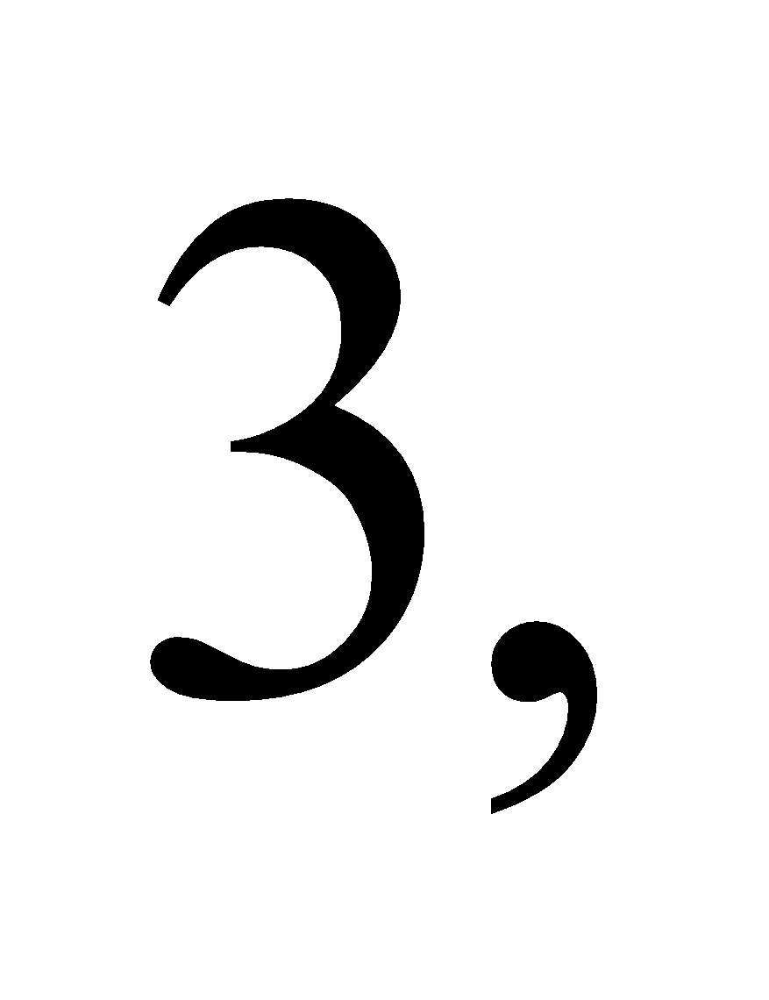 so 

**Assess** The rotational energy levels are some three orders of magnitude closely spaced than is the case for the atomic energy levels.

**17. Interpret** We are looking for the wavelength of the photons that would cause a transition in an oxygen molecule to the first excited rotational energy state above the ground state.

**Develop** Using Equation 37.2, the difference in energy between the *l* = 1 and *l* =0 states is

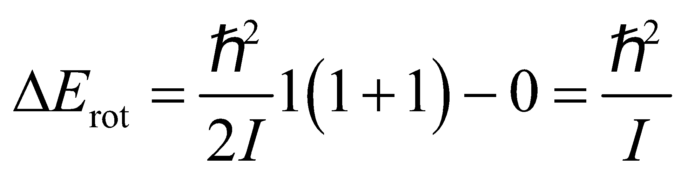

The photon wavelength corresponding to this transition is 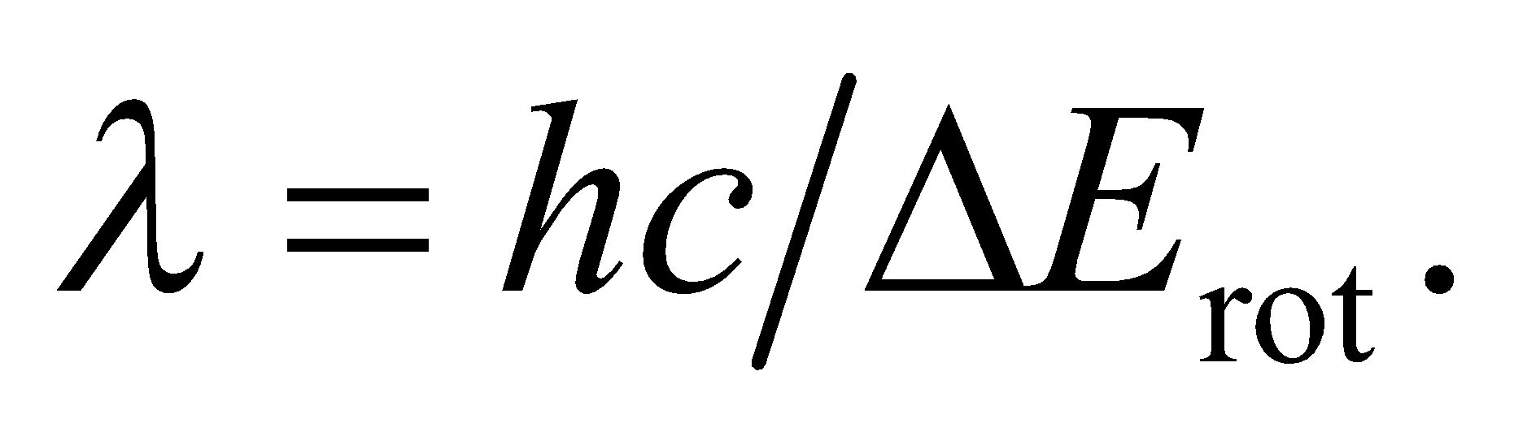

**Evaluate** Substituting the value of *I* given in the problem, we get

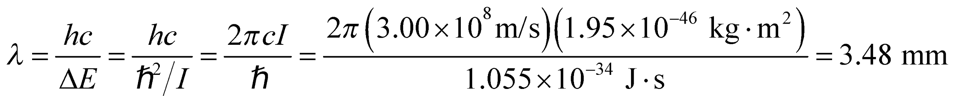

**Assess** Transition between adjacent rotational energy levels requires absorbing a photon in the microwave region (frequency *f* ~ 1011 Hz).

**18. Interpret** We are given the rotational inertia of a molecule and are to find the wavelength (i.e., energy) of a photon emitted by the given transition between rotational states.

**Develop** The energy of the rotational states is given by Equation 37.2,

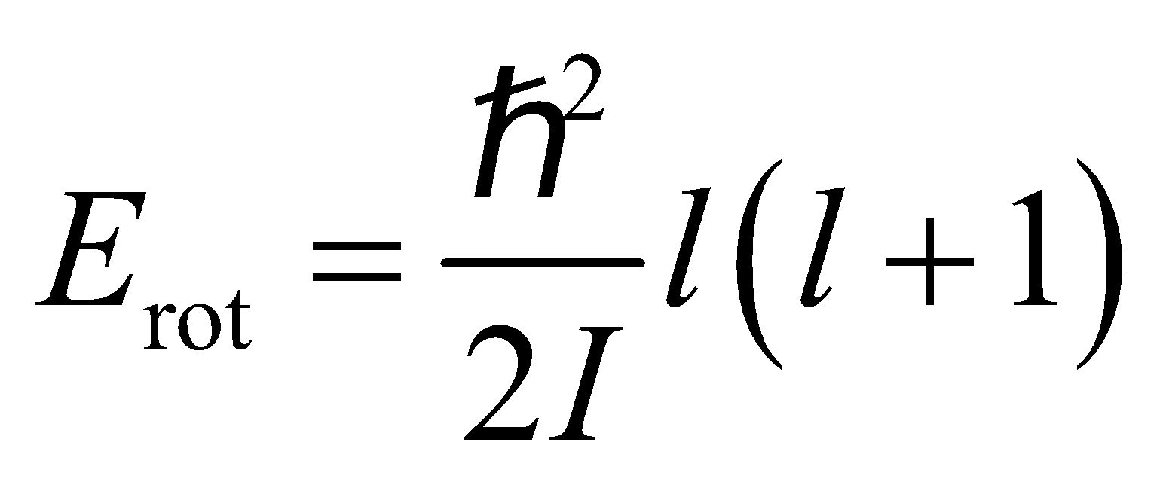

The energy difference between adjacent states is

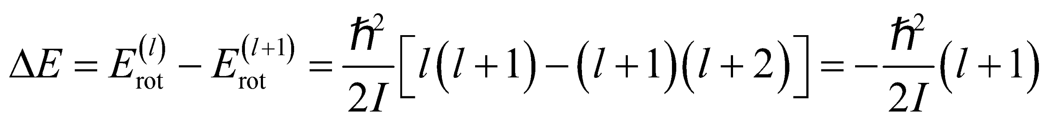

For this problem, *l* = 4. The energy of the photon emitted is given by Equation 34.6, *E* = *hf* = *hc/λ*, and must equate to the magnitude of the energy of the rotational transition, which gives

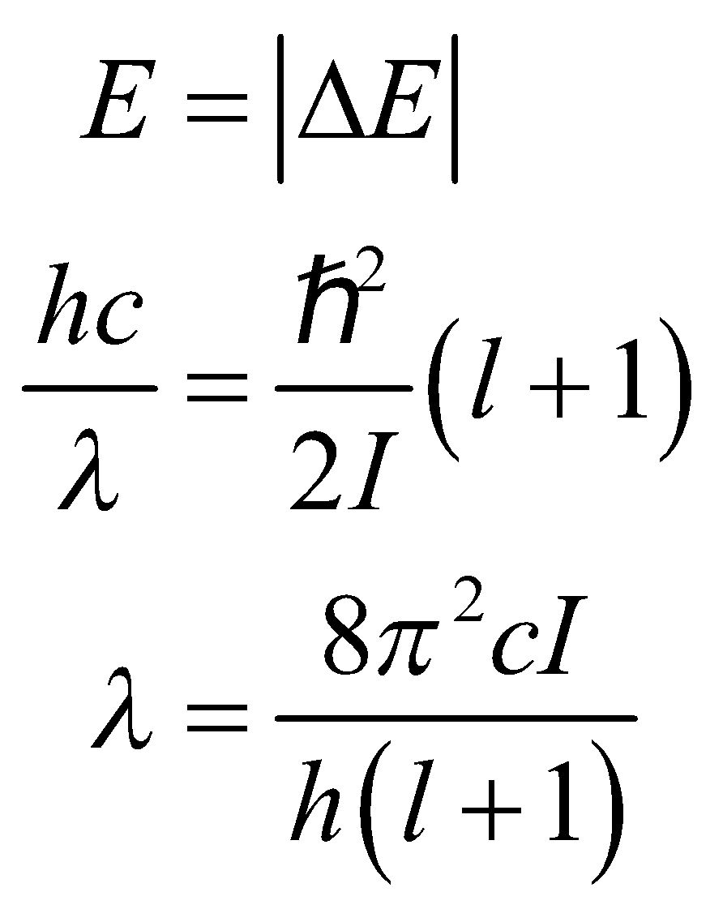

**Evaluate** Inserting the given values gives

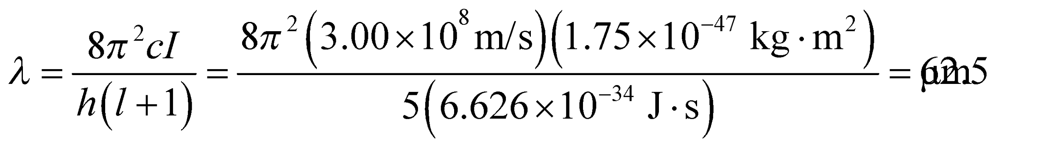

**Assess** This wavelength is in the infrared portion of the electromagnetic spectrum, as indicated in the text.

**19. Interpret** The gas molecules must absorb a photon in order to make a transition to the excited rotational state. We are given the wavelength of the photon, and asked to find the rotational inertia of the molecule.

**Develop** Using Equation 37.2, the difference in energy between the *l* = 1 and *l* = 0 states is

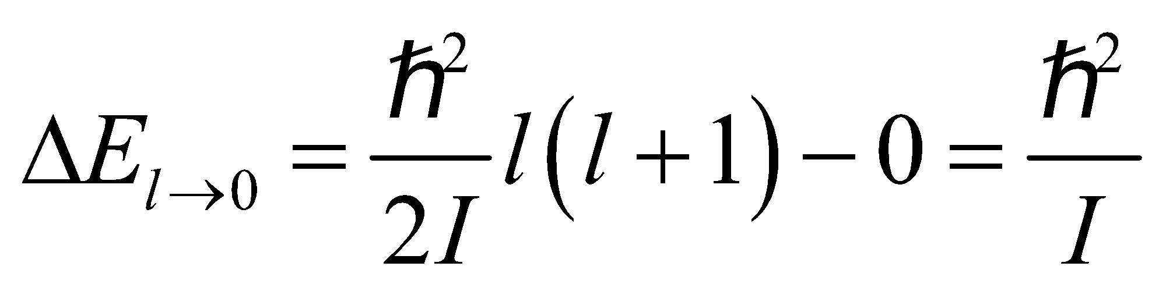

The energy of the absorbed photon must equate to this difference in energy: 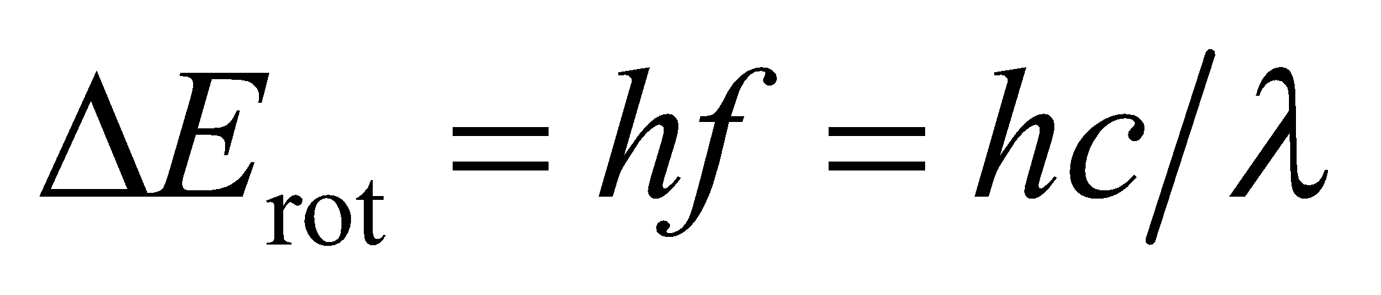 Thus,

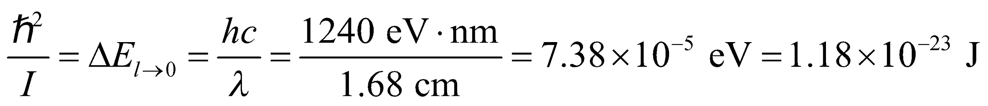

We can find *I* from the above equation.

**Evaluate** The rotational inertia is

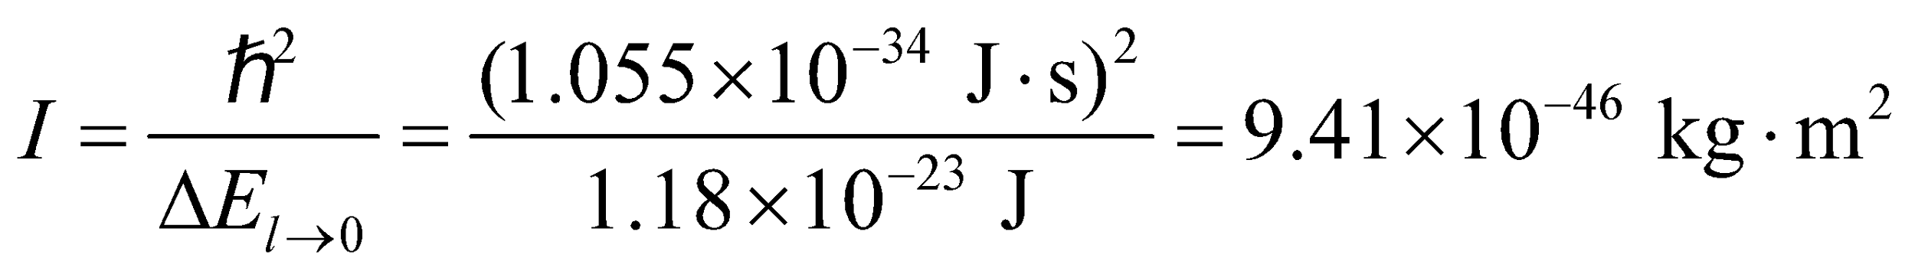

**Assess** The value of *I* is reasonable for a molecule (compare with previous problem). We can estimate the bond length of the molecule using 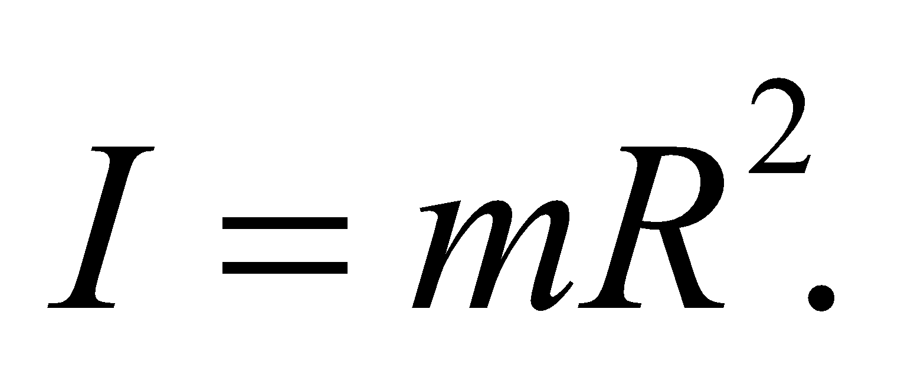 With *m* ~ 10−26 kg, we get *R* = 0.3 nm, which is also a reasonable value.

**20. Interpret** We are given the vibration frequency for diatomic hydrogen (i.e., a hydrogen molecule; H2) and are to find the spacing between its vibrational energy levels.

**Develop** Applying Equation 37.3, 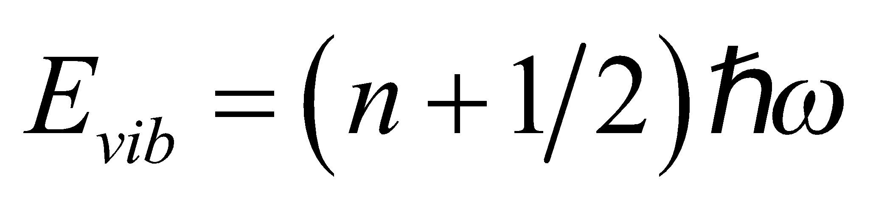, we see that the spacing between vibration energy levels is

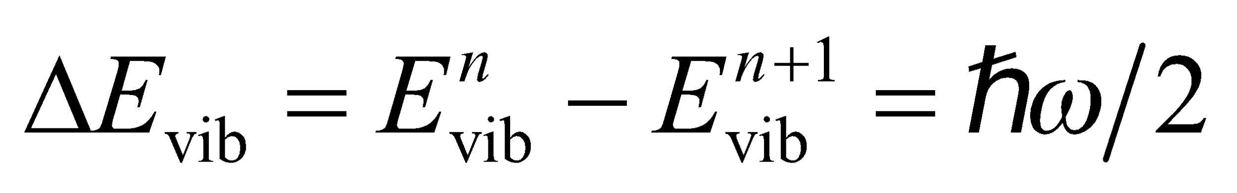

Using the relation *ω* = 2*πf*, the energy spacing may be written as

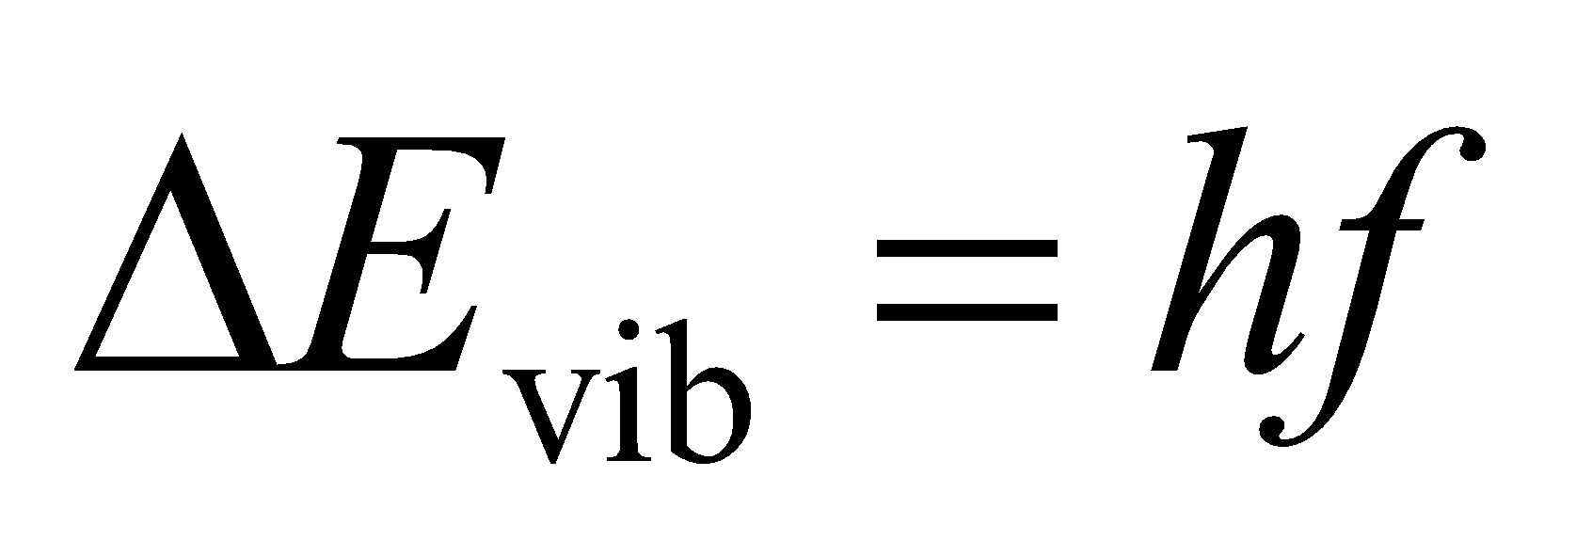

**Evaluate** Using the value given for *f* leads to



**Assess** This corresponds to the infrared portion of the electromagnetic spectrum.

**21. Interpret** This problem is about the vibrational motion of the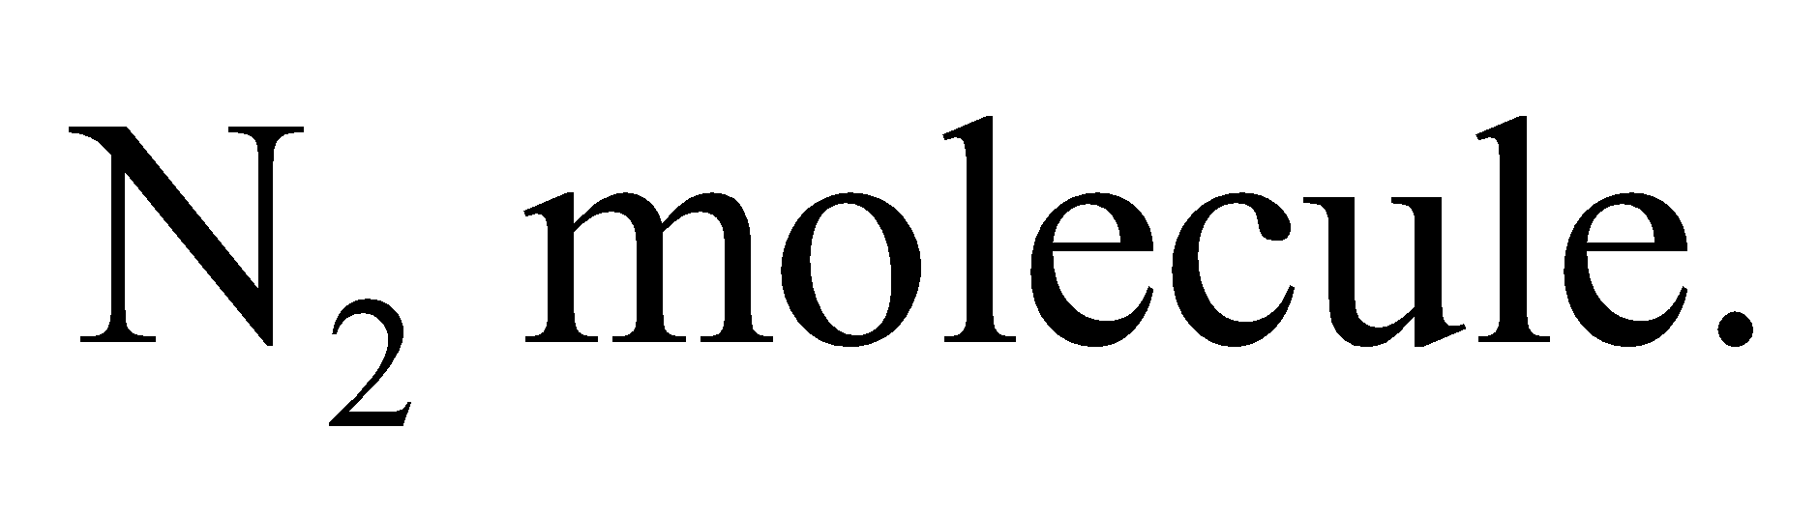 We are given the energy spacing between adjacent vibrational energy levels of the molecule and are asked to find the corresponding classical frequency of vibration.

**Develop** The quantized vibrational energy levels are given by Equation 37.3:

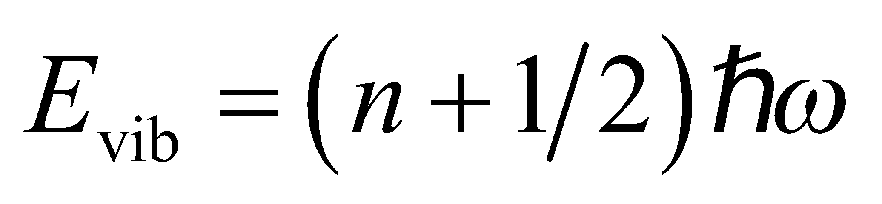

Therefore, the energy difference between the adjacent levels is 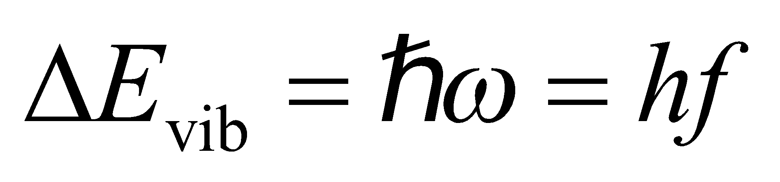.

**Evaluate** The classical vibrational frequency is

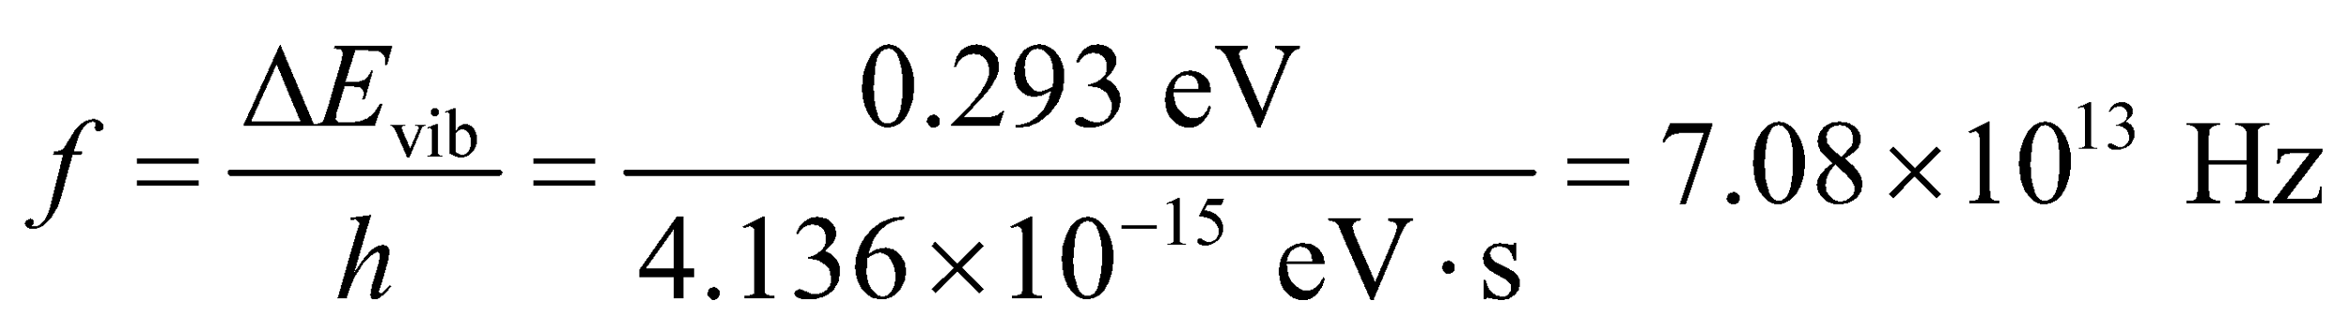

**Assess** The frequency associated with vibrational motion is 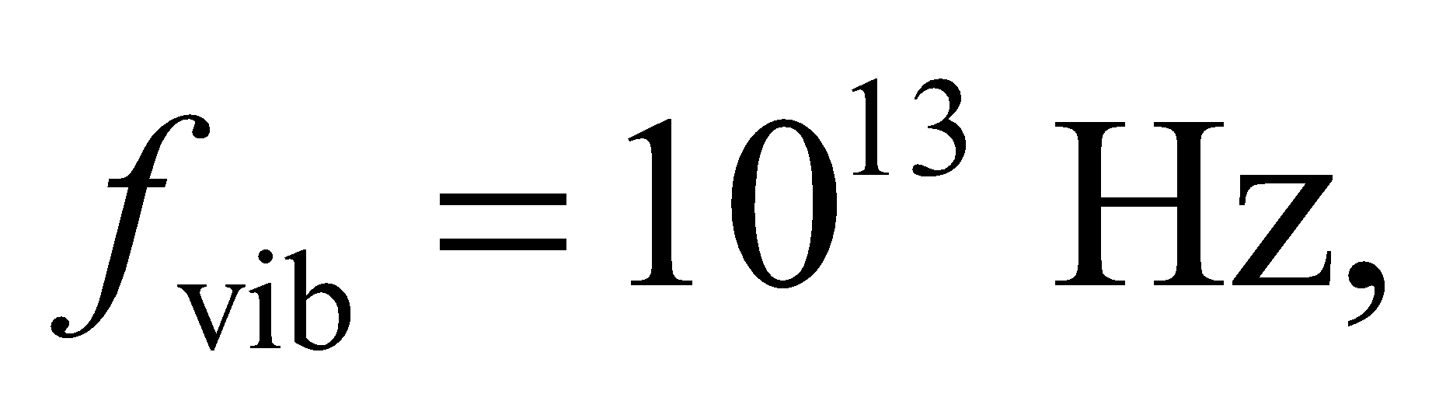 which is higher than that associated with rotation, 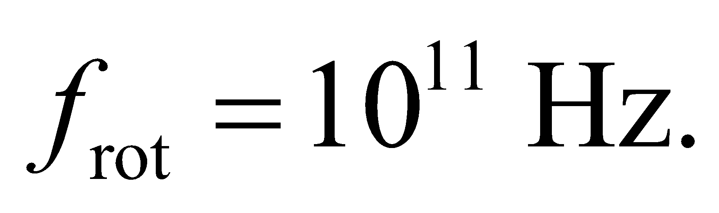 This means that a more energetic photon must be absorbed by the molecule in order to excite the vibrational modes.

**Section 37.3 Solids**

**22. Interpret** Given the density of NaCl, we are to estimate the spacing between ions in the crystalline solid.

**Develop** The atomic weights of Na and Cl are 22.99 and 35.45 (see Appendix D), so the average masses of these ions are

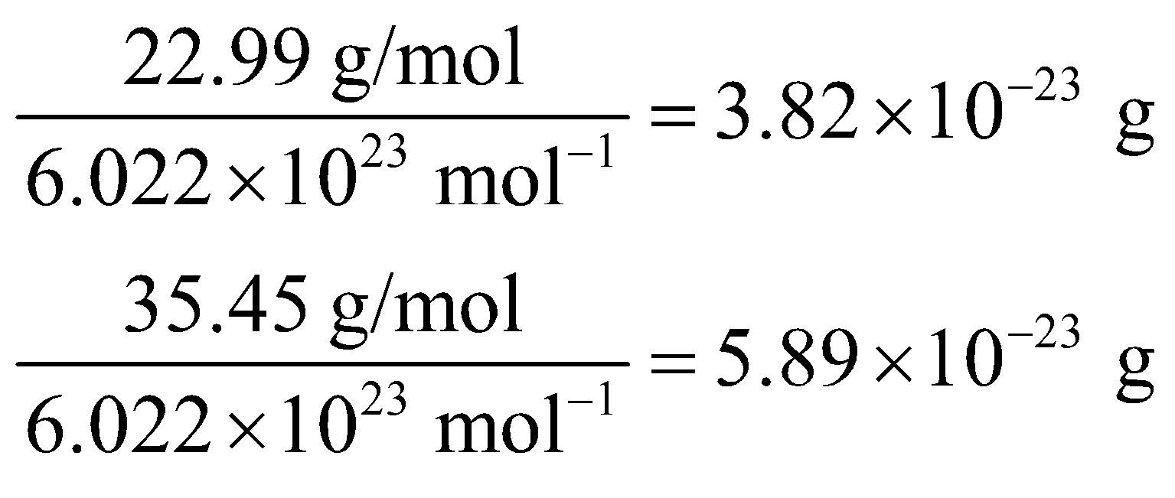

respectively. If each ion occupies the same cubic volume 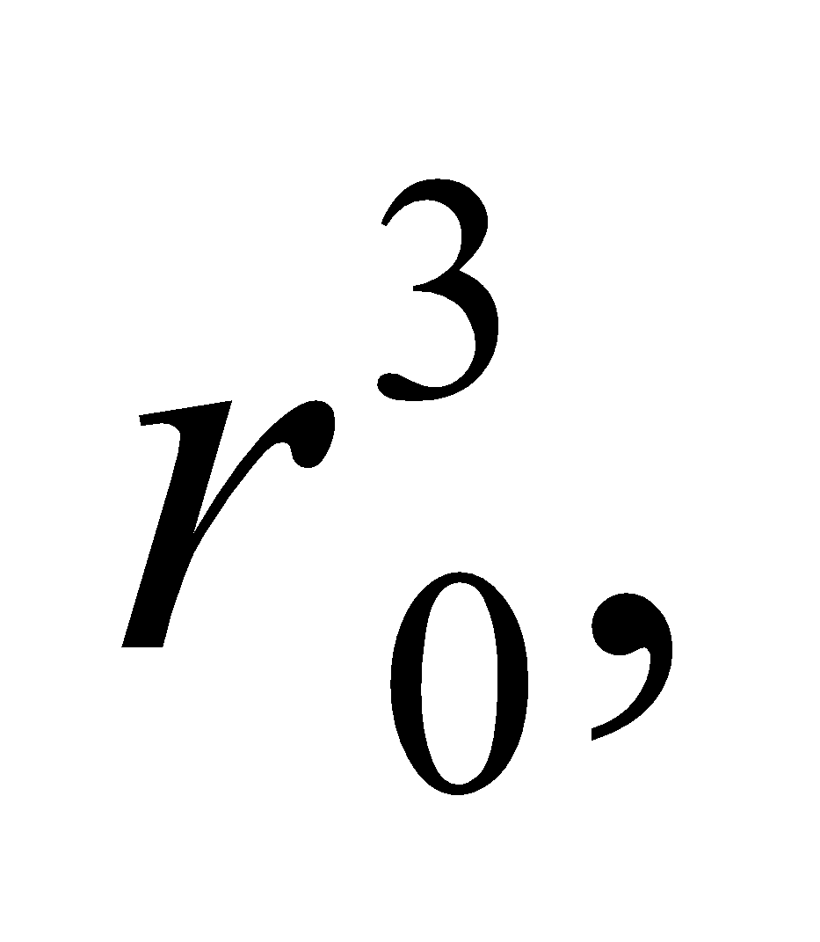 then the density of the crystal is

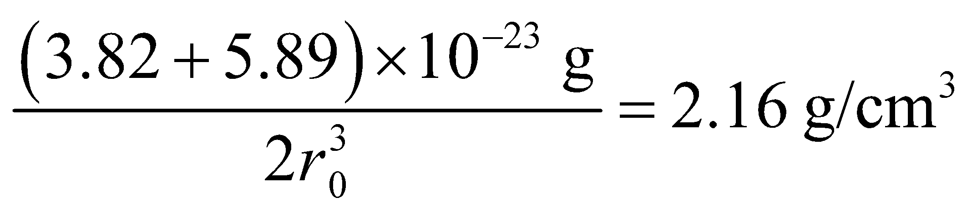

**Evaluate** Solving for the ionic separation *r*0 gives

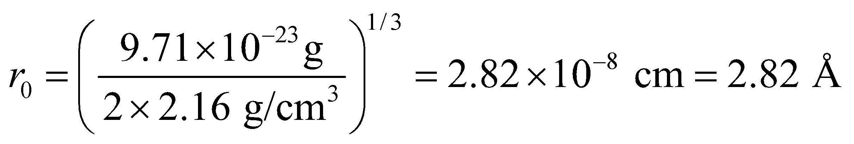

**Assess** Actually, the ionic radii of Na and Cl are different, but each cubic cell of NaCl crystal contains half Na and half Cl atoms, so the above estimate is the same; namely, 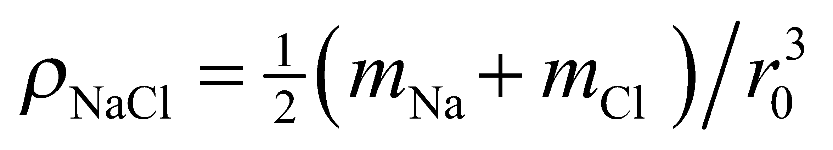.

**23. Interpret** This problem is an exercise in unit conversion. We are to express the ionic cohesive energy of NaCl in units of kcal/mol.

**Develop** To convert eV to kcal/mol, we use the following conversion factors (see Appendix C):

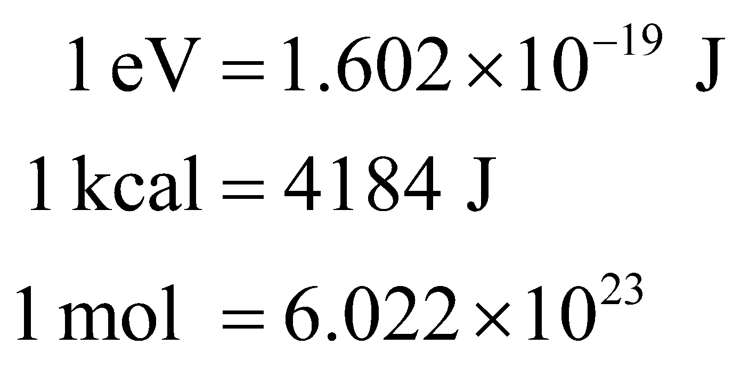

**Evaluate** Using the above conversion factors, we find:

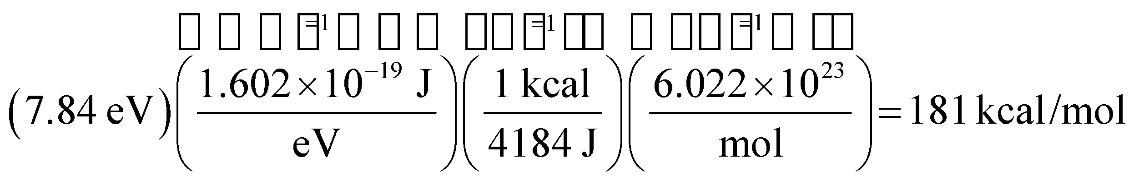

**Assess** The result means that it takes 181 kcal to break one mole of NaCl into its constituent ions.

**24. Interpret** We are to find the equilibrium separation of ions in the ionic crystal LiFl.

**Develop** At equilibrium, *r* = *r*0 and Equation 37.4 takes the form

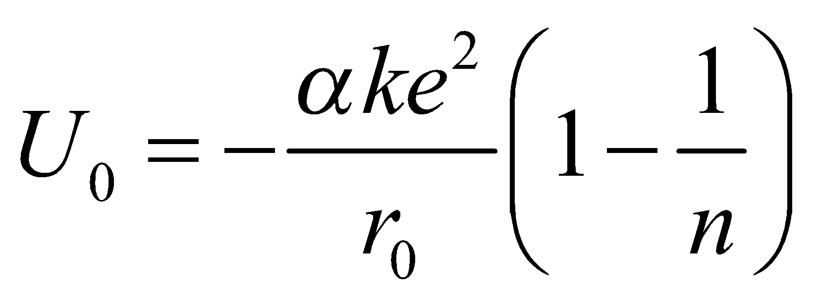

which we can solve for the equilibrium separation *r*0, given *α* = 1.748, *n* = 6.25, and *U*0 = −10.5 eV.

**Evaluate** Using

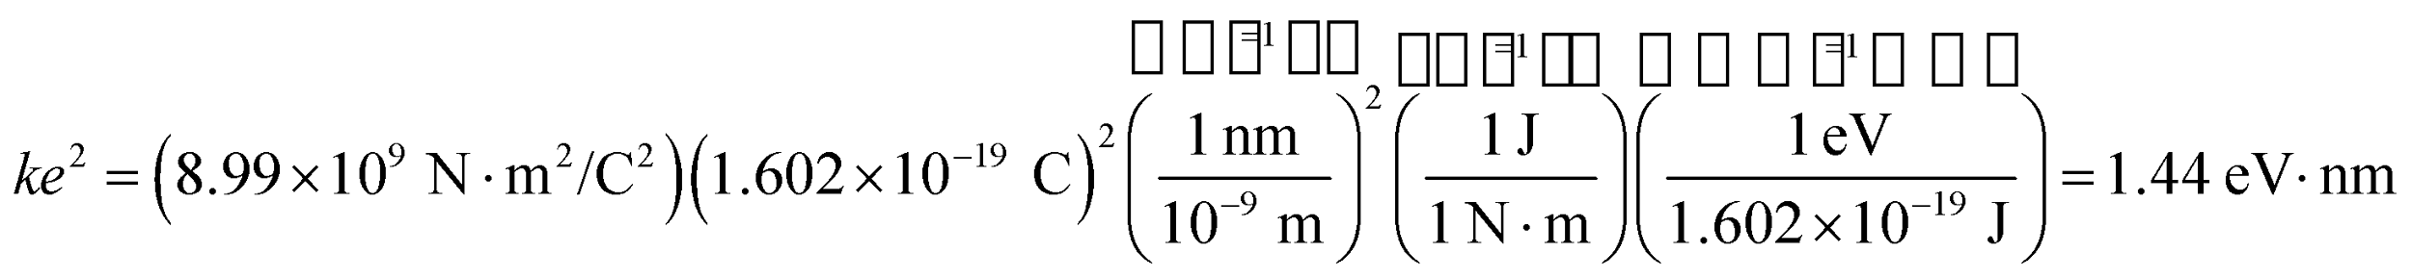

we find that the equilibrium separation is

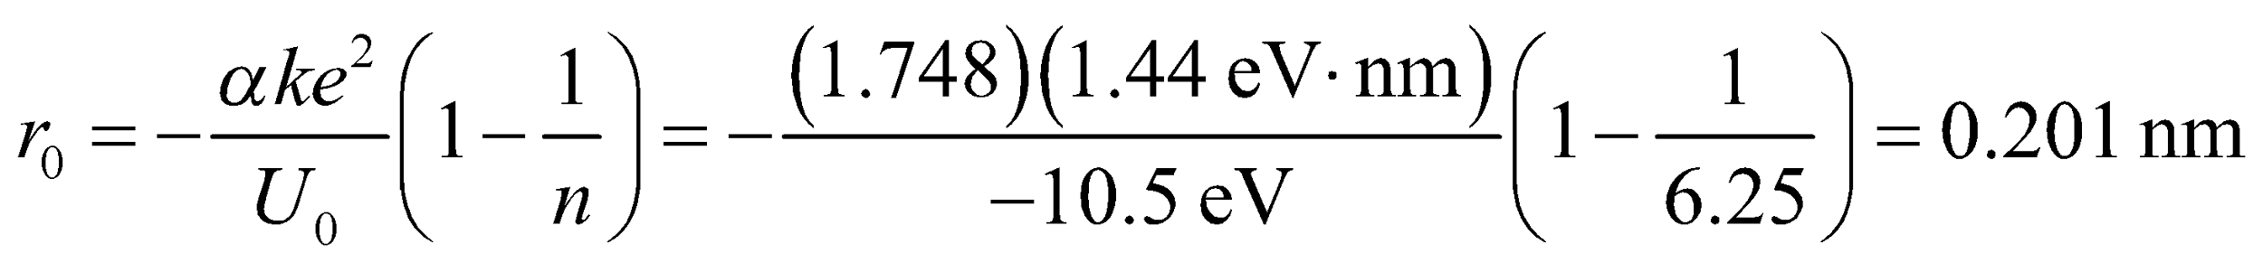

**Assess** This result is similar to that found in Problem 37.22.

**25. Interpret** We are to find the wavelength of light emitted by electrons that make transitions across the band gap of Gallium phosphide.

**Develop**  Gallium phosphide is a semiconductor with a band-gap energy of 2.26 eV (see Table 37.1). From Equation 34.6, *E* = *hf*, we know that a photon of energy corresponding to the band gap would have a wavelength of 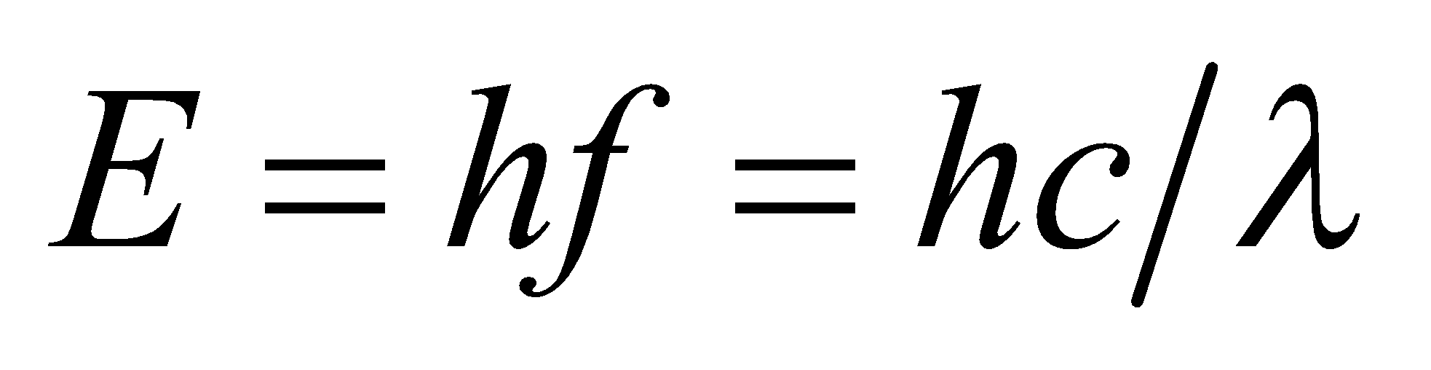, where *E* is the band-gap energy.

**Evaluate** Solving the expression above for the wavelength gives

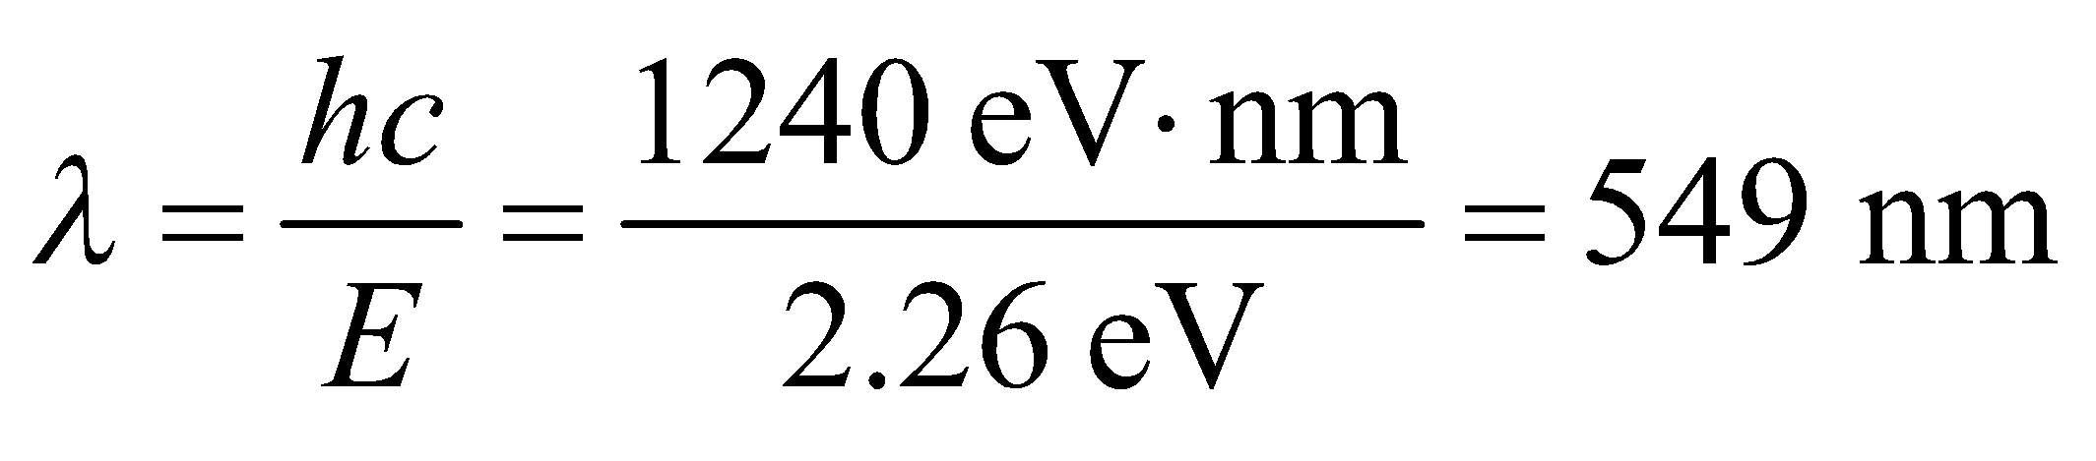

**Assess** This light is green in color.

**26. Interpret** We are to find the shortest wavelength emitted by electrons making transitions across the energy gaps of materials listed in Table 37.1 and the corresponding material.

**Develop** The solution to the previous problem shows us that the wavelength emitted when electrons make transitions across the energy gap depends on the energy gap according to 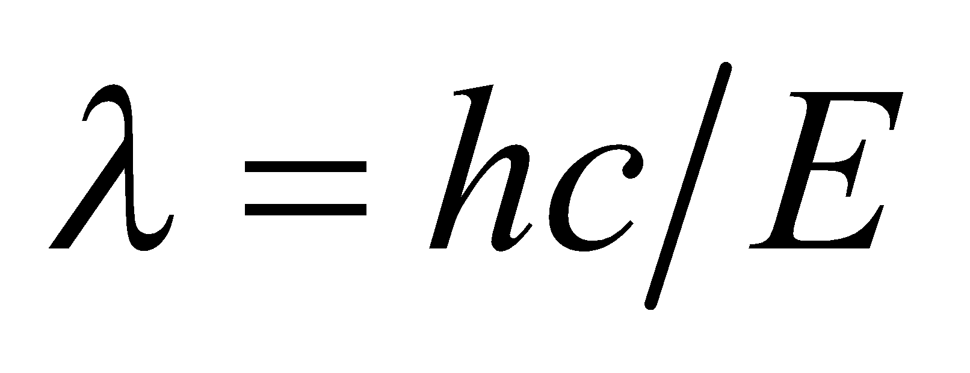. Thus, the shortest wavelength corresponds to the largest bandgap.

**Evaluate** The largest bandgap of materials listed in Table 37.1 is Zns, which has E = 3.6 eV. The wavelength emitted by this material is

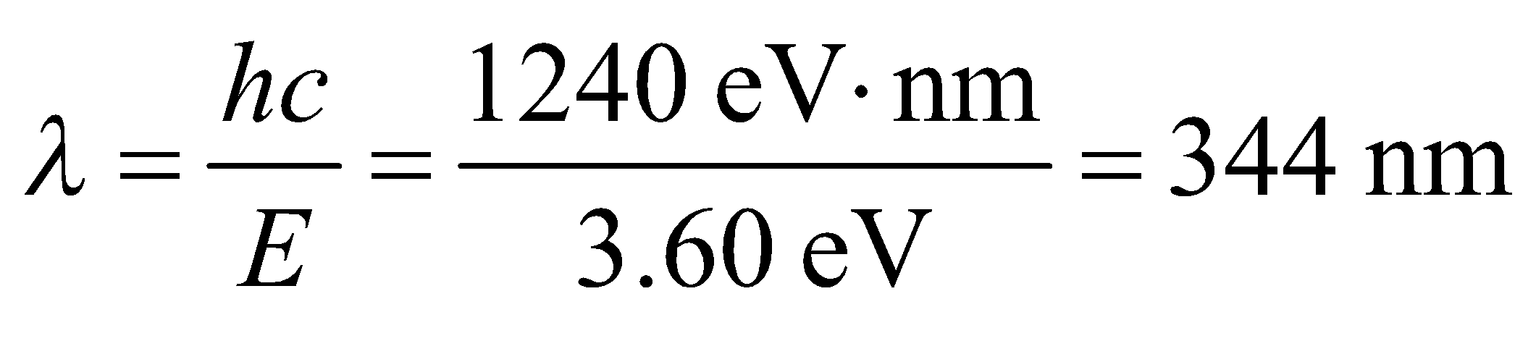

**Assess** This wavelength is in the ultraviolet portion of the electromagnetic spectrum.

**27. Interpret** From the list of materials given in Table 37.1, we want to know which would emit the longest wavelength if used in a light-emitting diode.

**Develop** The wavelength emitted depends on the energy gap according to . Thus, the maximum wavelength for the materials in Table 37.1 corresponds to the smallest energy gap.

**Evaluate** The material with the smallest energy gap is InAs, which has an energy gap of *E* = 0.350 eV. The wavelength of this emission is

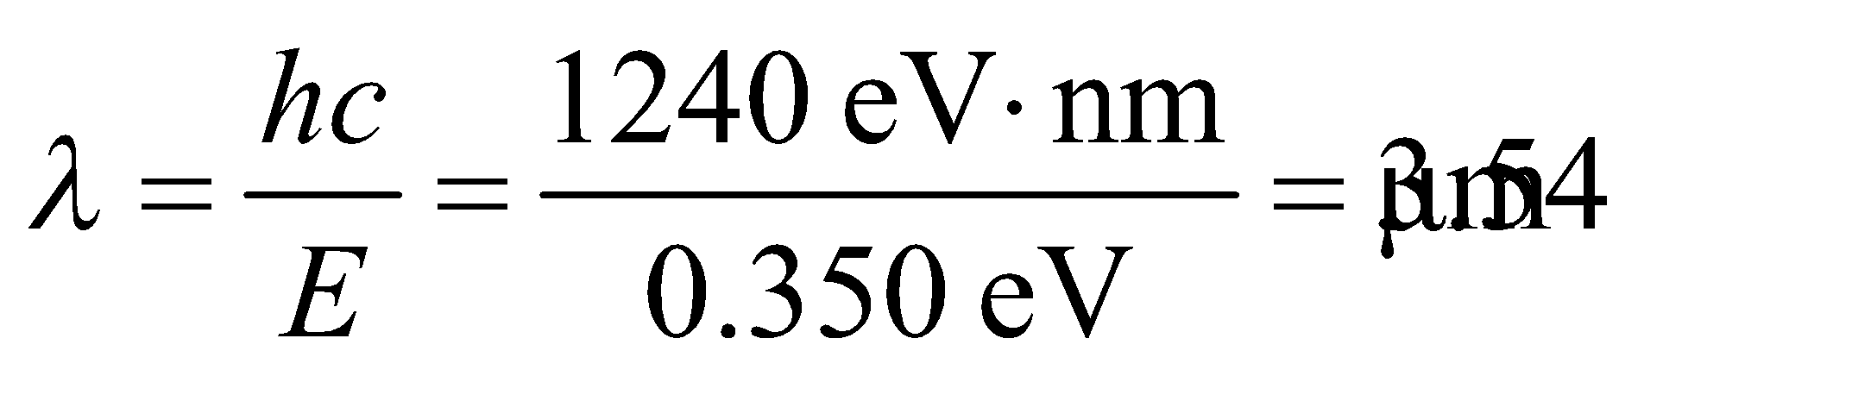

**Assess** The wavelength is in the infrared portion of the electromagnetic spectrum.

**28. Interpret** Given the wavelength of light emitted from a semiconductor material, we are to find the energy gap of the material.

**Develop** Equation 34.6, , gives the relationship between the wavelength and the energy of photons. By conservation of energy, the photon emitted when an electron makes a transition across the band gap of a material must equate to the energy of that band gap.

**Evaluate** The band gap corresponding to this wavelength is therefore

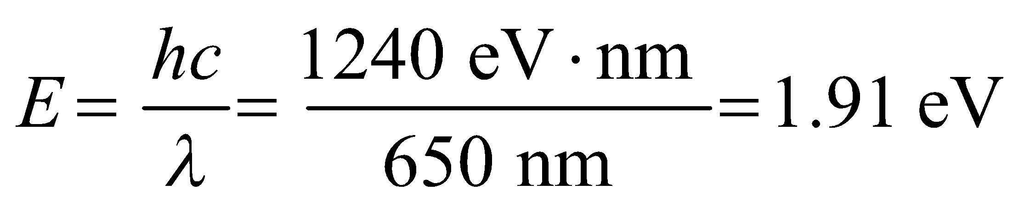

**Assess** This is a deep red color.

**Problems**

**29. Interpret** We have a molecule that emits a photon to make a transition to a state with lower rotational energy. We want to know the energy of the photon emitted for the 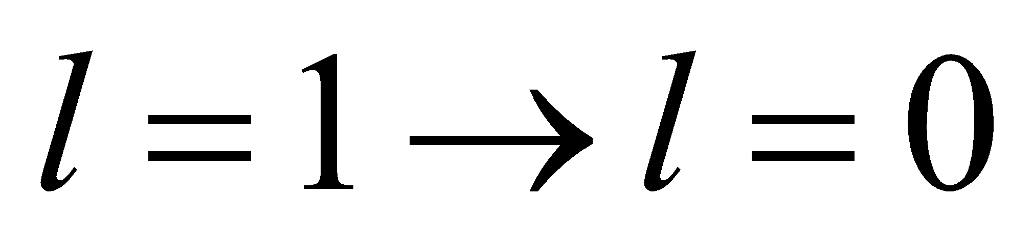 transition.

**Develop** Using Equation 37.2, the difference in energy between the *l* = 2 and the *l* = 1 state is

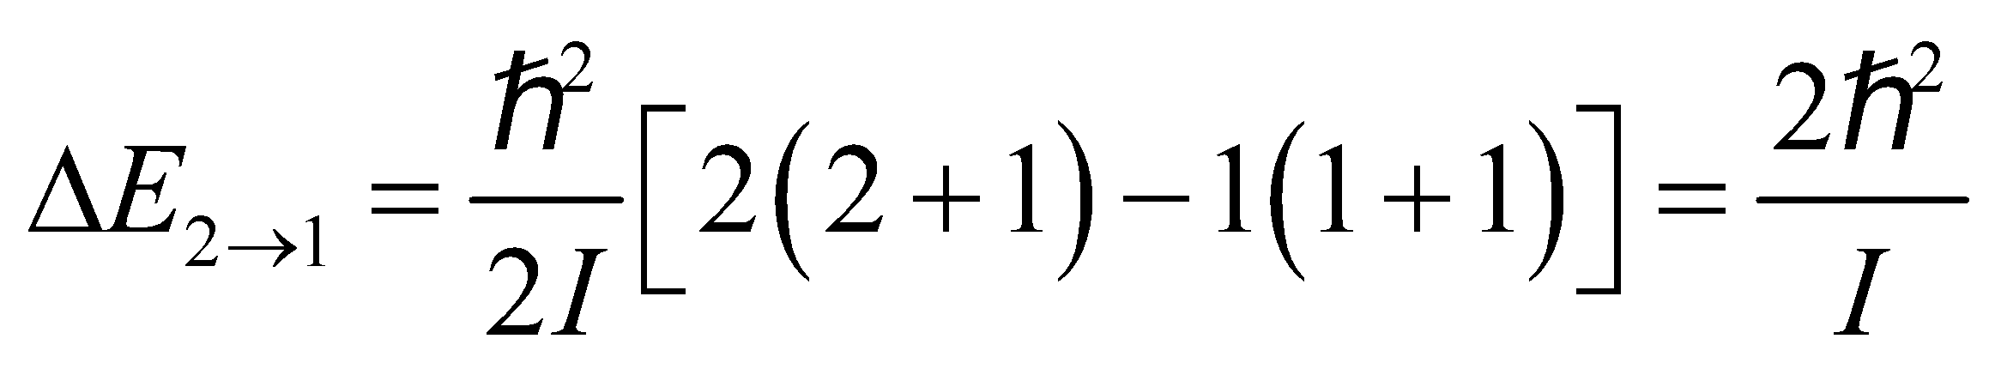

This means that 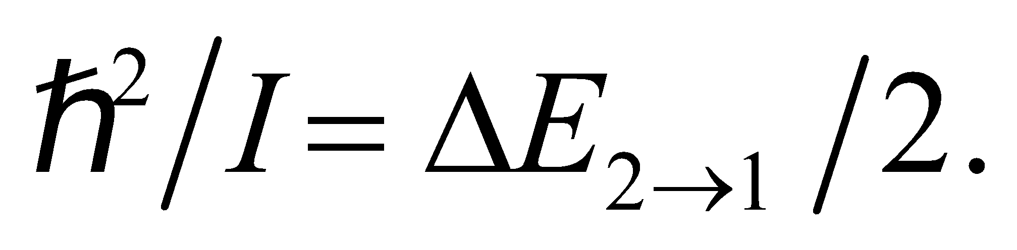 For the  transition,

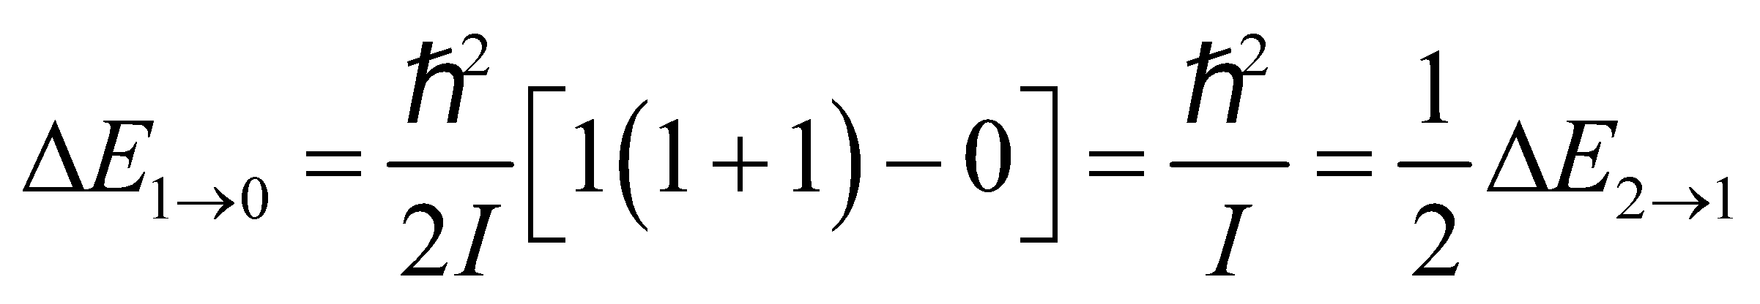

**Evaluate** Since 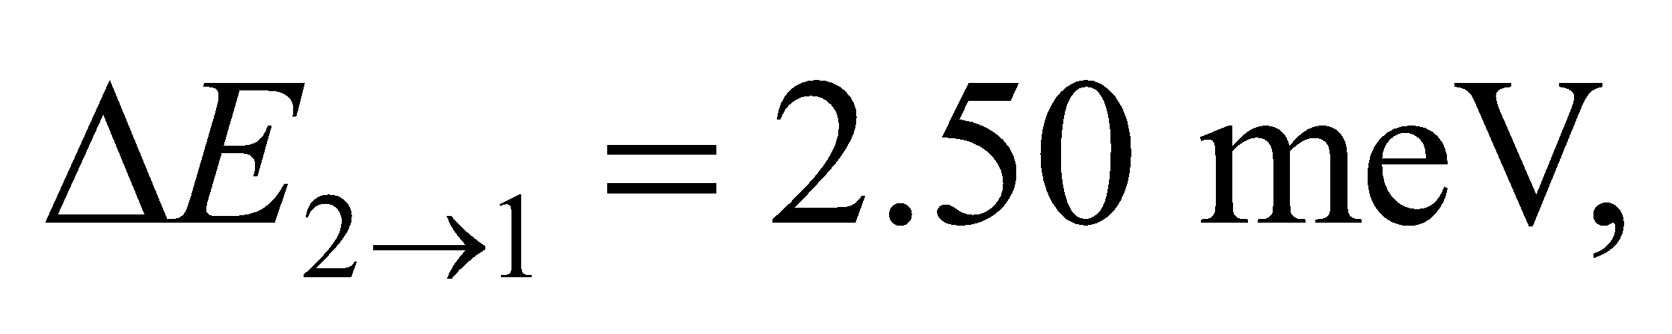 we have 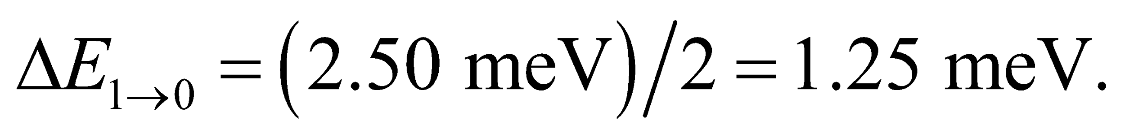

**Assess** The result shows that the energy levels are not evenly spaced. In general, the energy of a photon emitted in a transition between rotational levels with 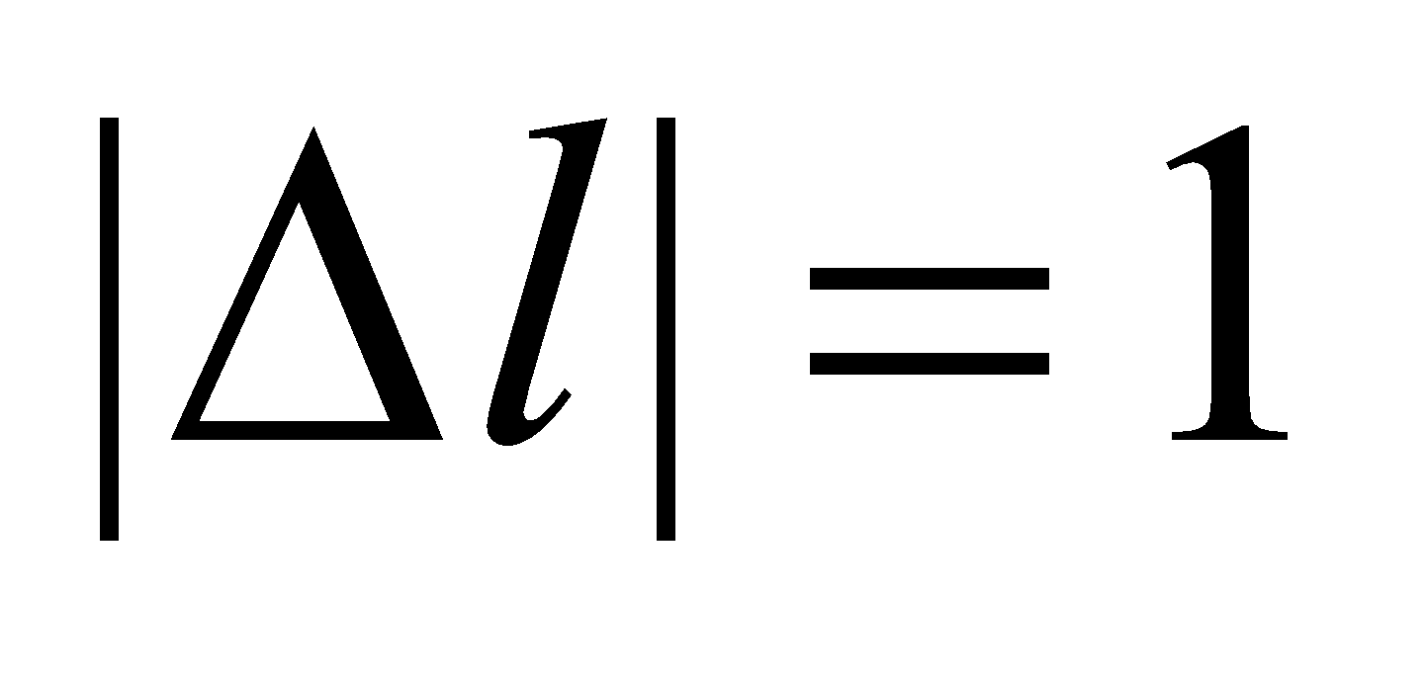is 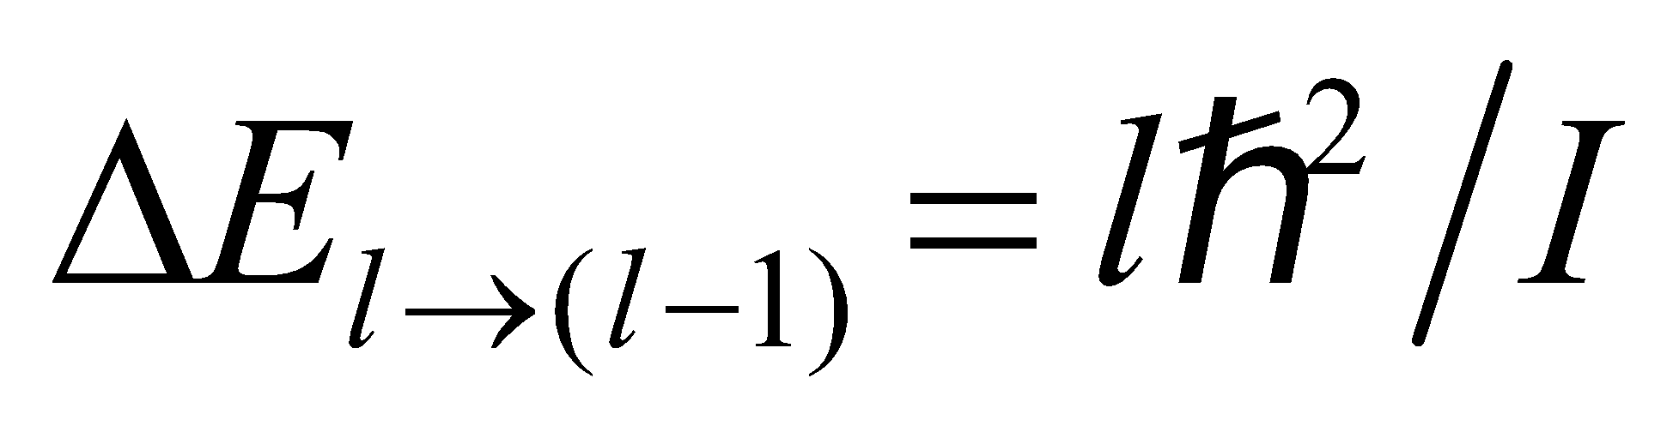.

**30. Interpret** We are told that a rotational transition requires three times the energy for the rotational transition between the rotational ground state and first excited state and are asked to find the two levels involved in the higher energy transition.

**Develop** From Equation 37.2, the photon energy absorbed in a 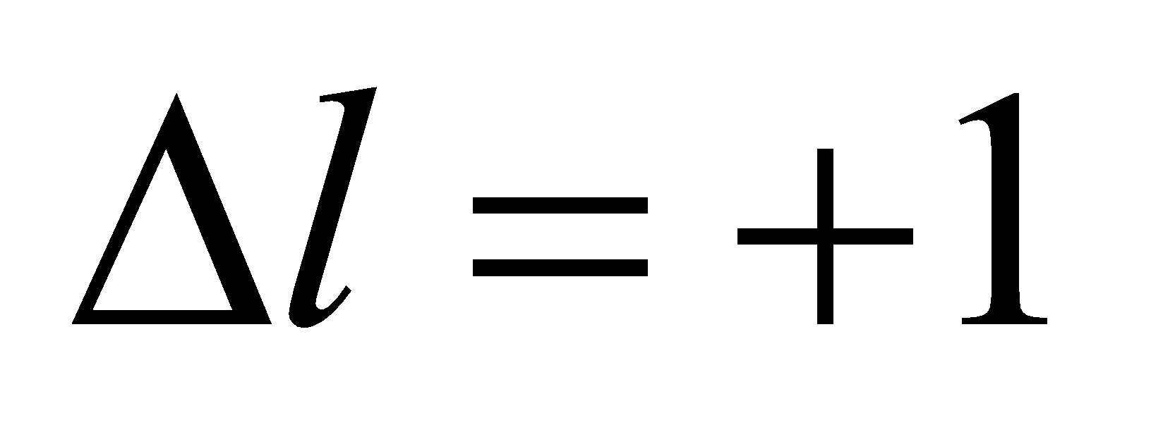 transition must be

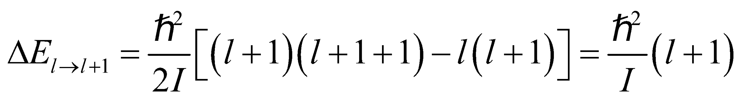

We are given that

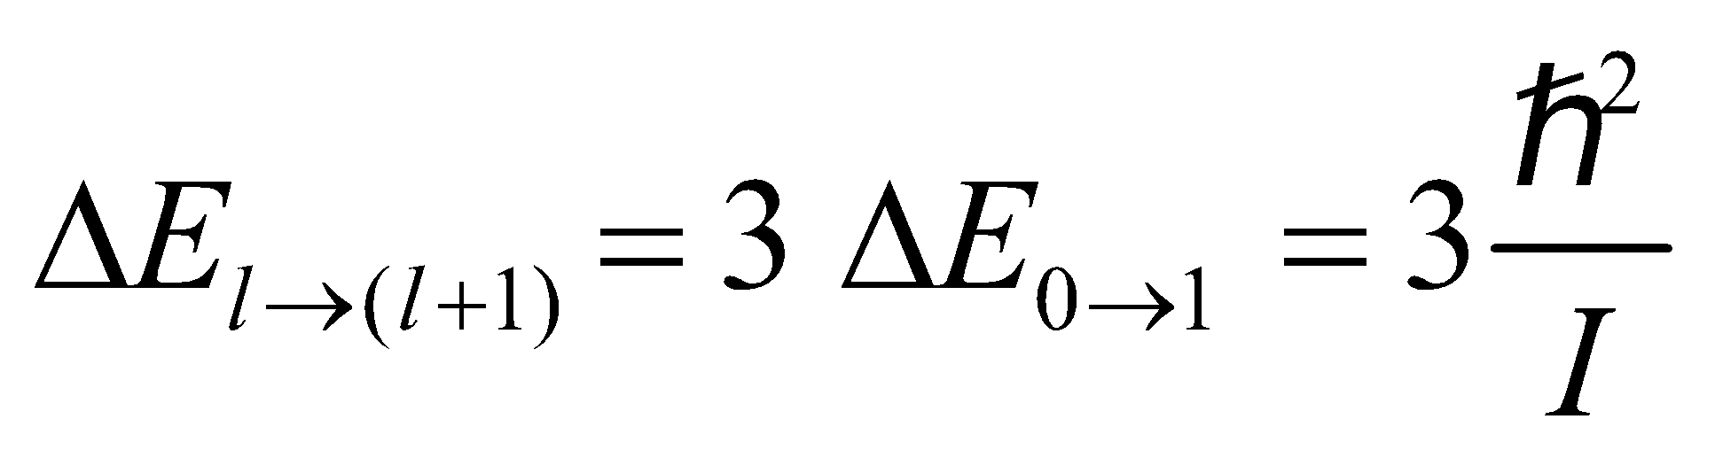

(where the last equality is derived in the solution to Problem 37.29), so we can solve for the quantum numbers of the two states involved in the unknown transition (i.e., *l* and *l* + 1).

**Evaluate** Combining the expressions above and solving for *l* gives

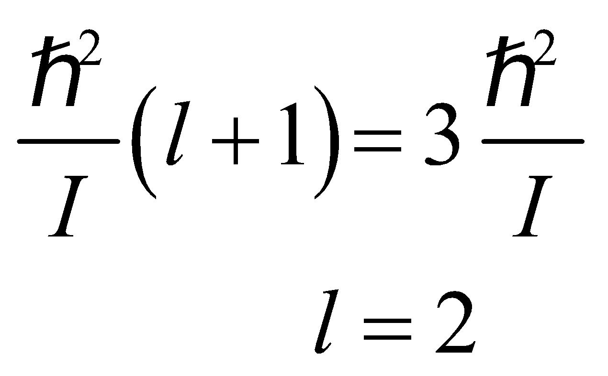

so the transition is from level 2 to level 3.

**Assess** The final state is at higher energy than the initial state because the system has absorbed the energy of a photon with energy 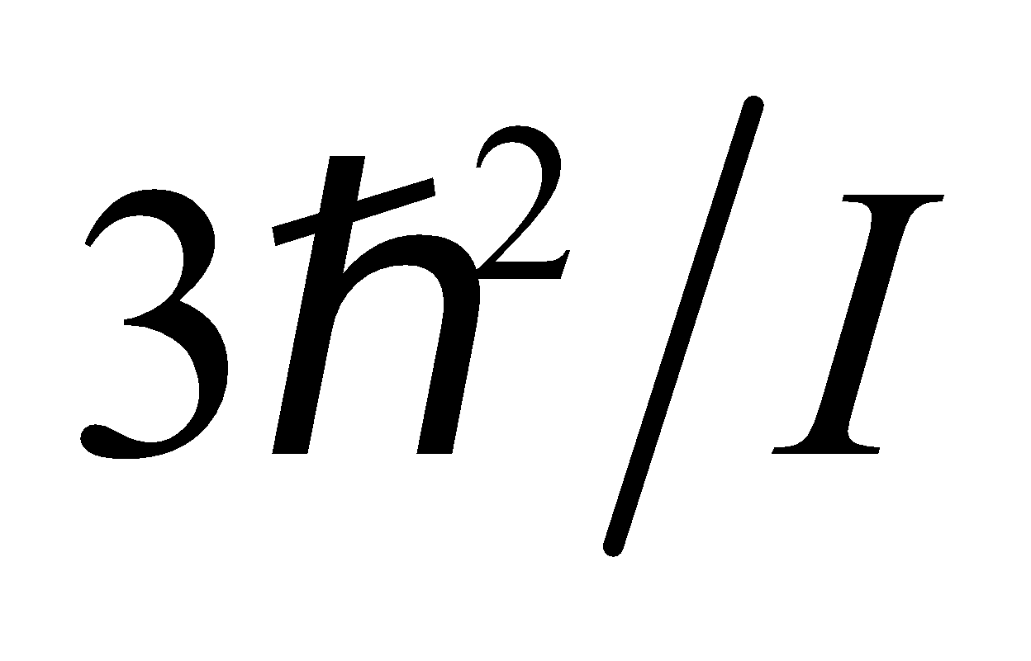.

**31. Interpret** A molecule must absorb a photon to make a transition to a higher energy rotational state. We want to find an expression for the energy of the photon associated with the transition 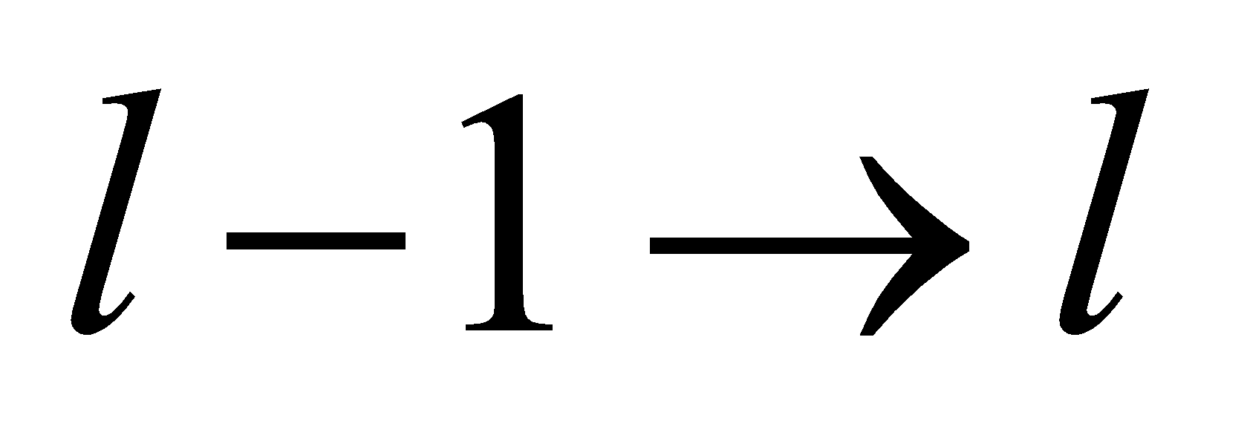.

**Develop** The quantized rotational energy of a molecule is given by Equation 37.2:



By conservation of energy, we know that the energy of the photon is equal to the energy difference between levels *l* and *l* − 1.

**Evaluate** Thus, the photon energy may be expressed as

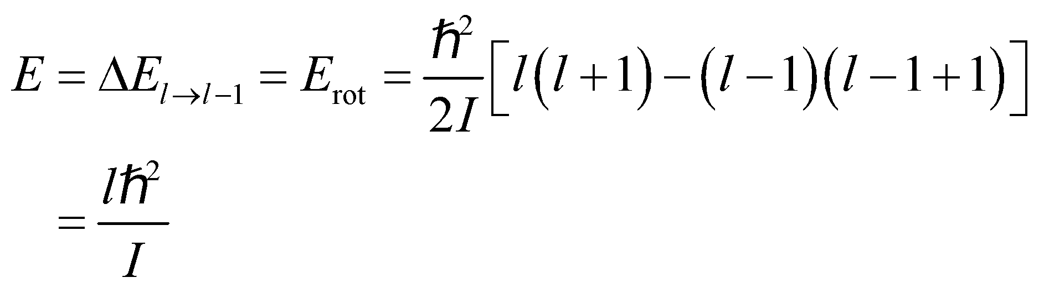

**Assess** The energy difference between two adjacent rotational levels is proportional to the upper *l*-value.

**32. Interpret** We are to derive the given expression for the wavelength of a photon emitted by a transition between adjacent rotational levels.

**Develop** Equation 37.2 gives the energy as a function of the rotational quantum number:

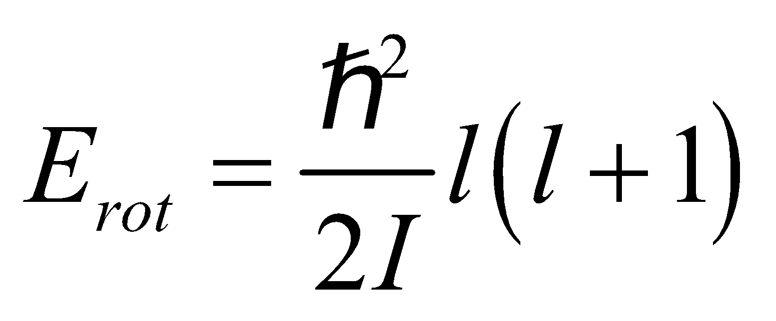

For a transition from state l to state l − 1, the energy difference is

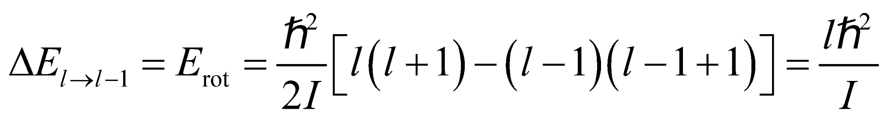

This is the energy *E* that must be carried away by the emitted photon (conservation of energy). The photon energy may be expressed in terms of wavelength using Equation 34.6:



**Evaluate** Equating these two expressions for the photon energy gives

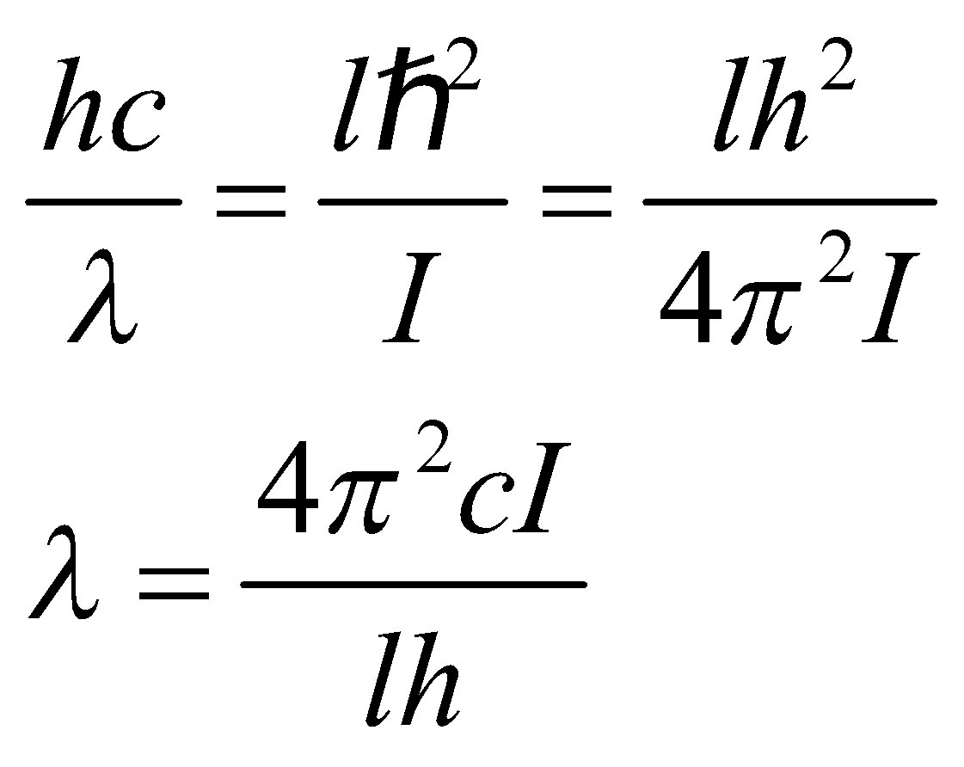

**Assess** We have expressed the wavelength in term of the crystal parameters.

**33. Interpret** In this problem we are asked to find the energy separation between the atomic rotational levels in the O2 molecule.

**Develop** The separation of the rotational spectral lines in energy is 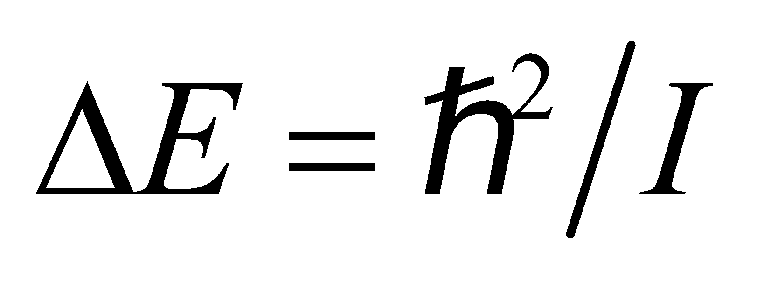 (see Example 37.1), or 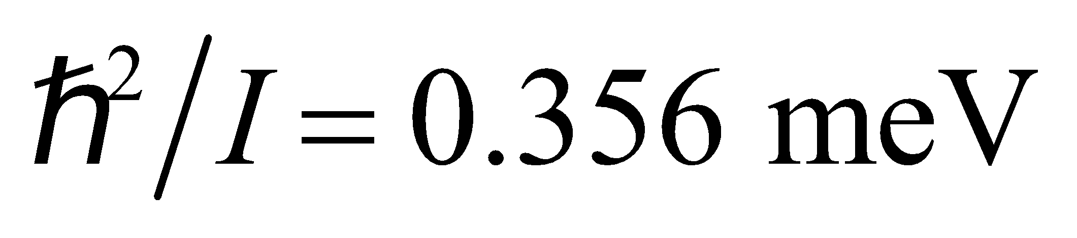 for O2. In a diatomic molecule, with equal-mass atoms and atomic separation *R*, each atom

rotates about the center of mass at a distance of *R*/2, so 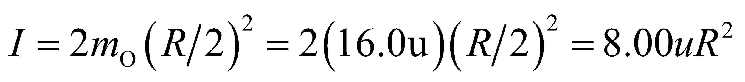, where the mass of an oxygen atom is taken to be *m*O = 16.0u.

**Evaluate** The above expressions can be simplified to give

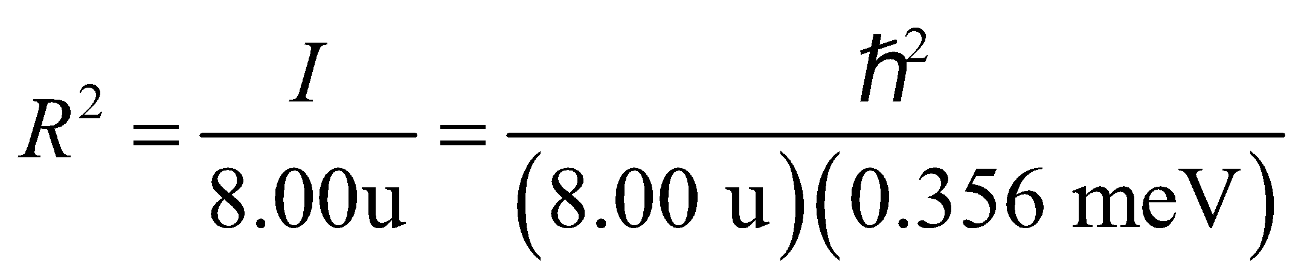

or

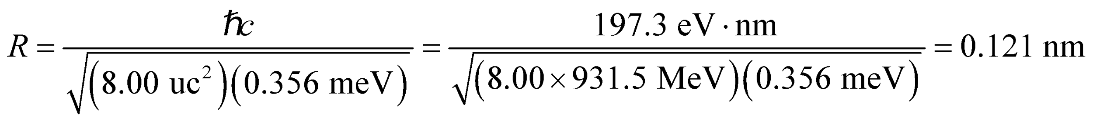

**Assess** Our result is in reasonable agreement with the experimental value of 0.146 nm.

**34. Interpret** We are asked to find the bond length of carbon monoxide (CO), given the wavelength of light needed to excite it to its first rotational state.

**Develop** The quantized rotational energy levels are given in Equation 37.2: 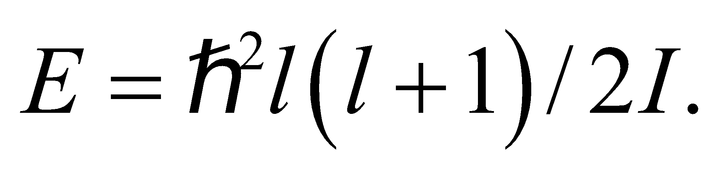 Therefore, the energy needed to excite a molecule from the non-rotating 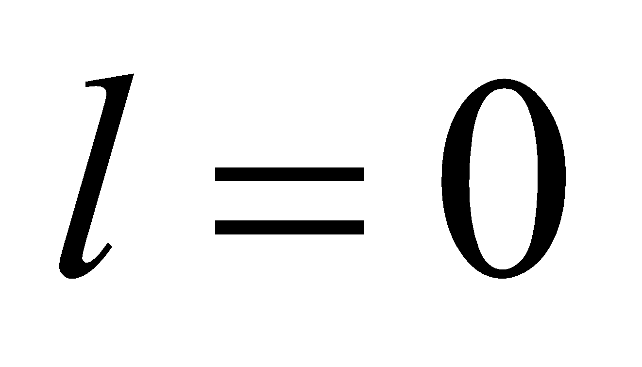 state to the first 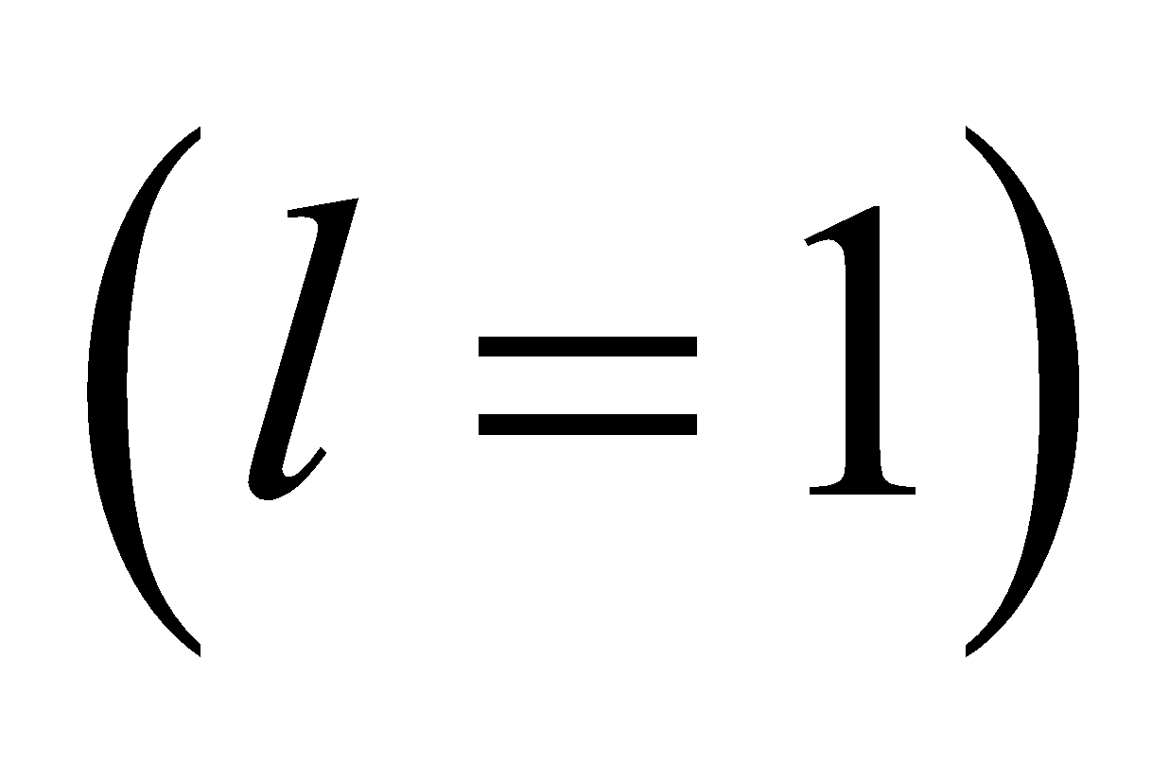 rotational state is 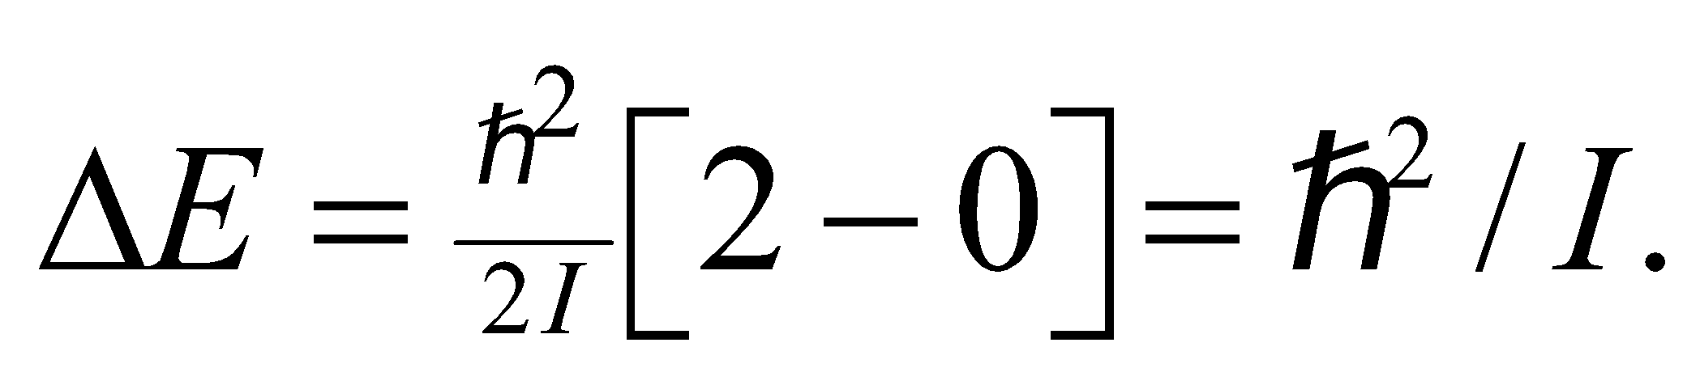 In terms of the photon wavelength, the rotational inertia is 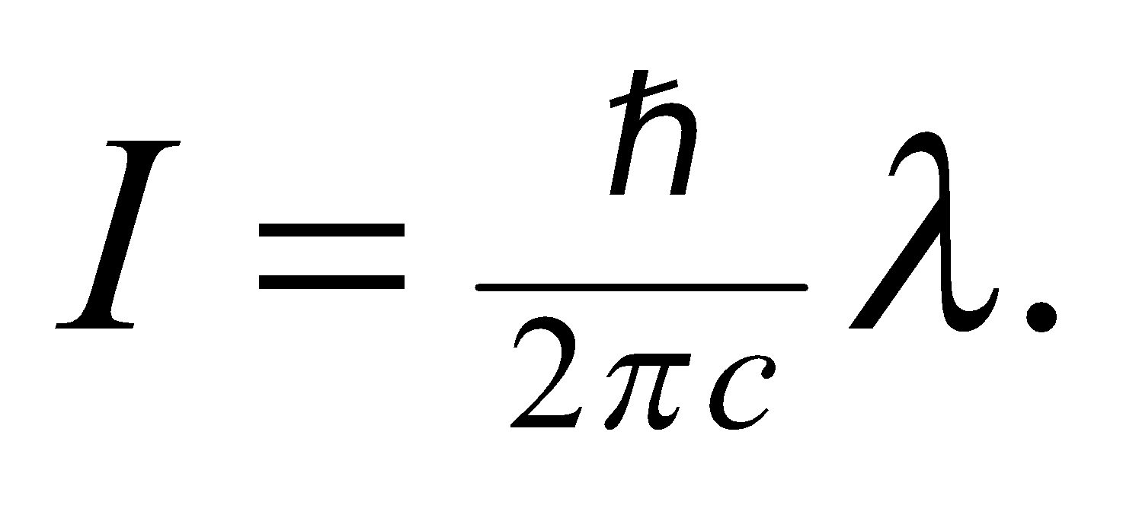 To find the bond length, *R*, we use the result from Problem 37.59 for the rotational inertia of a diatomic molecule: 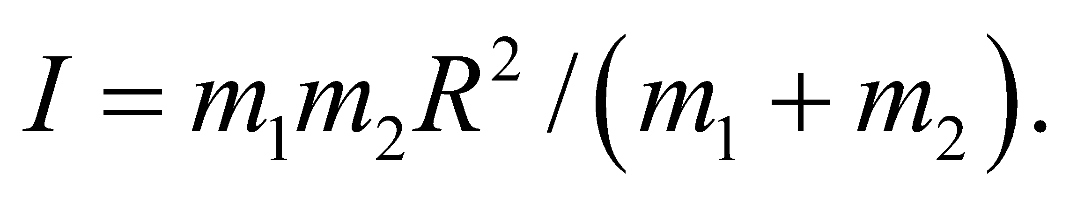 In this case, the masses are 12 u for carbon and 16 u for oxygen.

**Evaluate** Combining the two equations for the rotational inertia,

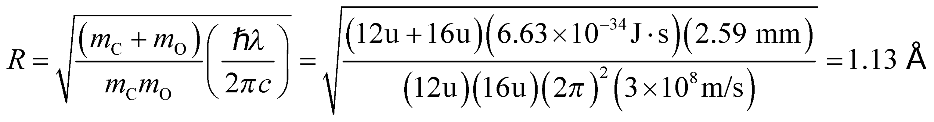

**Assess** This answer seems reasonable, since this is the typical size for atoms and molecules.

**35. Interpret** This problem is about the vibrational energy levels of the HCl molecule. We are given its classical vibration frequency and are to find its ground-state energy and the energy spacing between its vibrational levels.

**Develop** The quantized vibrational energy levels are given by Equation 37.3:

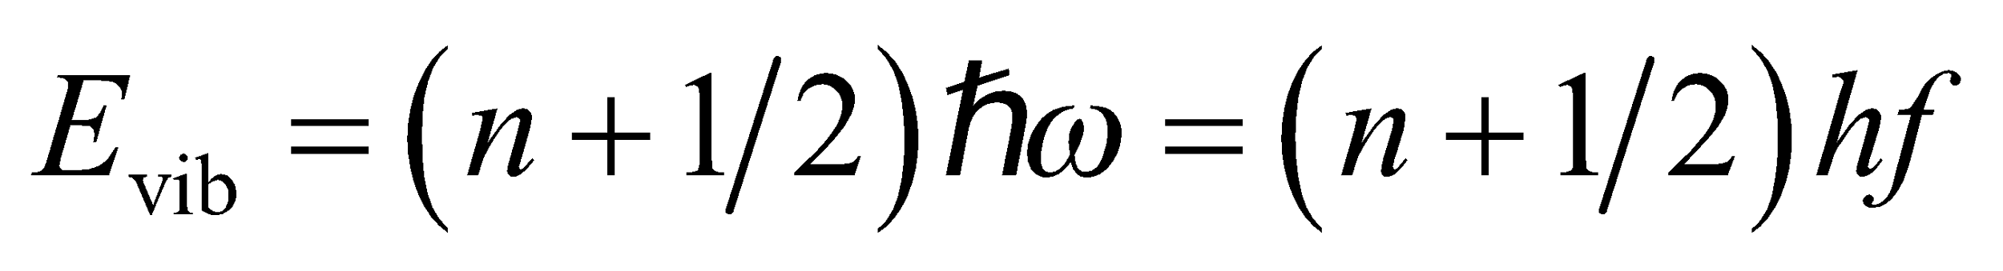

where we have used *ω* = 2*πf*. In the ground state energy *n* = 0, and the energy spacing between the adjacent levels is

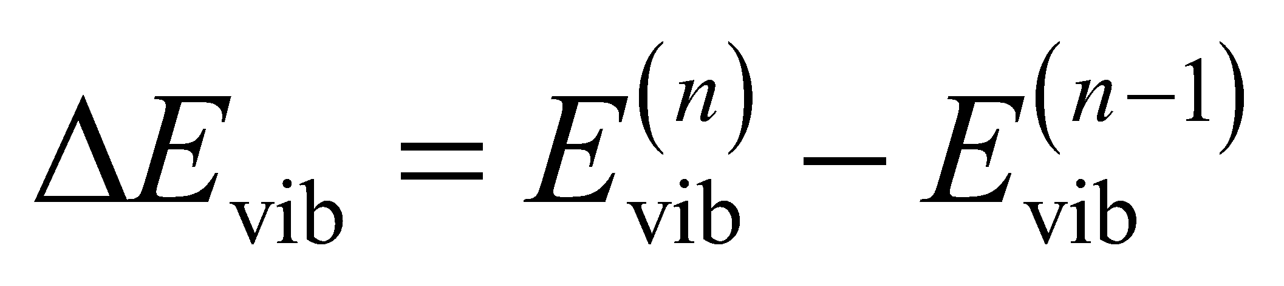

**Evaluate** **(a)** The vibrational ground-state energy is

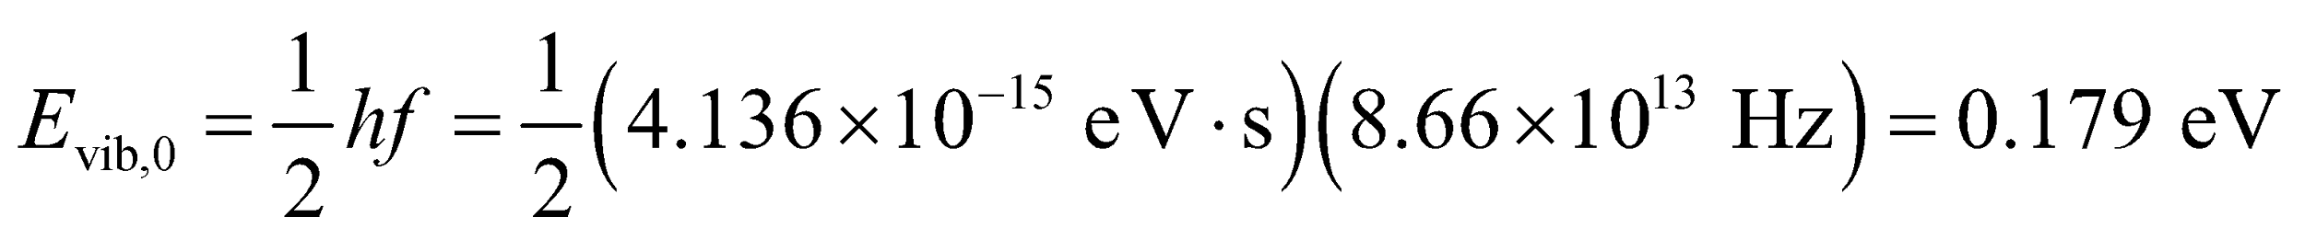

**(b)** The photon energy for allowed transitions 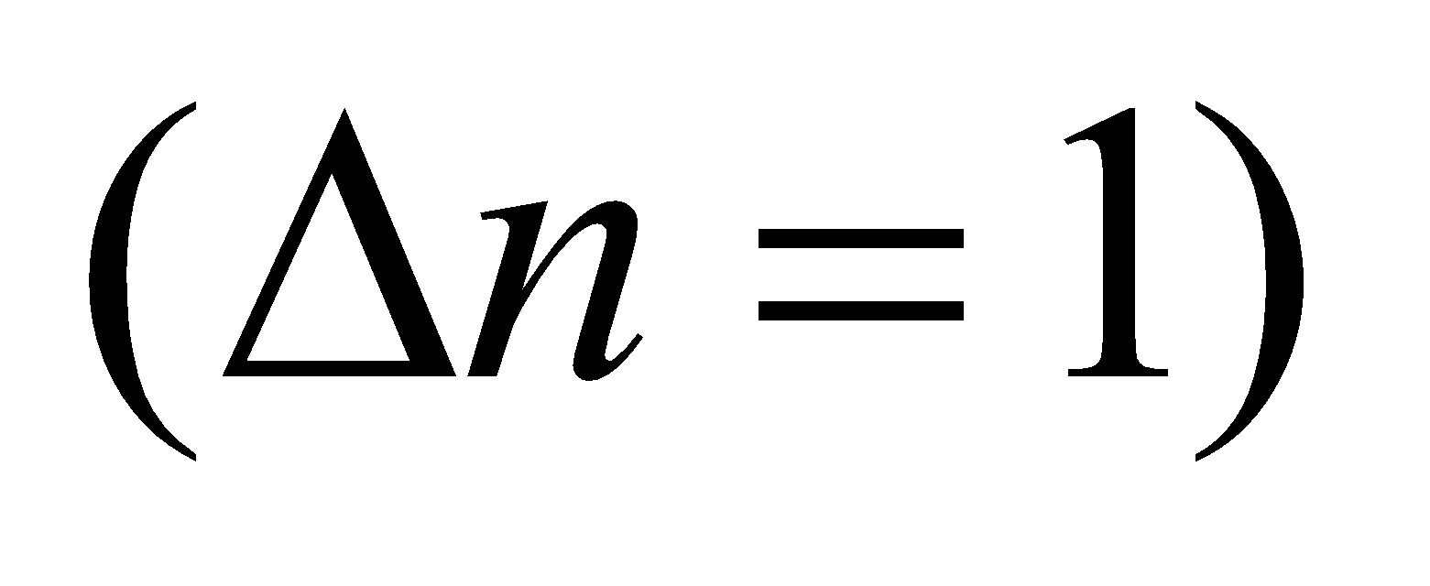 is

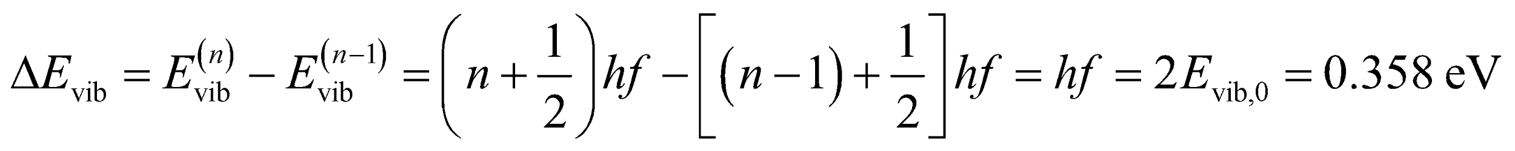

**Assess** Since *f* = 1014 Hz is in the infrared region of the spectrum, the study of molecular vibrations typically involves infrared spectroscopy.

**36. Interpret** We are given the classical vibration frequency and the rotational inertia of a molecule and are asked to find the energy between two quantum states with different vibrational and rotational quantum numbers.

**Develop** We shall apply Equations 37.2 and 37.3 to find the rotational and vibrational energy, respectively, of the initial and final quantum states and take the difference to find the energy difference between these states. By conservation of energy, the photon emitted by this transition must carry this energy difference. The initial state has *n* = 1 and *l* = 1, so its energy is

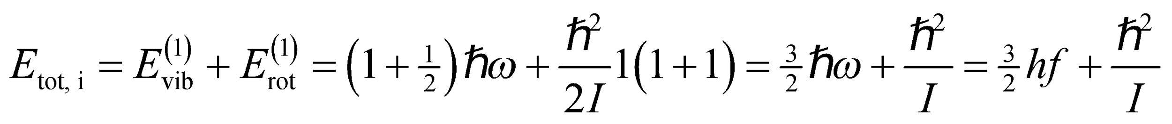

The final state has *n* = 0 and *l* = 2, so its energy is

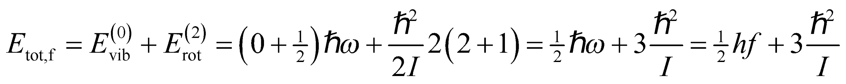

**Evaluate** **(a)** The transition energy is

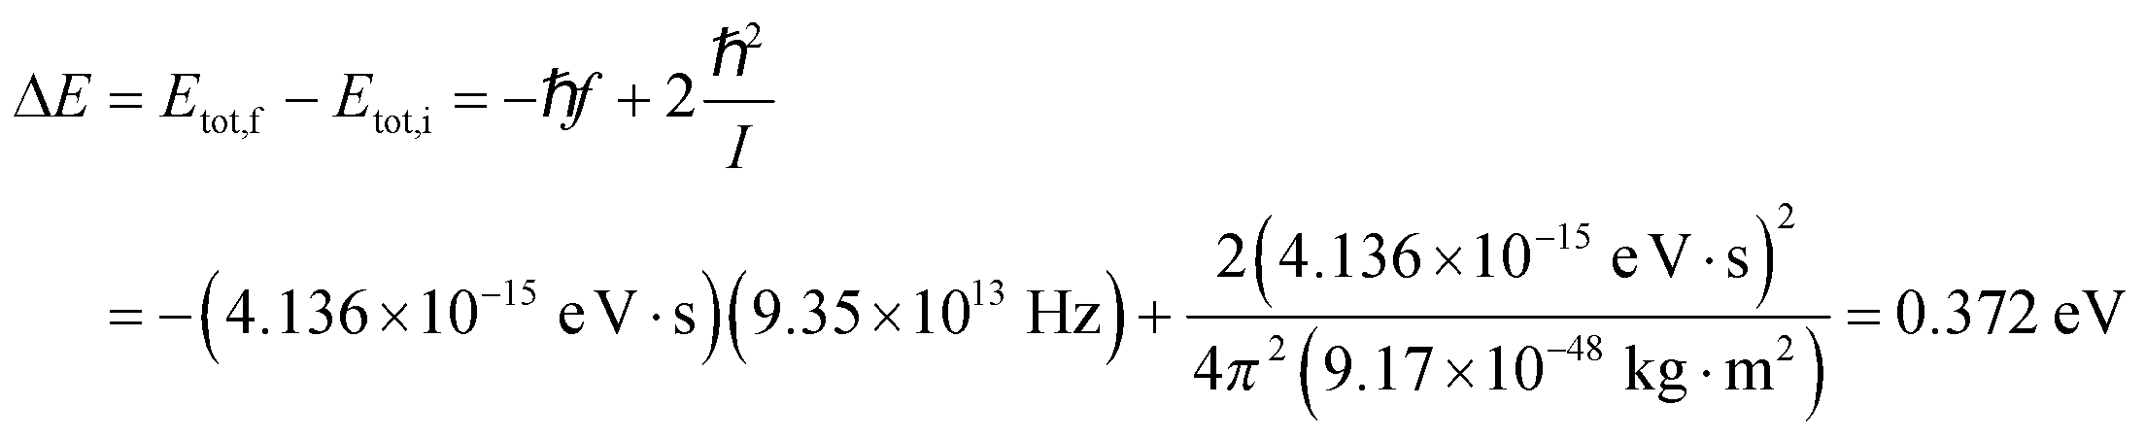

**(b)** From Equation 34.6, the corresponding photon wavelength is

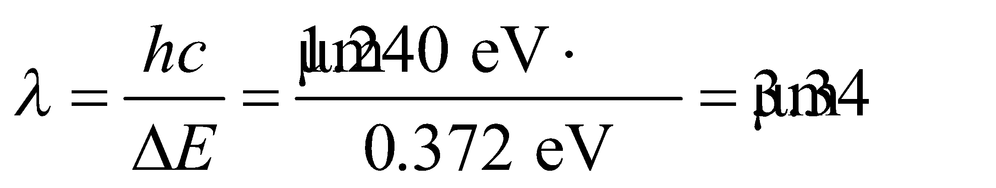

**Assess** This transition is in the infrared portion of the electromagnetic spectrum.

**37. Interpret** The problem concerns one of the dominant absorption wavelengths of carbon dioxide molecules.

**Develop** The relation between transition energy and photon wavelength is given by 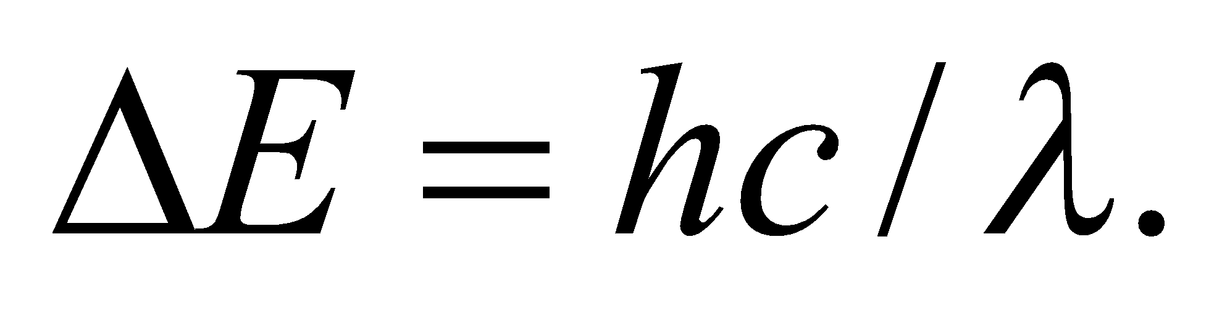

**Evaluate** Solving for the wavelength and using a shorthand expression for the quantity *hc*,

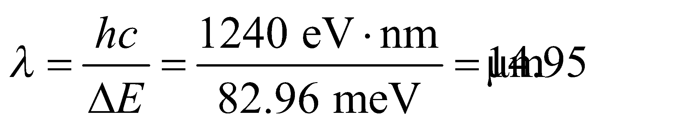

**Assess** The wavelength is longer than the limit of the visible region 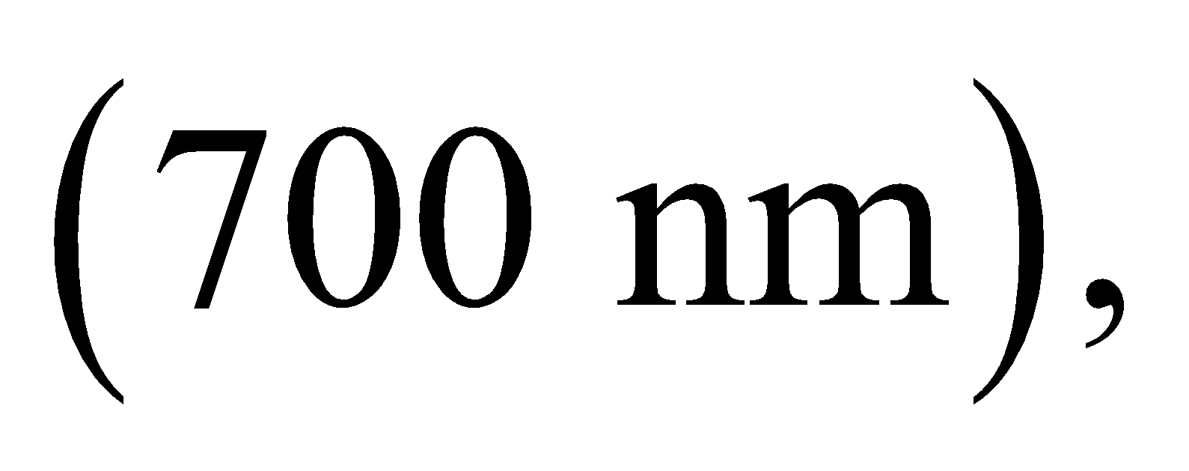 as we'd expect for infrared light.

**38. Interpret** This problem involves both rotational and vibrational transitions of an oxygen molecule which is initially in the ground state with *n* = 0 and *l* = 0. Given the energy difference between two different states, we are to find the classical vibration frequency and the rotational inertia of the molecule.

**Develop** The quantized vibrational energy levels are given by Equation 37.3:



Therefore, the energy difference between adjacent vibrational levels is 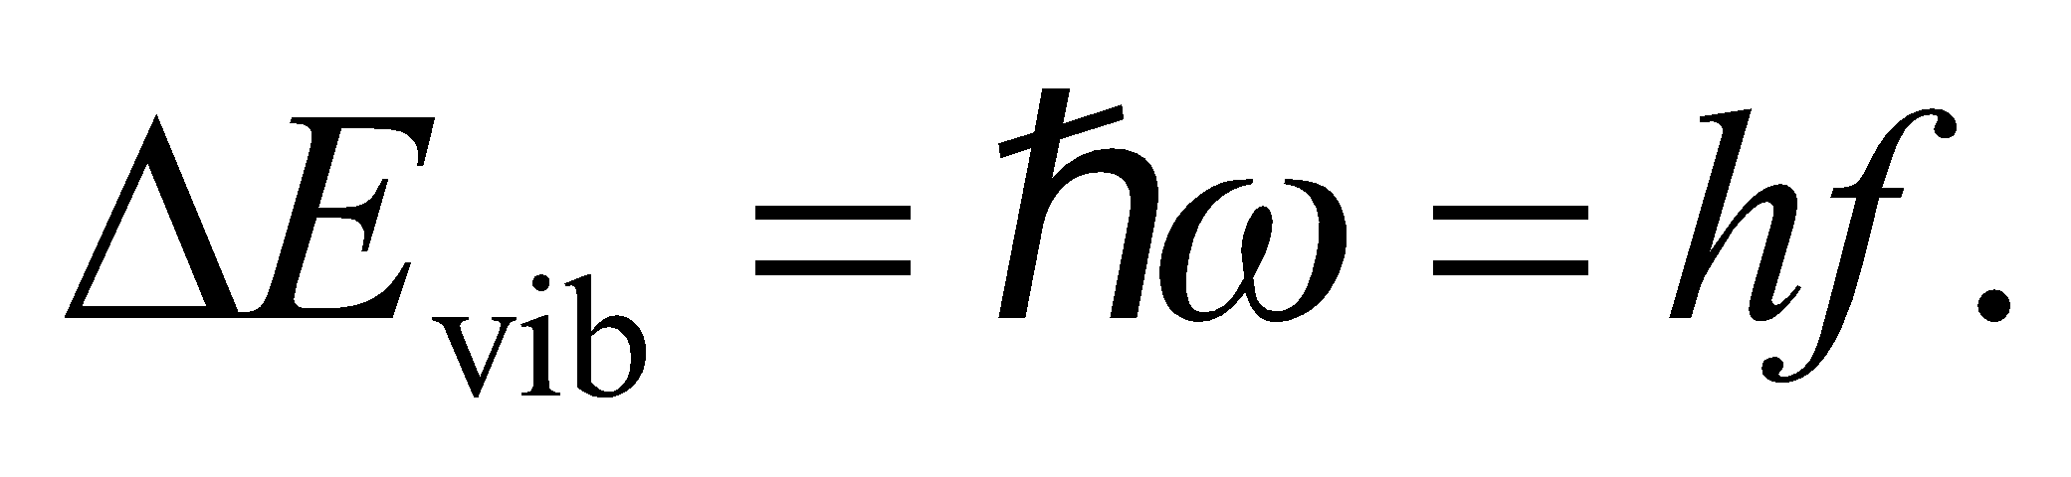 Similarly, using Equation 37.2, the difference in energy between the *l* = 1 and *l* = 0 states is

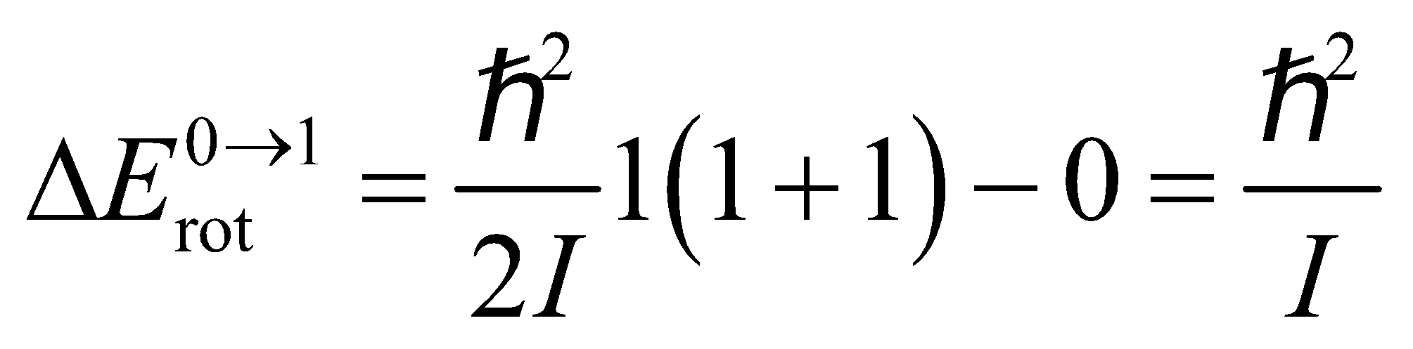

and between the *l* = 1 and *l* = 2 states, the rotational energy difference is

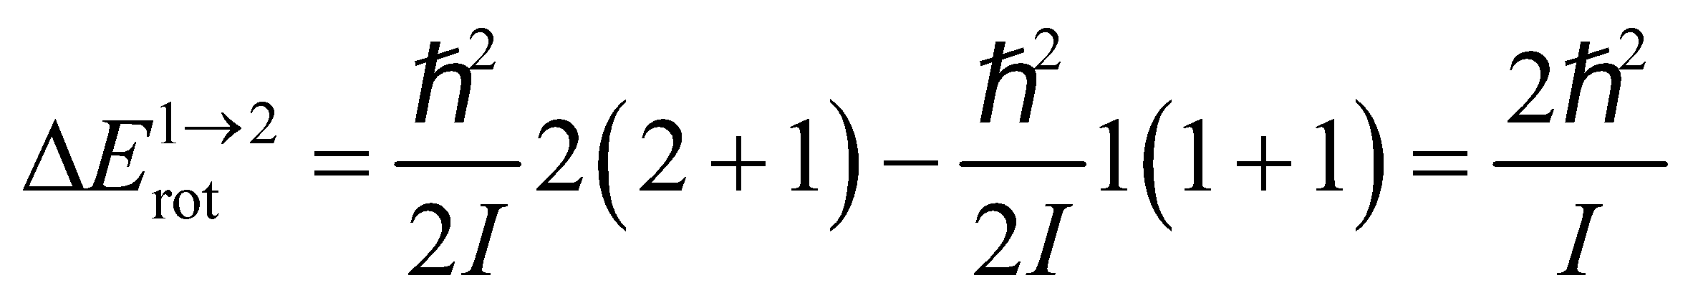

Thus, for the *n* = 0, *l* = 0 to *n* = 1, *l* = 1 transition, the energy difference is

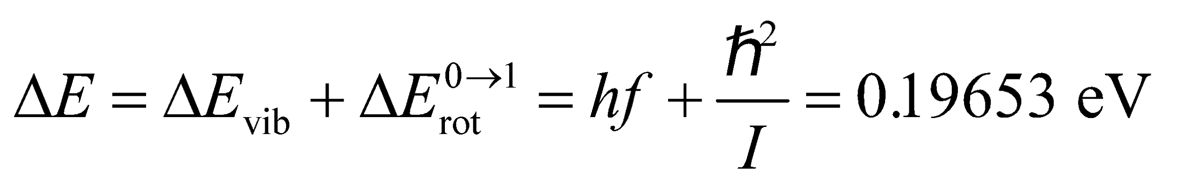

and for the *n* = 1, *l* = 1 to *n* = 0, *l* = 2 transition, the energy difference is

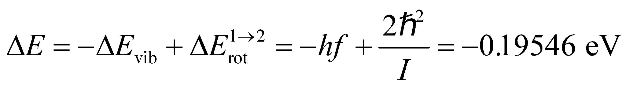

We can solve these equations simultaneously for *f* and *I*.

**Evaluate** **(a)** Multiplying the first equation by 2 and adding to the second, we get

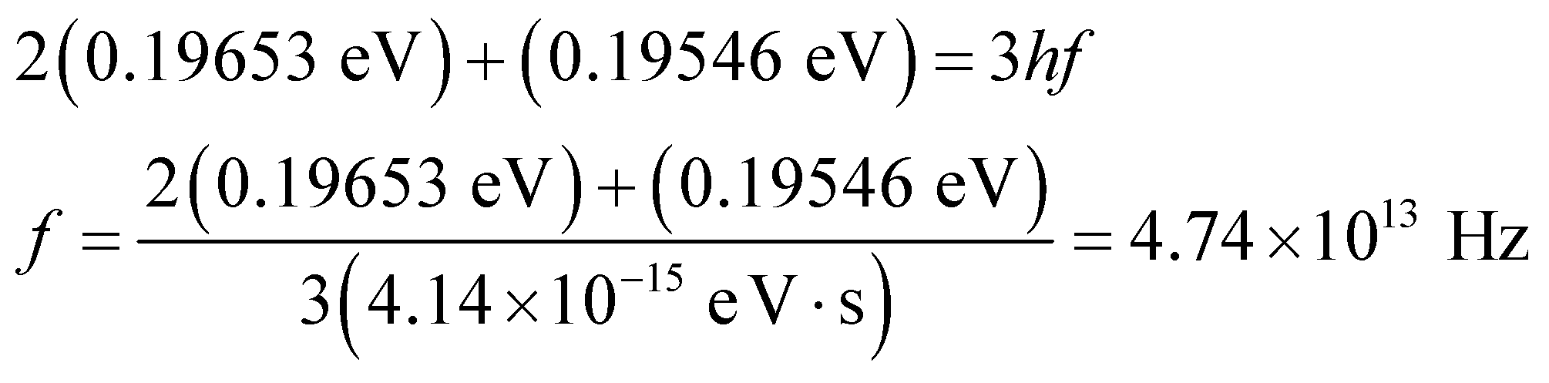

**(b)** Similarly, subtracting the second equation from the first one gives

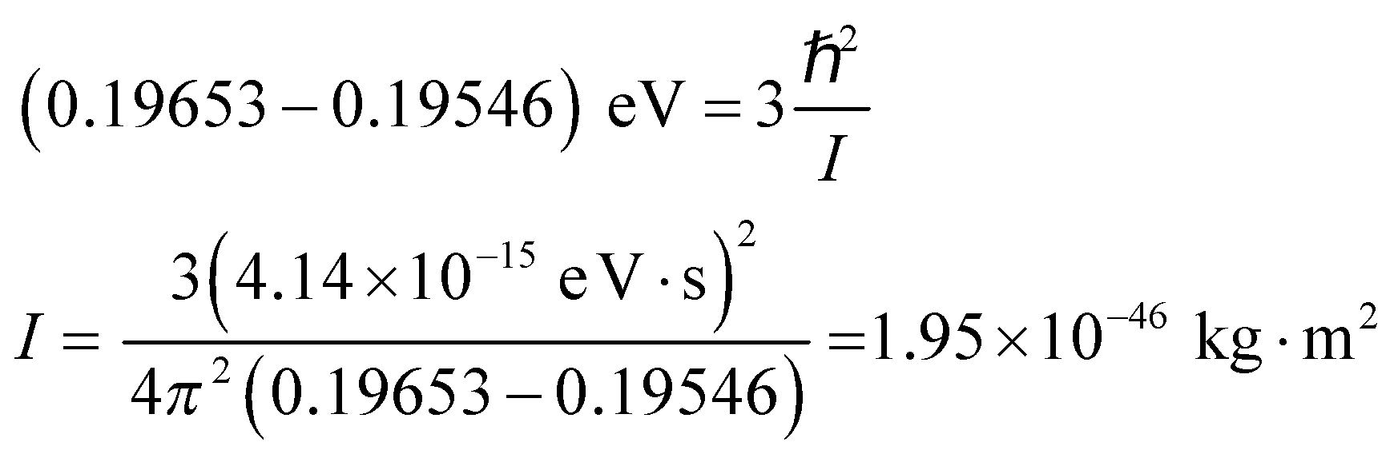

**Assess** Since 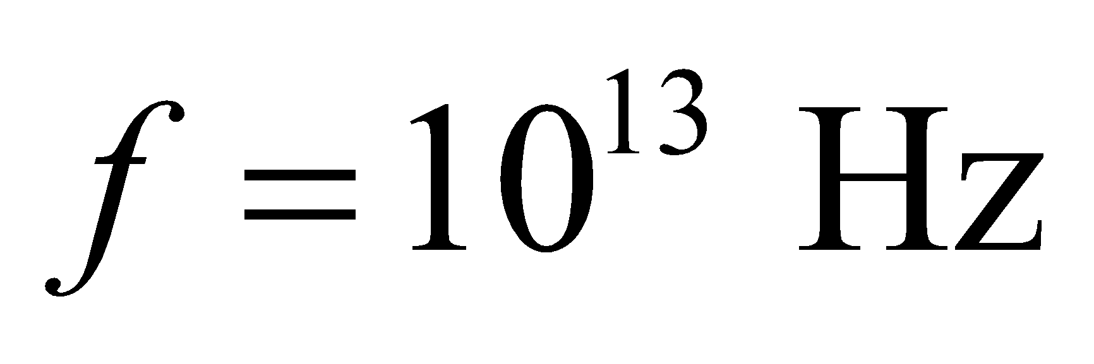 is in the infrared region of the spectrum, study of molecular vibrations typically involves infrared spectroscopy. A rotational inertia 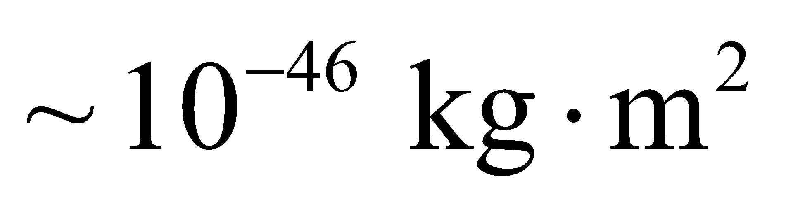 is typical of diatomic molecules.

**39. Interpret** We are given the distance between the atoms in diatomic hydrogen (i.e., H2) and are asked to find the energy spacing between the rotational ground state and the first rotational excited state.

**Develop** From Equation 10.12, the rotational inertia of an H2 molecule is

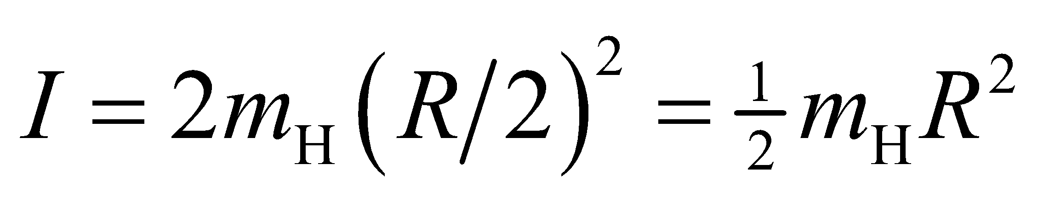

where *R* = 74 pm and *R*/2 is the distance from each atom to the center-of-mass, which is the point about which they rotate. From Equation 37.2, the energy difference between the rotational ground state and first excited state (*l* = 0 and *l* = 1, respectively) is

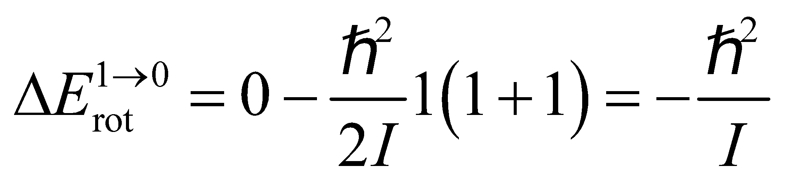

By conservation of energy, this is the magnitude of the energy that must be carried away by the photon emitted by this transition.

**Evaluate** The energy of the photon released in the *l* = 1 to *l* = 0 transition is thus

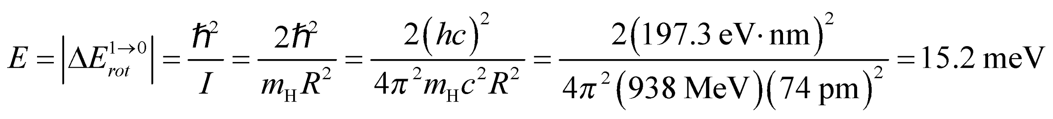

**Assess** The wavelength of this photon is ~81 μm, which is in the far infrared portion of the electromagnetic spectrum. Note that we have used the proton’s mass as the mass for the hydrogen atom, which is warranted because it is an accurate value for the precision of this problem.

**40. Interpret** We're asked to convert the wavelength of a "breathing mode" in DNA molecules into its associated frequency and energy.

**Develop** For light, the wavelength is related to frequency by 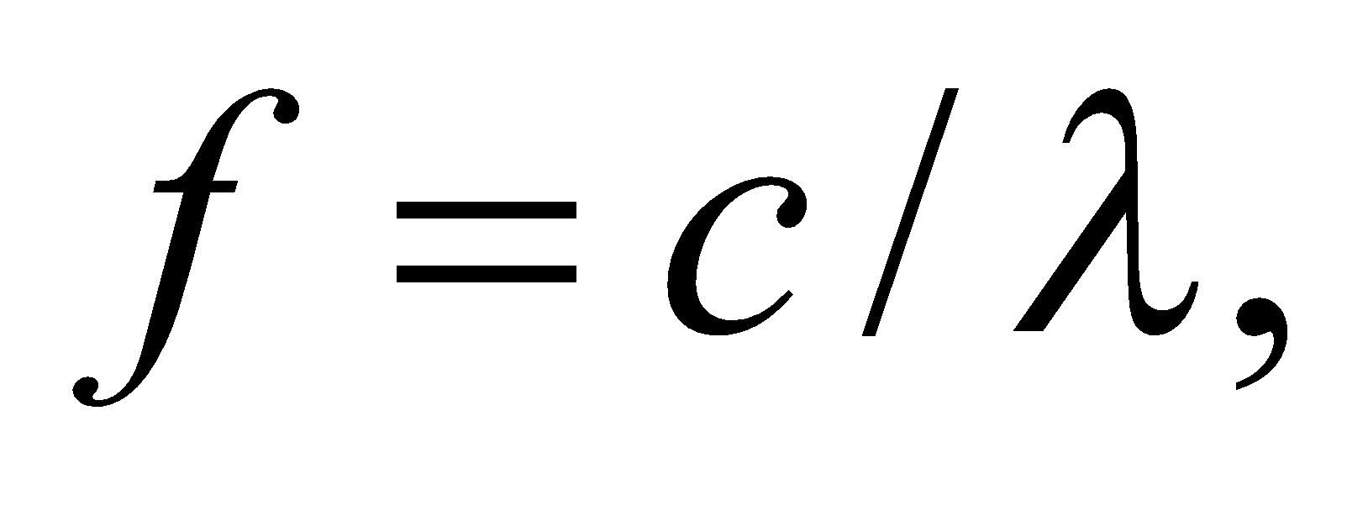and energy by 

**Evaluate**  **(a)** The frequency of the given mode is

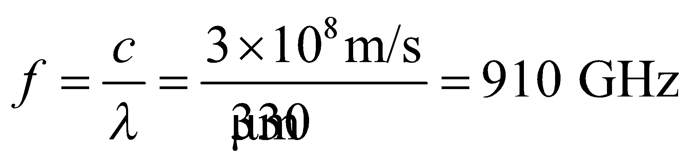

**(b)** The energy of the mode is

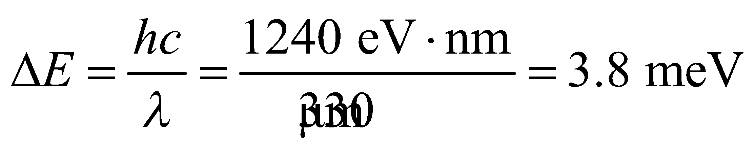

**Assess** The frequency is at the border between microwaves and infrared radiation, in a region of the electromagnetic spectrum that is sometimes referred to as terahertz light, or T-rays.

**41. Interpret** This problem involves both rotational and vibrational transitions of a KCl molecule. We are given the classical vibration frequency and the rotational inertia and are asked to find the energy difference for a given transition.

**Develop** The quantized vibrational energy levels are given by Equation 37.3:



Therefore, the energy difference between adjacent levels is 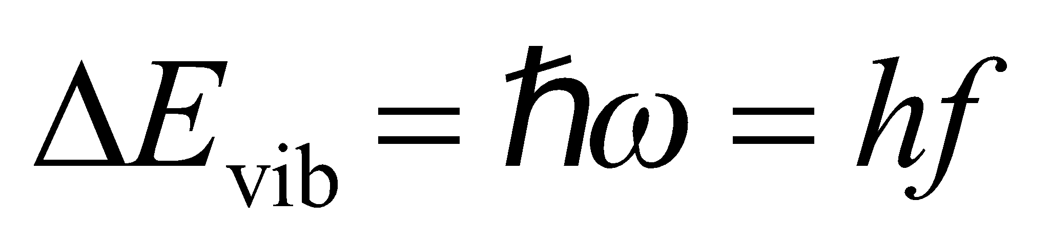. Similarly, using Equation 37.2, the difference in energy between the *l* = 2 and *l* = 3 states is

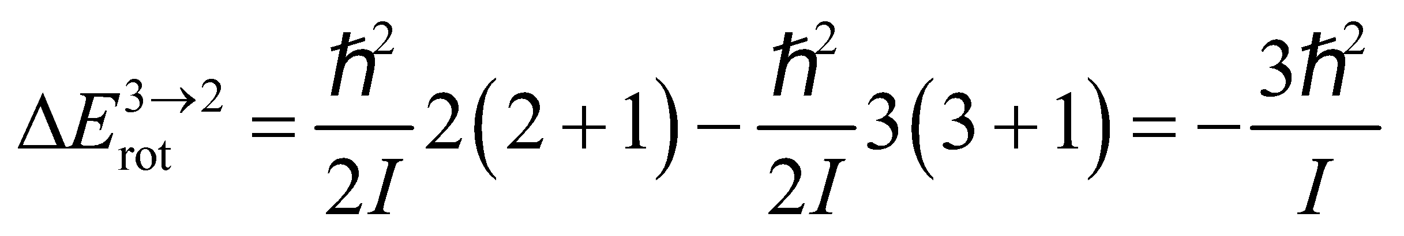

Thus, the difference in energy between these vibrational-rotational levels is

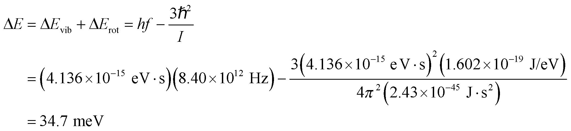

**Evaluate** The energy corresponds to a photon wavelength of 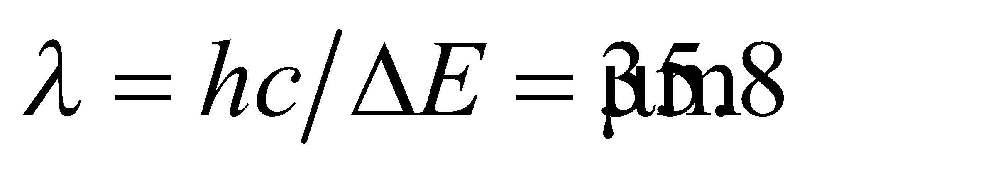.

**Assess** Since 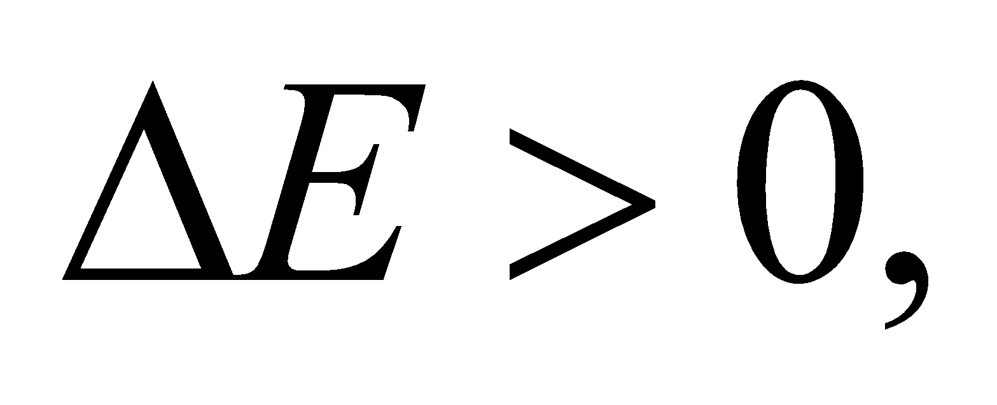 the final state has higher energy than the initial state, so the transition involves absorbing a photon in the infrared.

**42. Interpret** Given the rotational inertia and classical vibration frequency of H2, we are to find the wavelength (i.e., energy) of photons emitted by all allowed transitions from the first three rotational levels in the *n* = 1 vibrational state to the *n* = 0 state.

**Develop** The allowed transitions are defined by *Δn* = ±1, *Δl* = ±1, so the allowed transitions from the first three rotational levels (*l* = 0, 1, 2) are

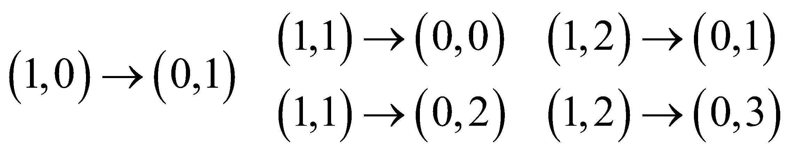

where we have used the notation (*n*, *l*) to define each state. The quantized vibrational energy levels are given by Equation 37.3:



Therefore, the energy difference for the transition from state *n* to state *n* − 1 is



The quantized rotational energy levels are given by Equation 37.2, so the energy difference for the transition from state *l* to state *l* − 1 is

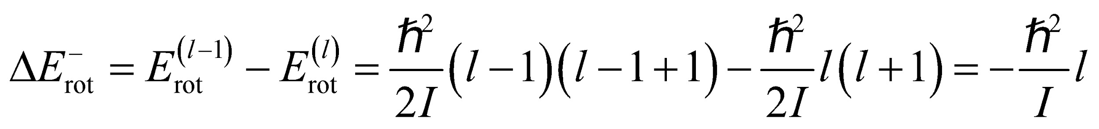

and the energy difference for the transition from state *l* to state *l* + 1 is

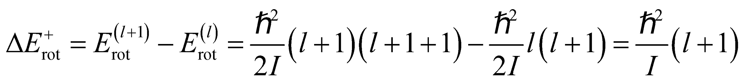

The total energy difference is the sum of the vibrational and rotational energy differences. Thus, the energy difference for each transition is

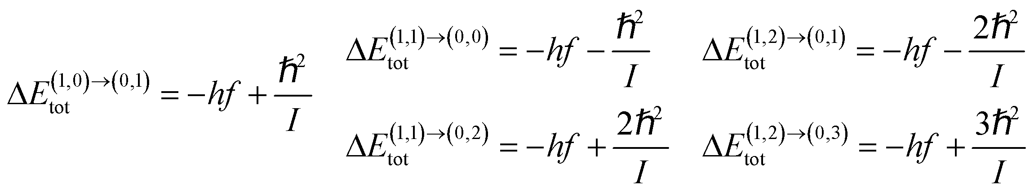

We can evaluate each of these differences using the data provided and, by conservation of energy, equate these energies to that of the photons emitted in the transitions. The wavelengths of the photons may then be found using Equation 34.6: *E* = *hf* = *hc*/*λ*.

**Evaluate** From the given data for the H2 molecule,



and

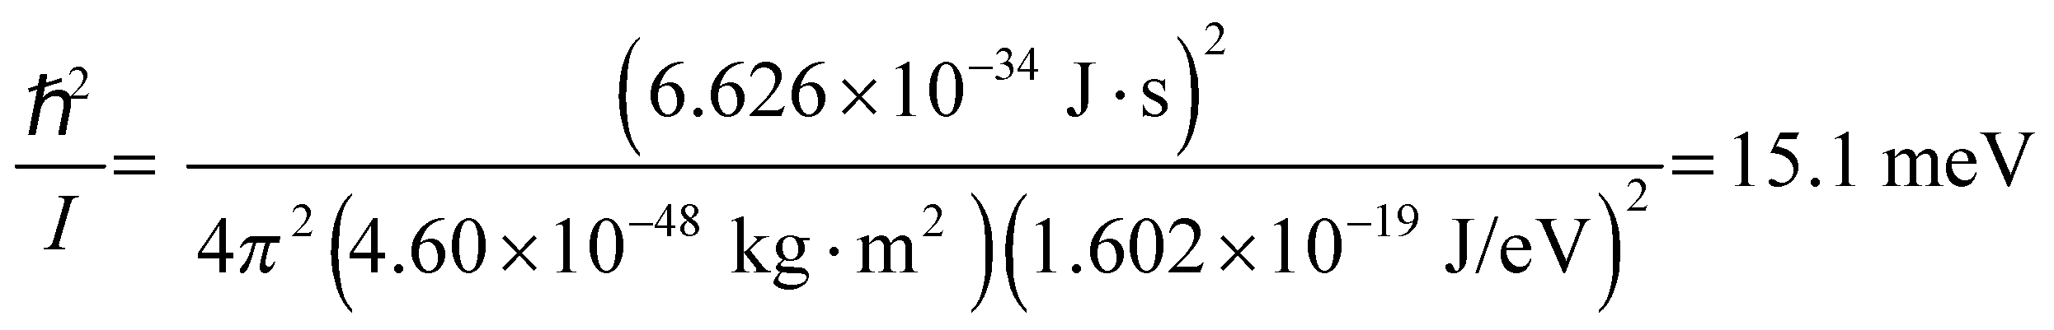

so the transition energies are

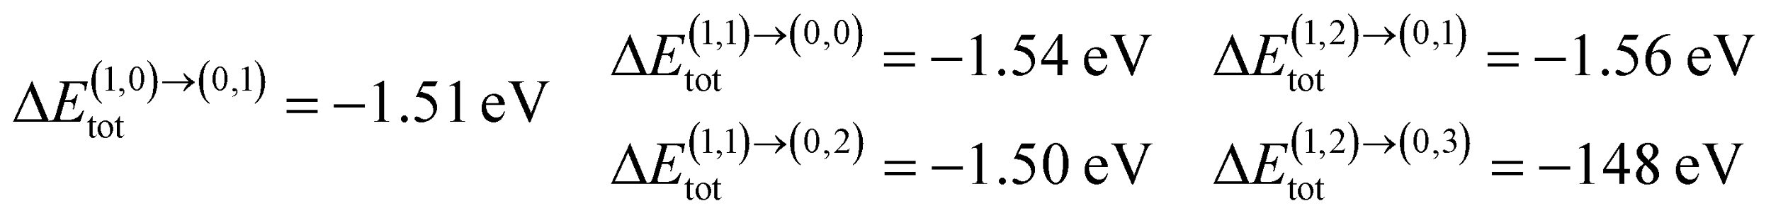

These energies are lost by the H2 molecule, so conservation of energy implies that the energies of the photon emitted must balance these energies, so *Eγ* = −*ΔE*tot. Combining this with Equation 34.6 gives *λ* = −*hc*/*ΔE*tot. Thus, the wavelengths are

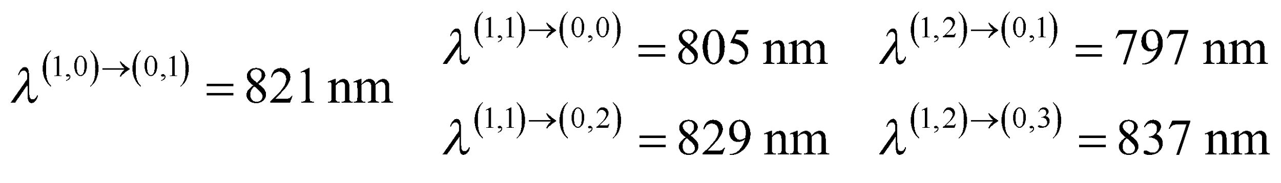

**Assess** These wavelengths are all in the near-infrared range of the electromagnetic spectrum.

**43. Interpret** This problem is about the ionic cohesive energy of KCl. We are asked to solve for the constant *n* in Equation 37.4.

**Develop** As shown in Example 37.3, the constant *n* (not to be confused with the quantum number *n* used above) is given by

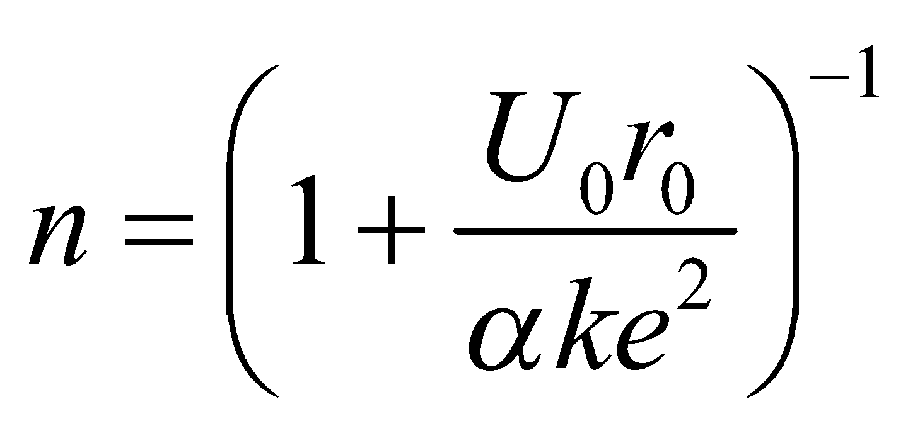

Since the crystal structures of KCl and NaCl are the same, *α* = 1.748.

**Evaluate** Substituting the values given, we get

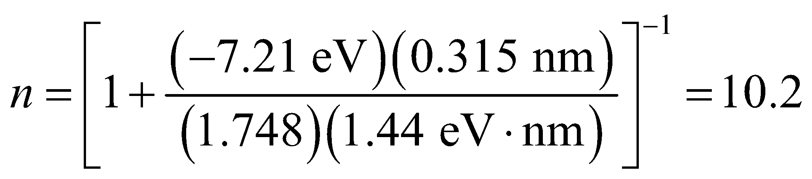

where we used a convenient value of 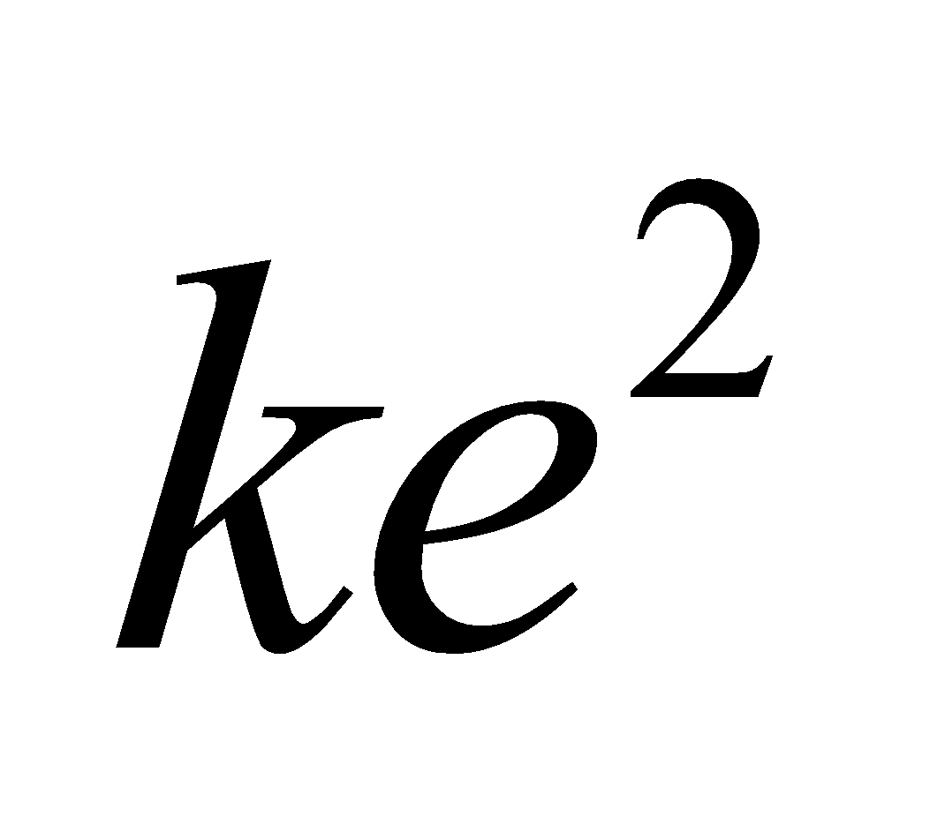 in atomic units:

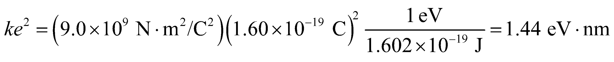

**Assess** The result can be compared with *n* = 8.22 for NaCl (see Example 37.3). The large value of the exponent implies that KCl is strongly resistant to compression.

**44. Interpret** We are to find the energy required to compress an NaCl crystal to 90% of its original volume.

**Develop** For the volume of the crystal to decrease to 90% of its original volume, the equilibrium separation *r*0 between atoms must decrease by

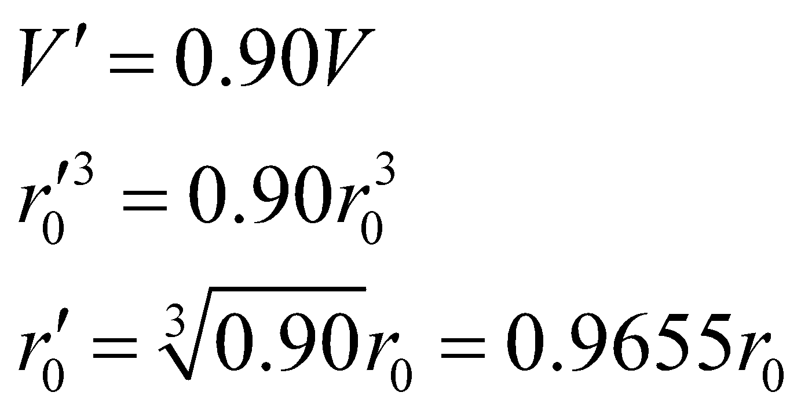

The energy per ion pair would increase, under compression, to

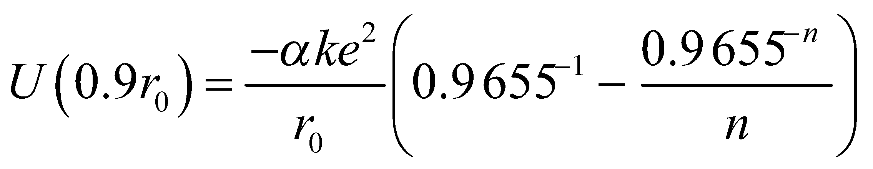

from its normal value of 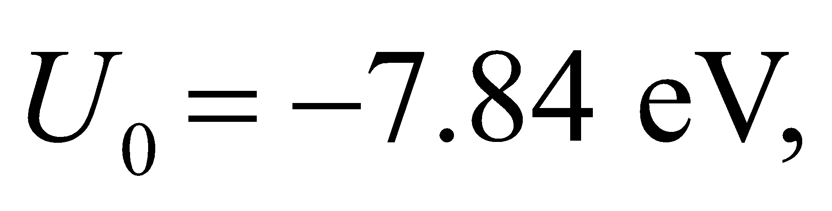 where *n* = 8.22 for NaCl. From the data for the noncompressed crystal, the constant 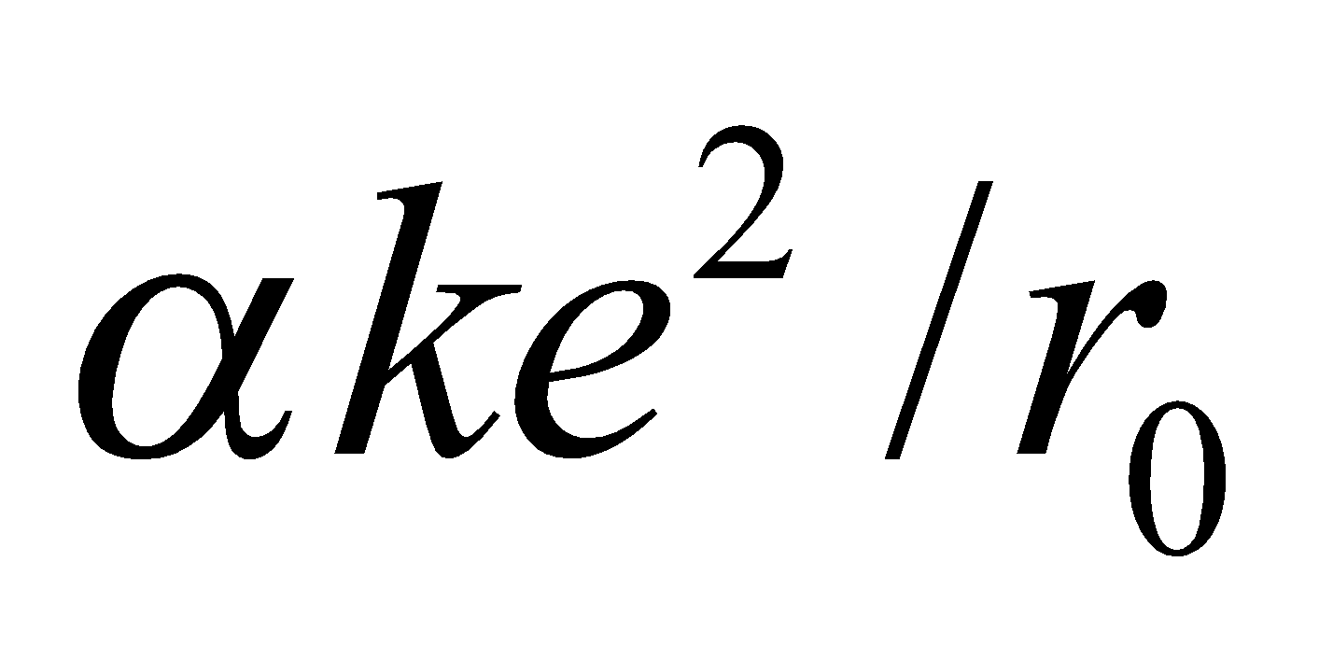 has the value

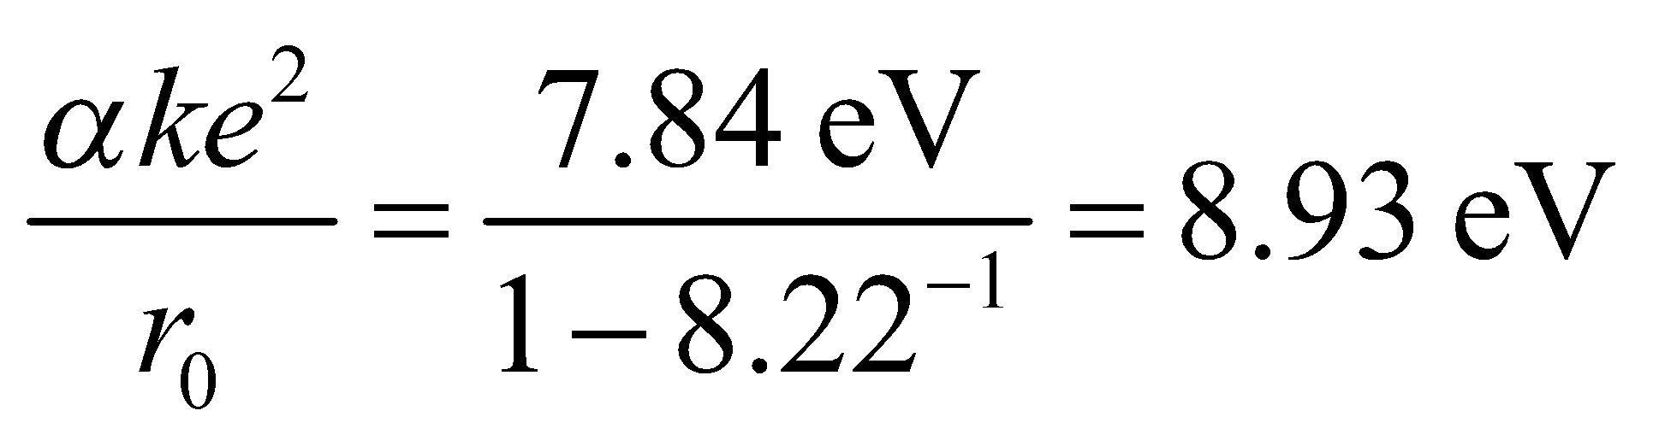

**Evaluate** The energy required to compress 1021 ion pairs is



**Assess** This energy is roughly equivalent to the kinetic energy of one liter of water dropped from rest through 66 cm.

**45. Interpret** For this problem, we are to find the ionic cohesive energy of LiCl, which has the same structure as NaCl.

**Develop** As calculated in Example 37.3, the ionic cohesive energy for NaCl is



**Evaluate** With *n* = 7 and *r*0 = 0.257 nm, the cohesive energy for LiCl is

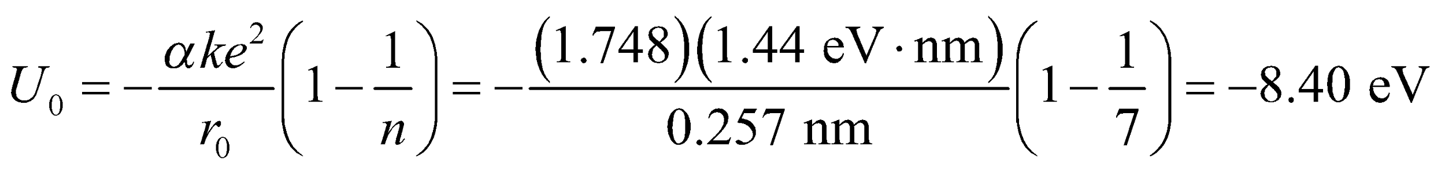

**Assess** The result can be compared with 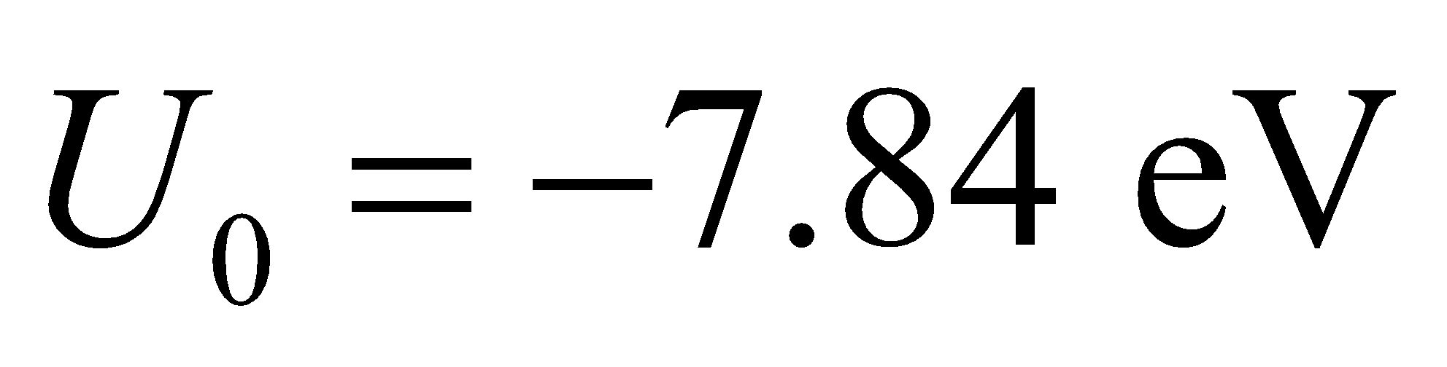 for NaCl (see Example 37.3). The large value of the exponent implies that LiCl is strongly resistant to compression.

**46. Interpret** You are arguing that a salt formation is structurally sound for storing waste. You support this conclusion by calculating the force between ions, which resists compression.

**Develop** Equation 37.4 gives the generic formula for the potential energy of an ion in a crystal structure:

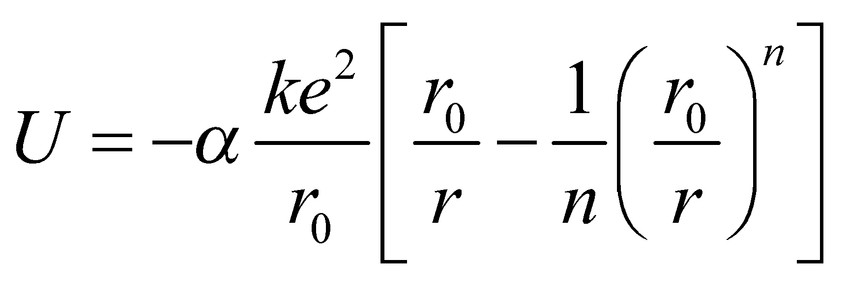

For NaCl, the values of this equation's parameters are given in Example 37.3: 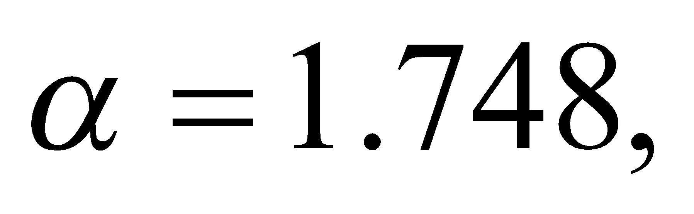 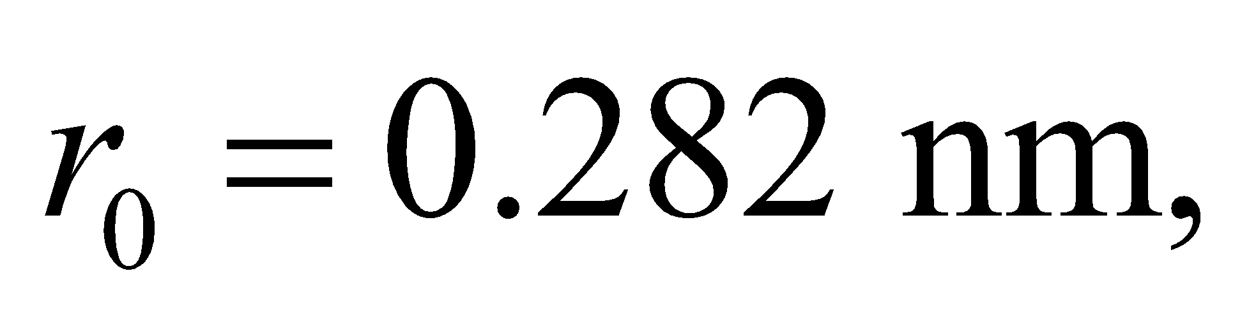 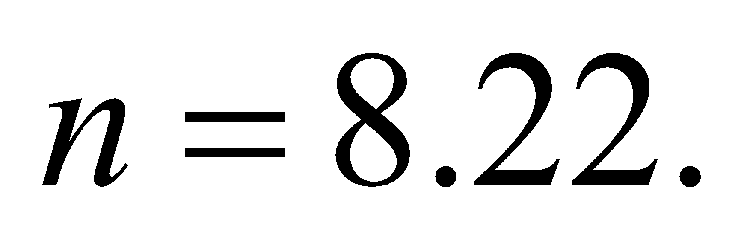 To find the force on an ion moved from its equilibrium position, we take the derivative with respect to 

**Evaluate** In general, the force on an ion in a crystal structure is

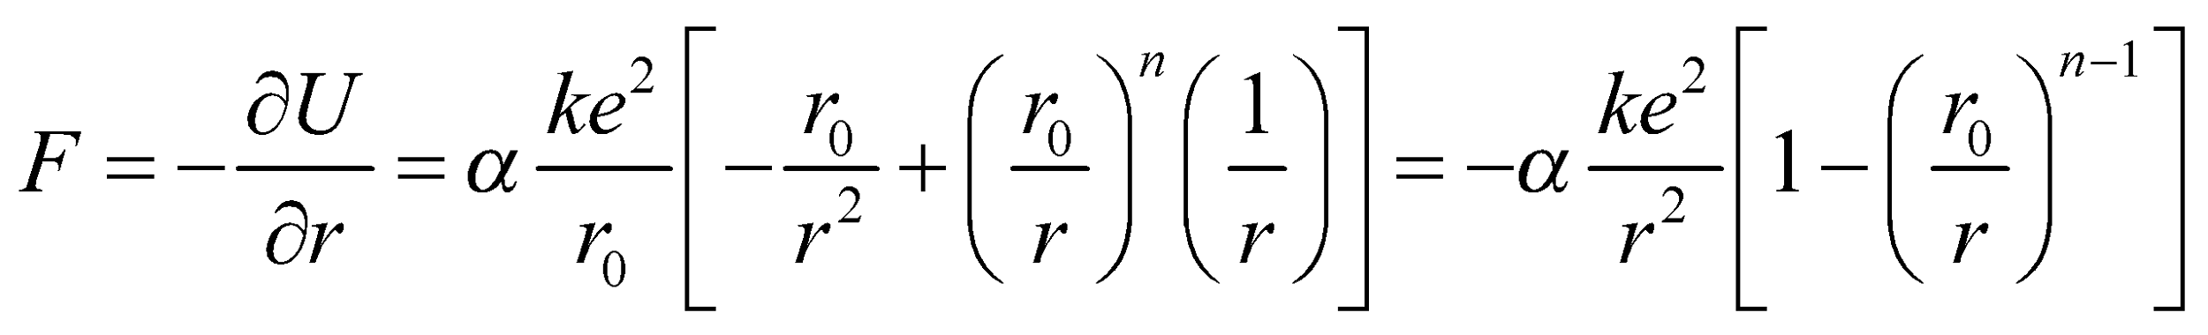

Note that the term 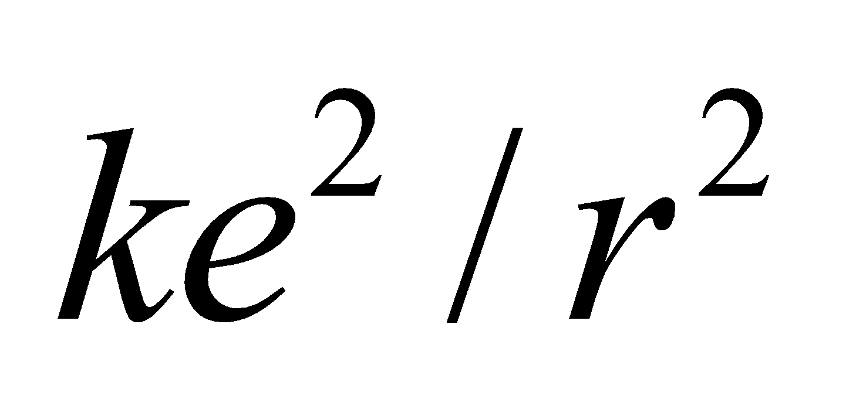is the Coulomb attraction, 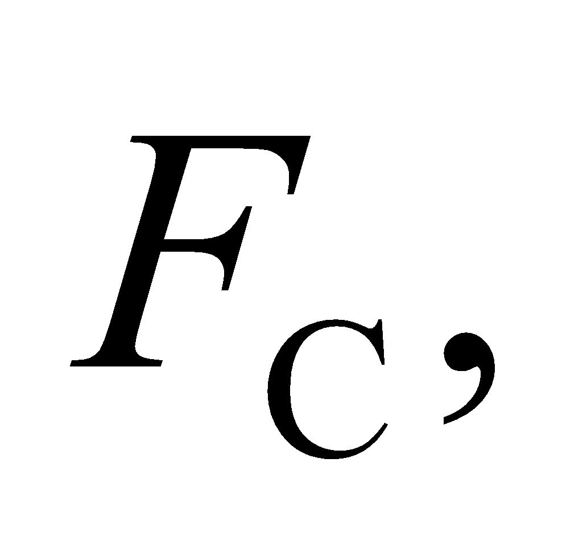which you can imagine is the attractive force between a positive sodium ion and a negative chlorine ion. If 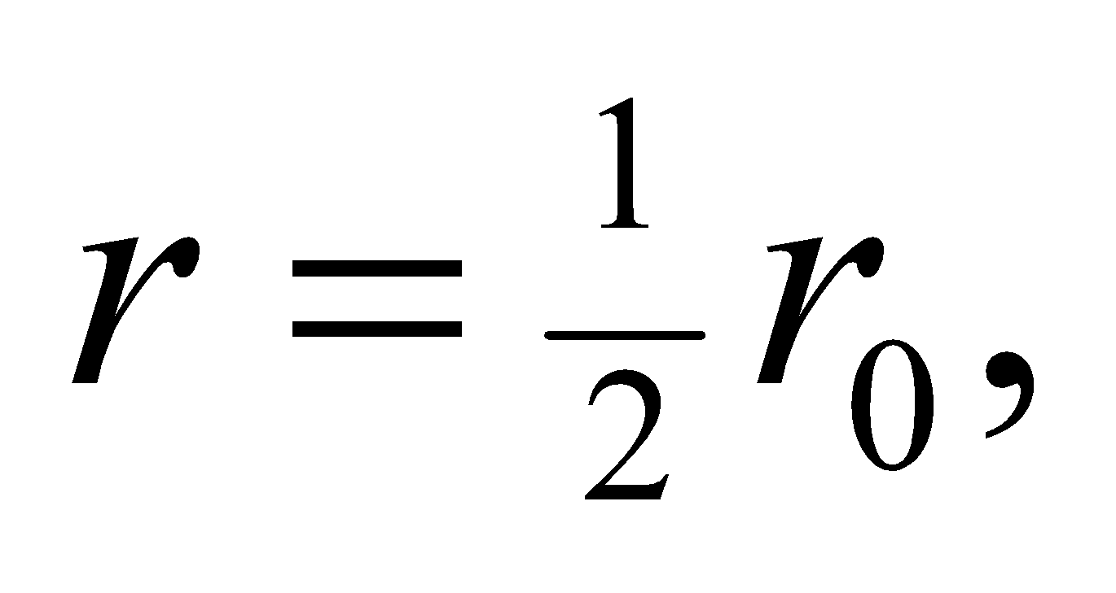then the Coulomb attraction and the force on a salt ion are

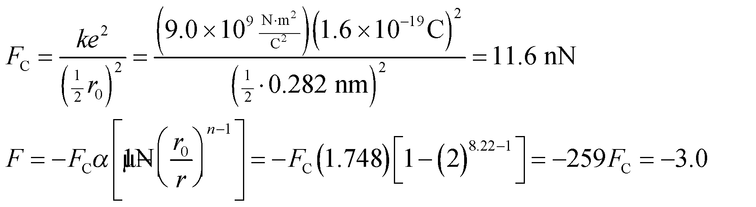

The negative sign for *F* signifies that it is a restoring force that opposes as the Coulomb attraction. The fact that this force is 259 times the Coulomb force assures you that salt is stable under compression.

**Assess** How compressible a crystal is will be determined by the exponent, *n*, in the repulsive part of the potential. The larger *n* is, the more the ions will resist compression. Typical values of n range from 5 to 12, which means there are crystals that are much more and much less compressible than NaCl.

**47. Interpret** We are to integrate the density of states for a metal over all occupied states to find the number of conduction electrons per unit volume.

**Develop** Equation 37.5 tells us that the density of states is

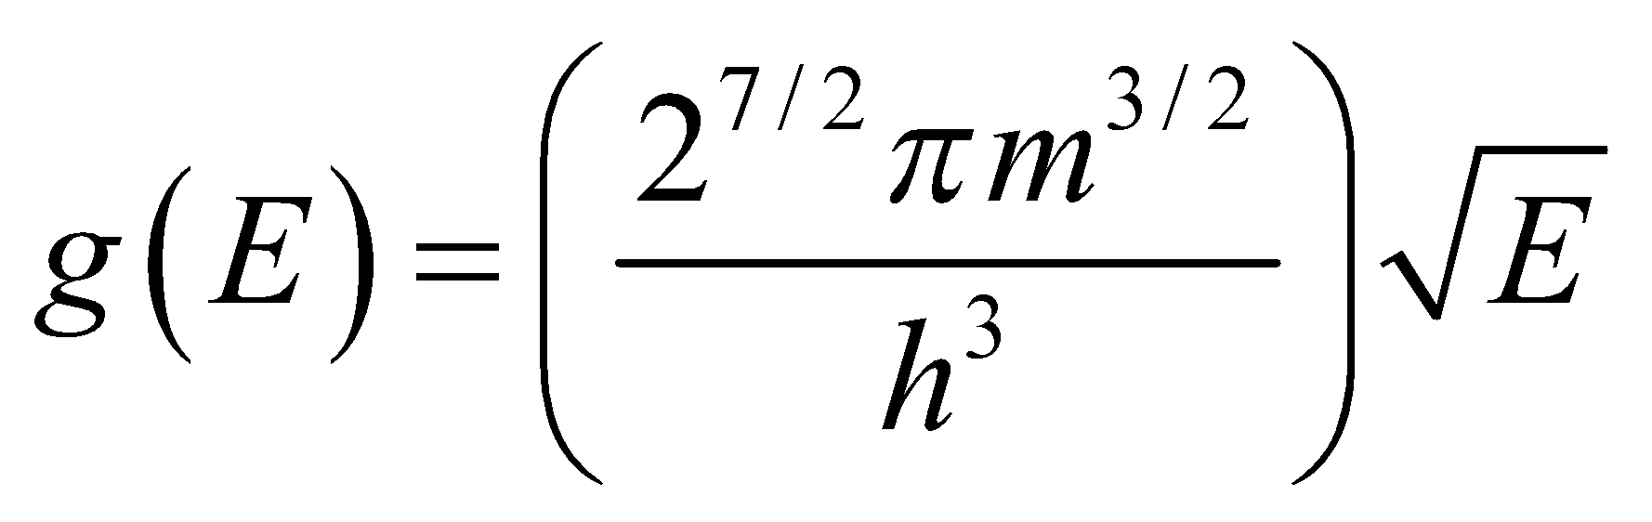

We will integrate this density from *E* = 0 to *E* = *E*F to find the electron number density.

**Evaluate** Performing the integration gives

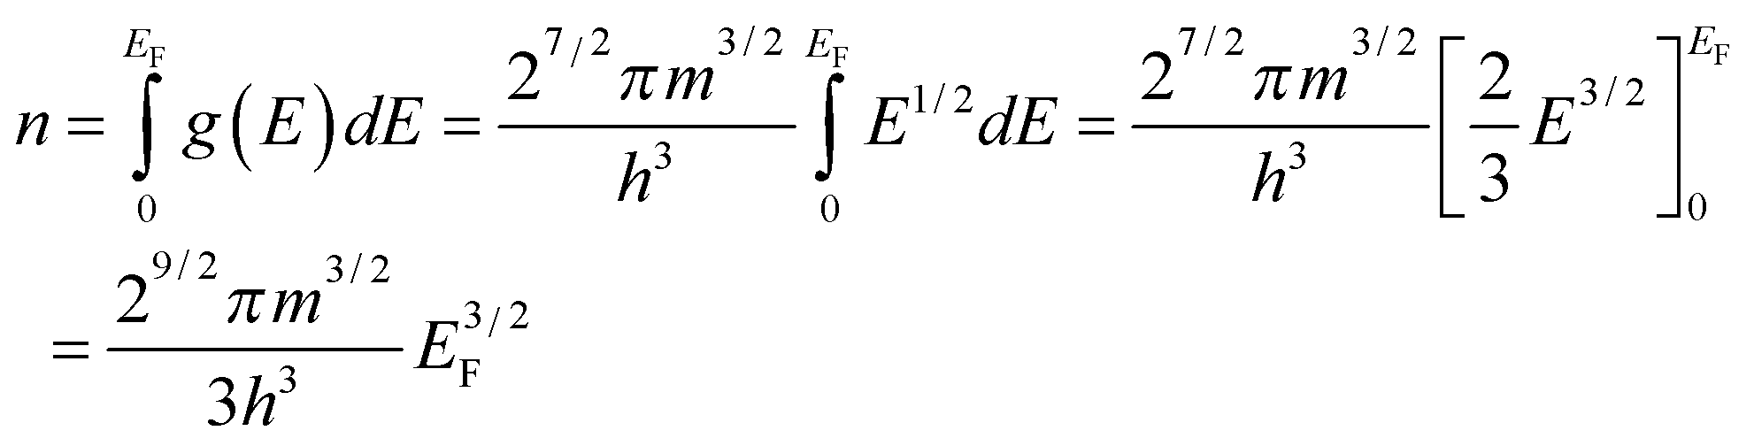

**Assess** We have shown what was required.

**48. Interpret** We shall use the results of Problem 37.47 to find the number density *n* of conduction electrons in aluminum.

**Develop** From Problem 37.47, we have 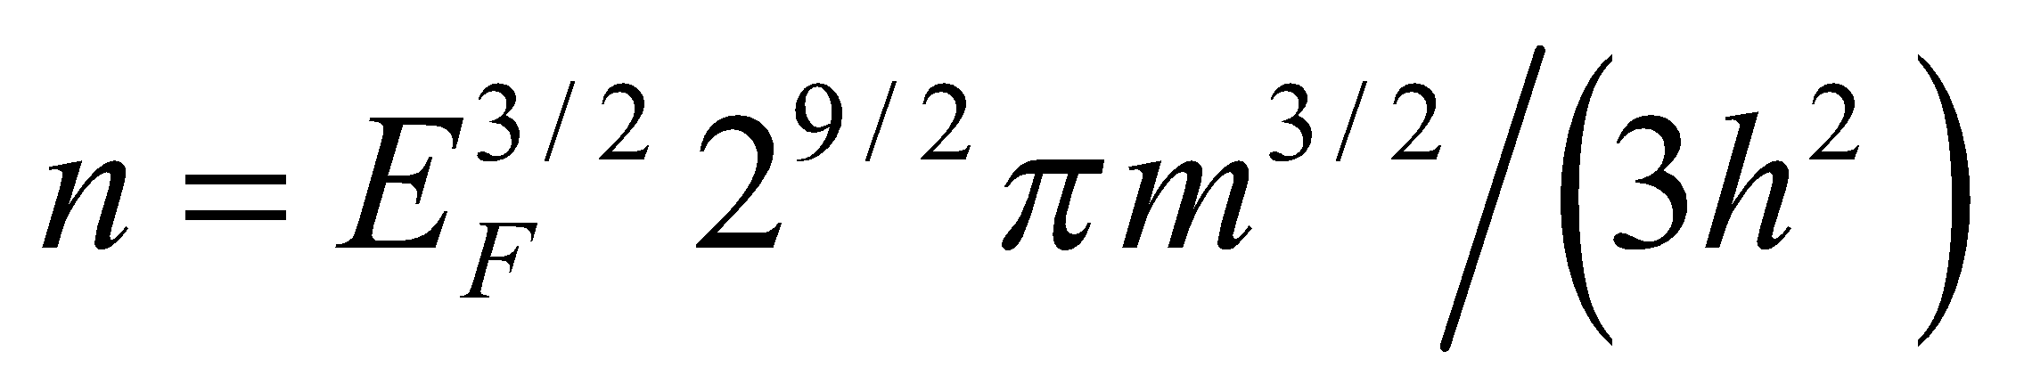 and in this problem we are given the Fermi energy *E*F = 11.6 eV. We simply plug in the mass of the electron m = 9.109 × 10−31 kg and the rest of the constants to obtain the number density *n*.

**Evaluate** The number density is

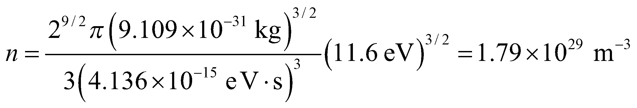

**Assess** It is actually more common to report number densities in terms of number per centimeter cubed, and in those units the answer would be 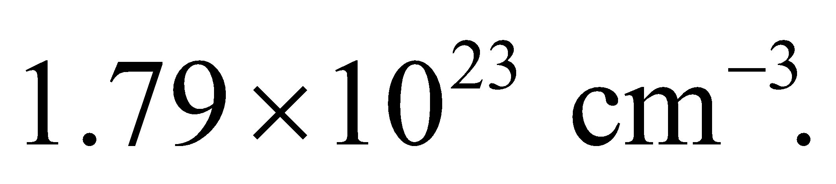 To check the units, we have

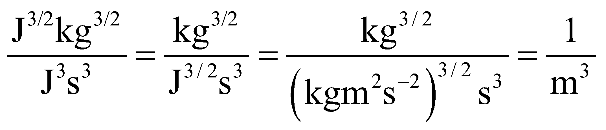

**49. Interpret** We shall use the results of Problem 47 to calculate the Fermi energy for calcium, given the number density.

**Develop** The number density of conduction electrons for calcium is 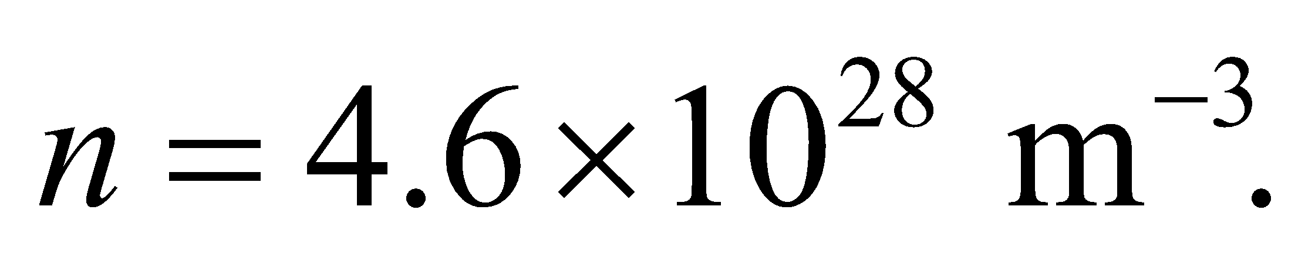 We use this, and the electron mass 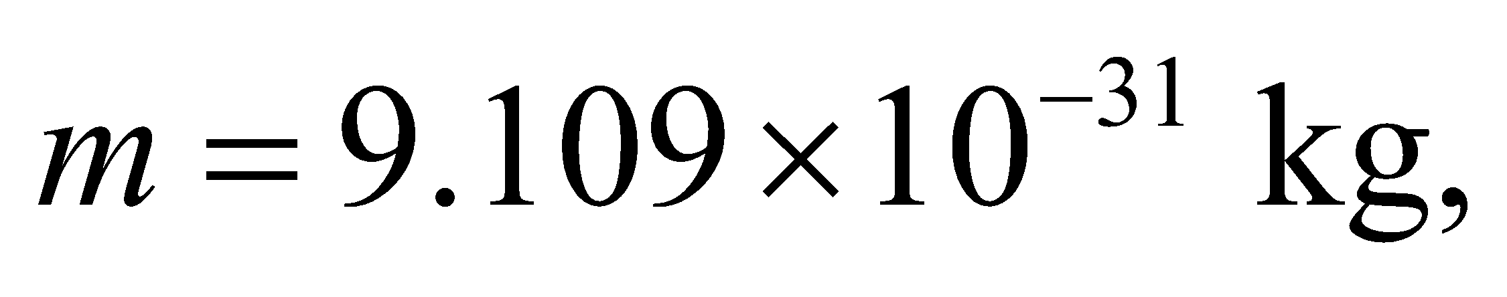 to solve 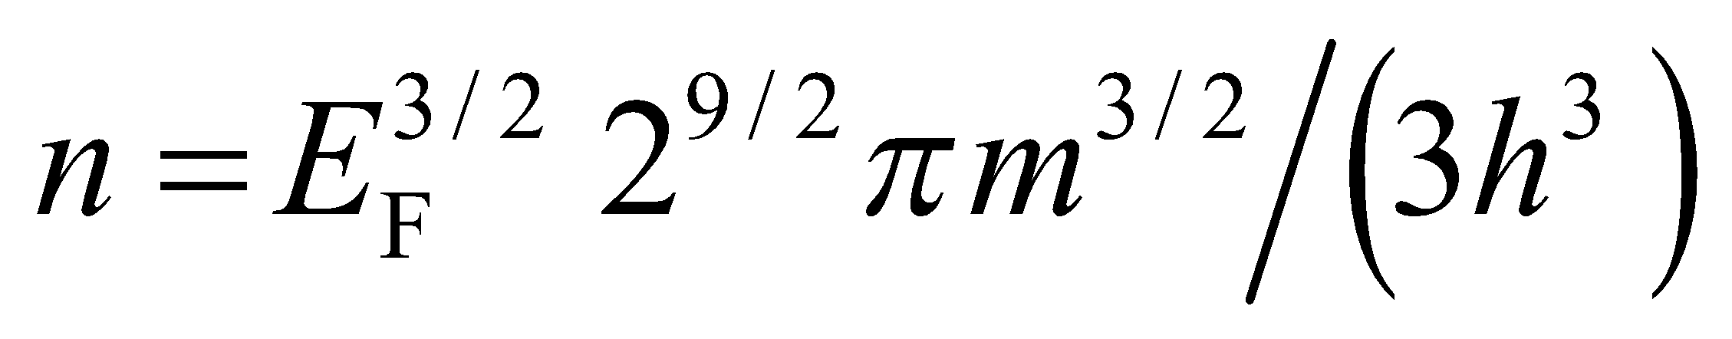 for *E*F.

**Evaluate** Solving for the Fermi energy gives

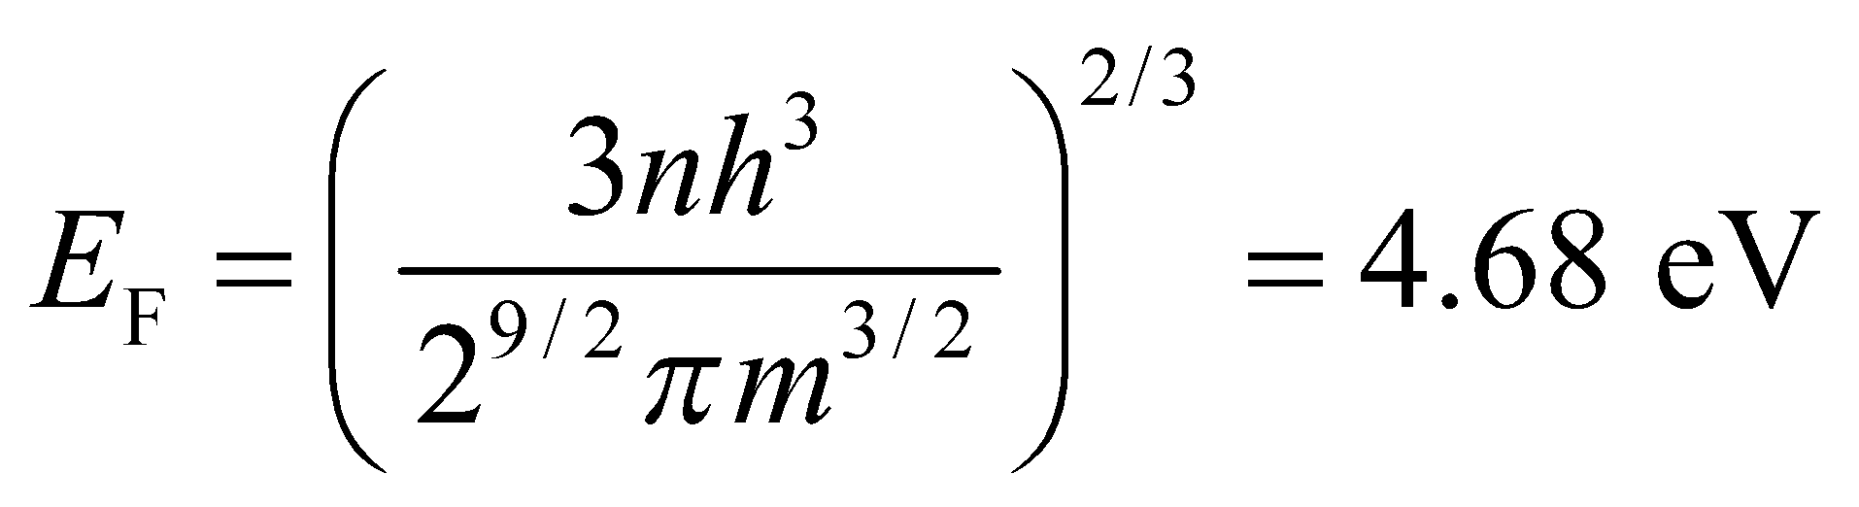

**Assess** This is a reasonable value for the Fermi energy in an alkali metal.

**50.** **Interpret** You want to compare a quantum and classical representation of electrical conduction.

**Develop** The Fermi energy is the maximum electron energy in a conductor at 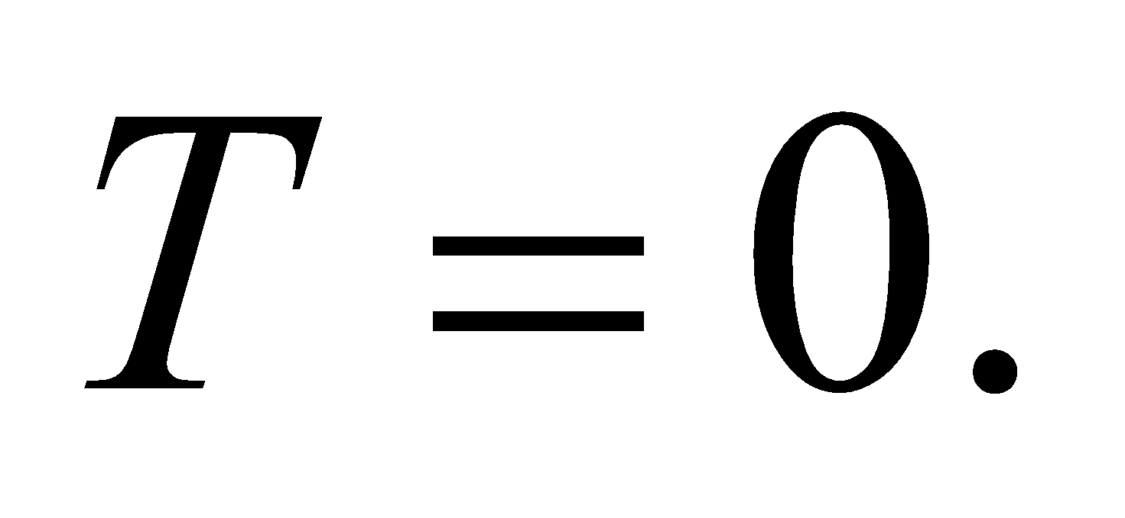 You can associate this with an electron speed: 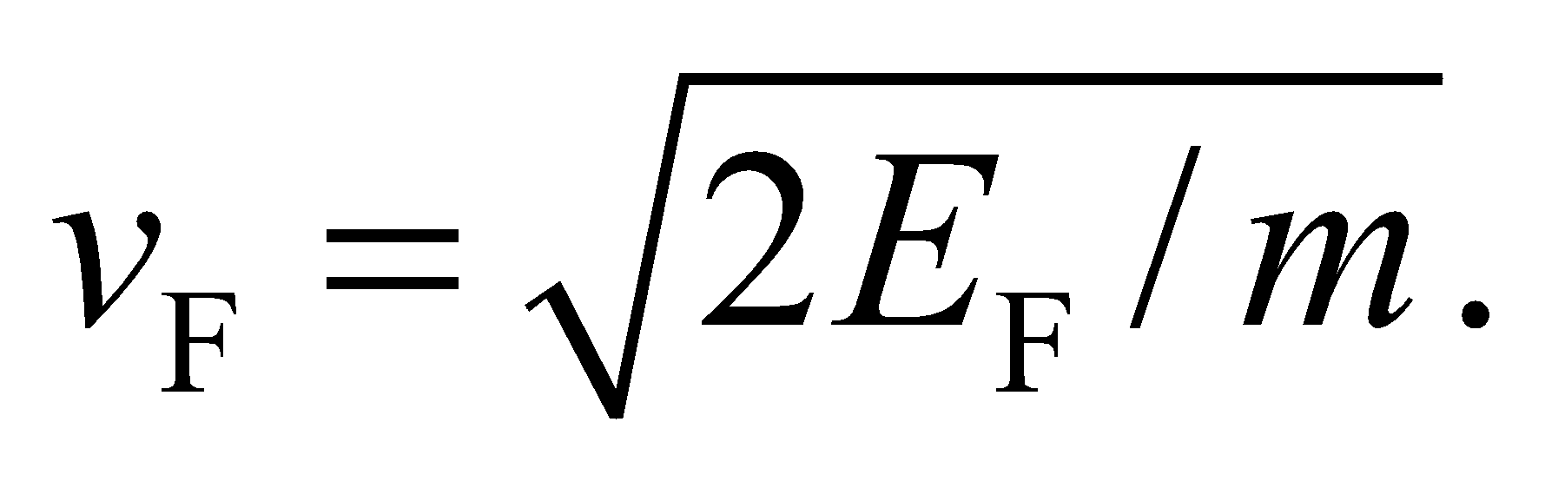 In the classical picture, electrons are like a gas with an average of 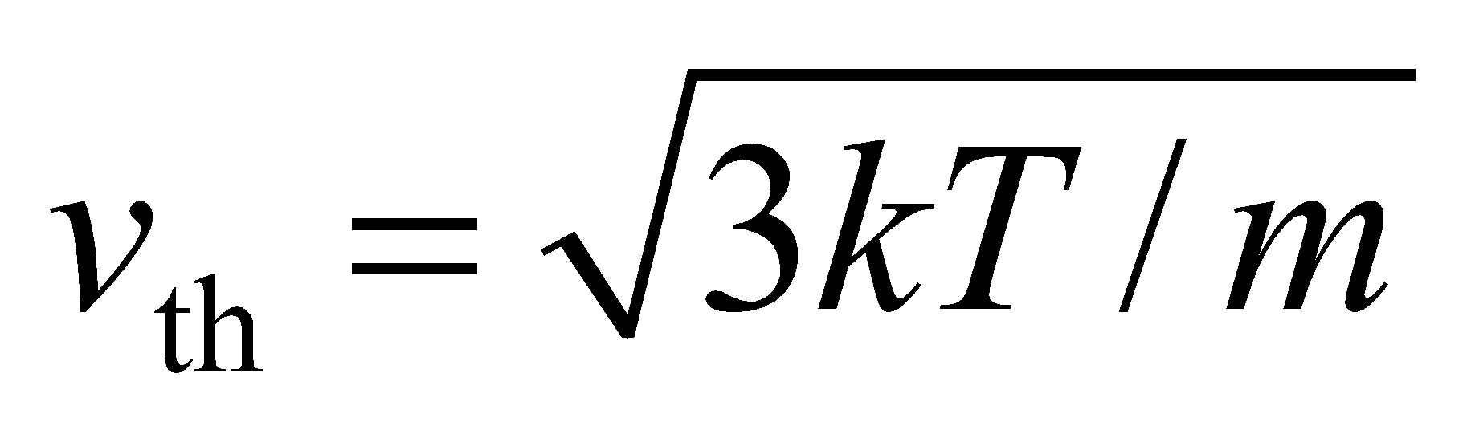 (Equation 17.4).

**Evaluate** The speed associated with the Fermi energy of copper is

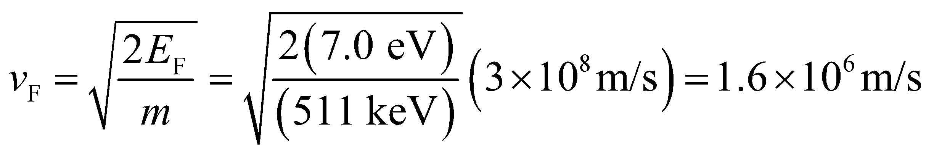

where for simplicity the rest energy 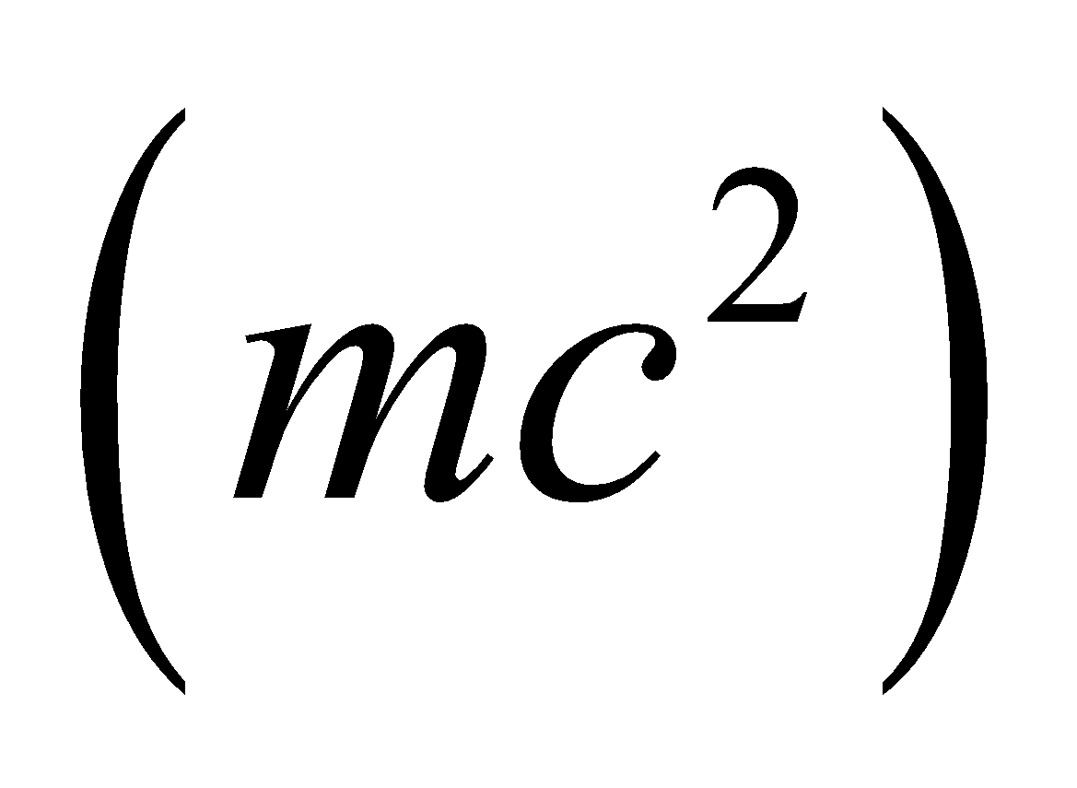 of the electron is used. In comparison, the classical thermal energy of electrons at room temperature is

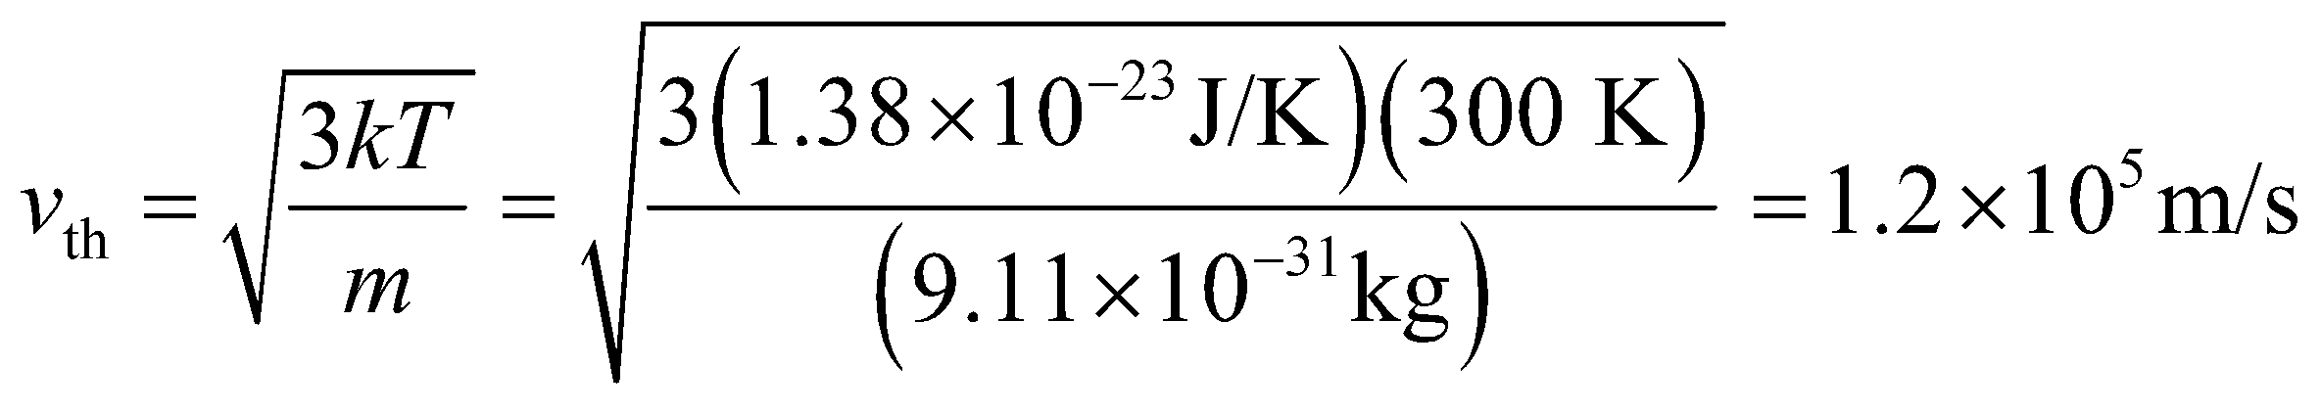

This is 13 times less than the Fermi speed.

**Assess** The difference between a quantum and classical description of conductivity was touched on in Chapter 24. The resistivity in a wire is proportional to the number of collisions each electron experiences, and this is proportional to the electron speed. In the classical picture, then, the resistivity should be related to the temperature by 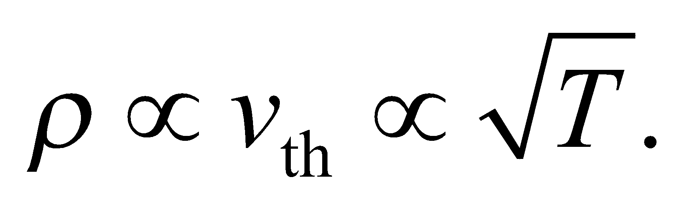 But in fact, the resistivity increases linearly with temperature, as depicted in Figure 24.7. This is a quantum mechanical effect, explained in part by the ions in the wire's crystal structure vibrating more as the temperature increases. The larger ion vibrations leads to more collisions with the electrons conducting through the wire.

**51. Interpret** We are to find the Fermi temperature for silver, given its Fermi energy.

**Develop** From the problem statement, we see that the Fermi temperature can be expressed mathematically as

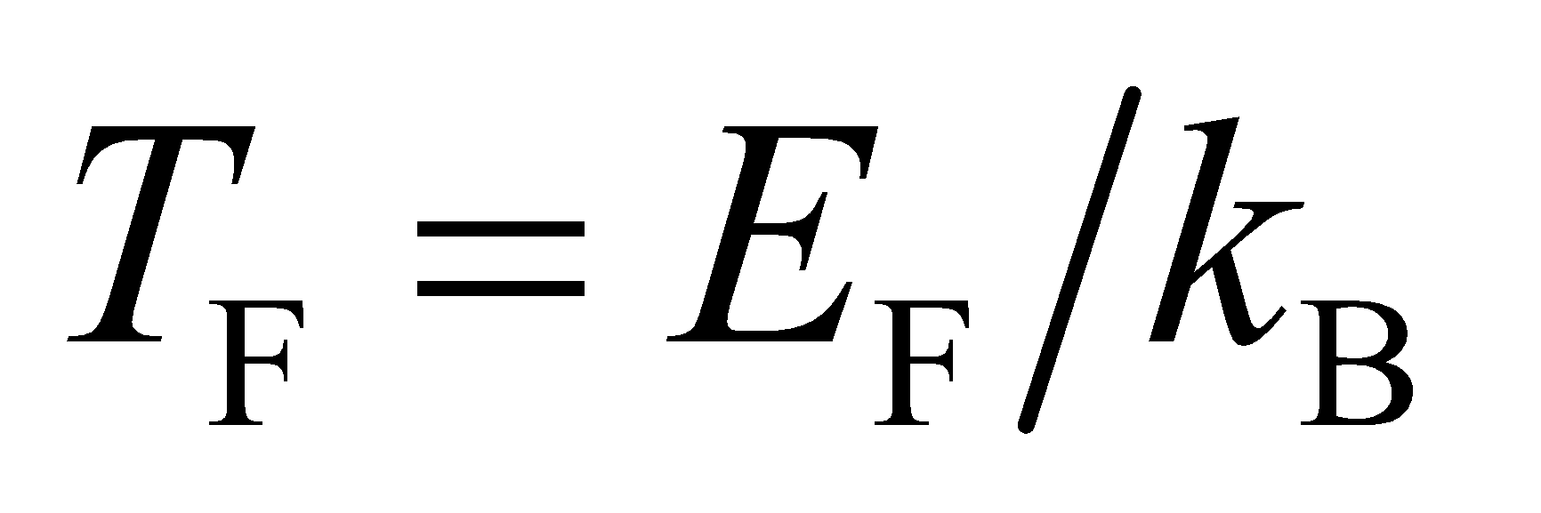

**Evaluate** With 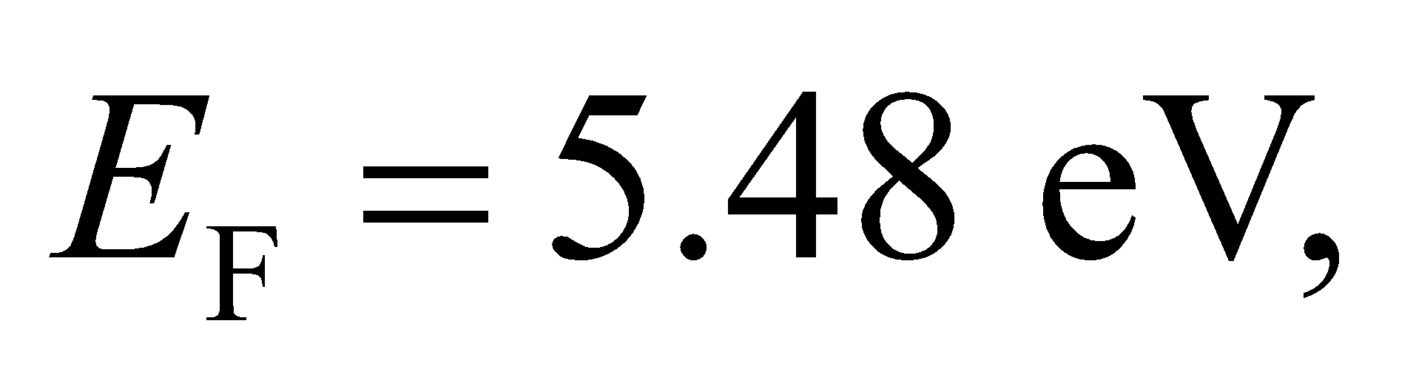 we find the Fermi temperature of silver to be

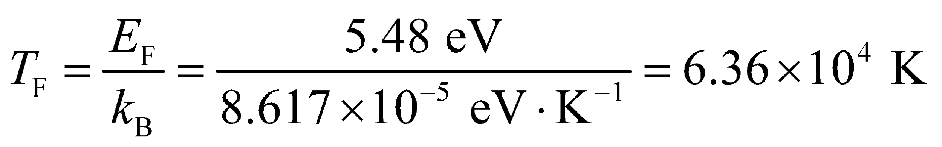

This is about 212 times the room temperature (300 K).

**Assess** The characteristic Fermi temperature is on the order of 105 K for a metal, and the Fermi energy is about 1 to 10 eV, much higher than the thermal energy at typical temperatures (0.025 eV at room temperatures).

**52. Interpret** We are to calculate the band gap of Si given the maximum wavelength absorbed.

**Develop** The band-gap energy corresponds to the maximum wavelength (or minimum energy) photon absorbed by the material. Thus, using Equation 34.6, *E*g = *hf* = *hc*/*λ*.

**Evaluate** The band gap is

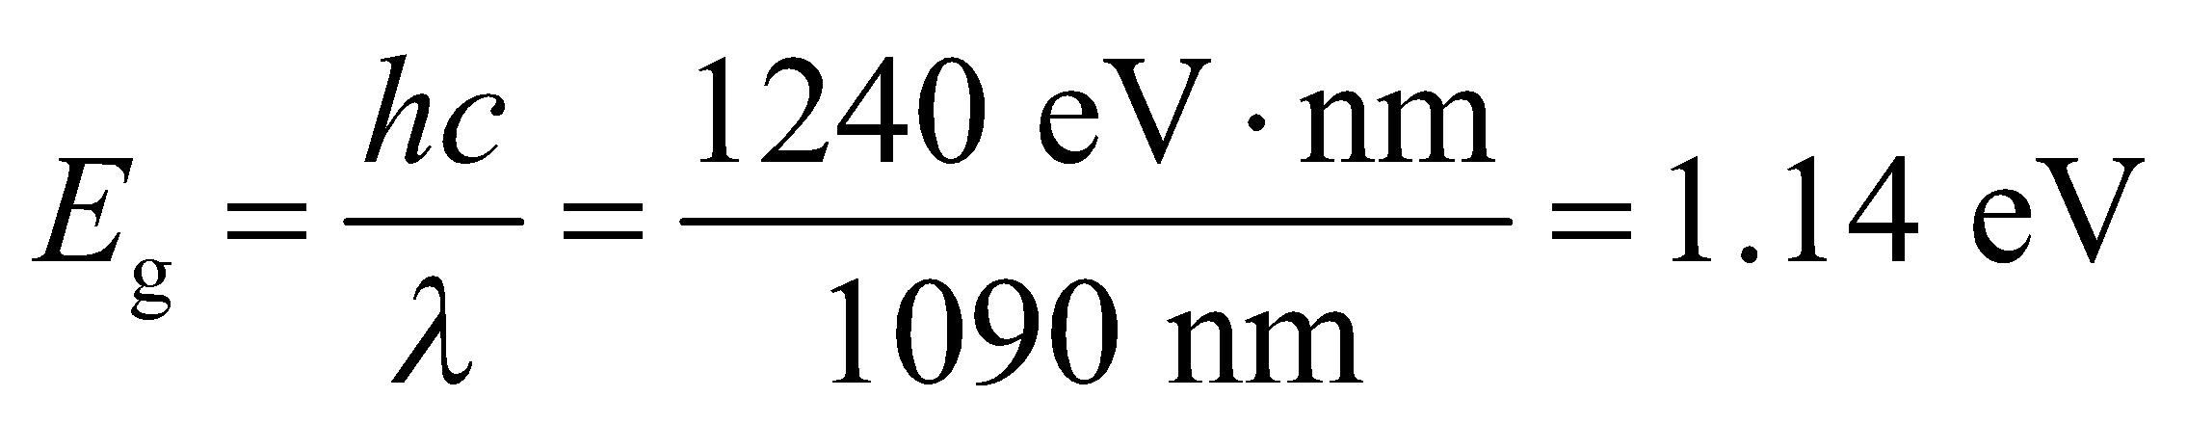

**Assess** This agrees with the entry in Table 37.1 for Si.

**53. Interpret** We want to know whether zinc selenide would make a good photovoltaic cell. We shall do this by treating the Sun as a blackbody and finding the median wavelength of solar emission then comparing that wavelength with the band-gap energy for ZnSe.

**Develop** We approximate the Sun as a 5800-K blackbody, and use 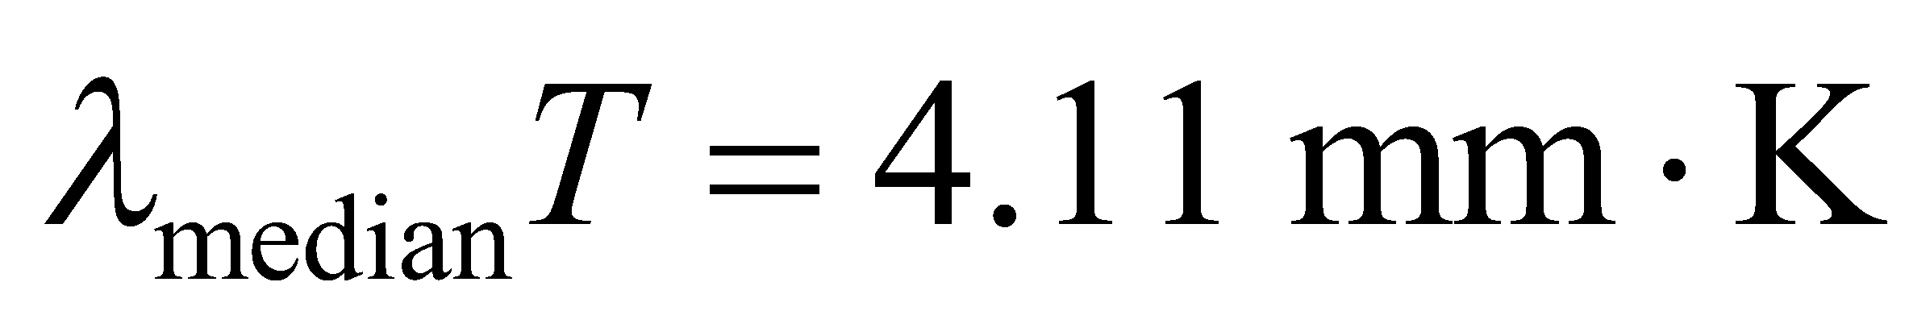 to find the median wavelength. Next, we convert that wavelength to an energy using Equation 34.6, *E* = *hf* = *hc*/*λ* and compare the energy of the median photon with the band-gap energy of ZnSe, *E*g = 3.6 eV.

**Evaluate** 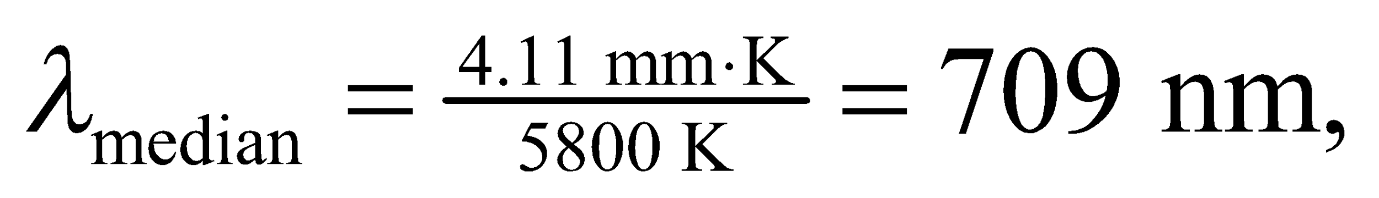 so the energy of the median photon is

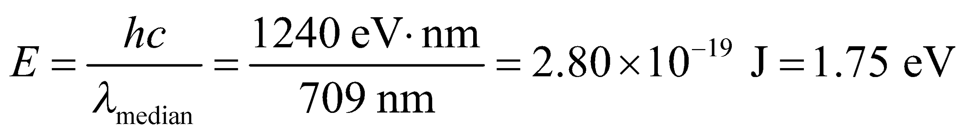

**Assess** The energy of this photon is less than the energy of the band gap for ZnSe, so ZnSe would not make a good photovoltaic cell.

**54. Interpret** We are to find the maximum current allowed in an Al wire without exceeding the given critical magnetic field.

**Develop** As shown in Figure 37.21, the maximum magnetic field occurs at the edge of the wire. Using Ampère’s law (Equation 26.17) as per Example 26.7, we find that the magnetic field at the surface of the wire is *B*max = *μ*0*I*/(2*πR*).

**Evaluate** The maximum magnetic field will be less than the critical field if

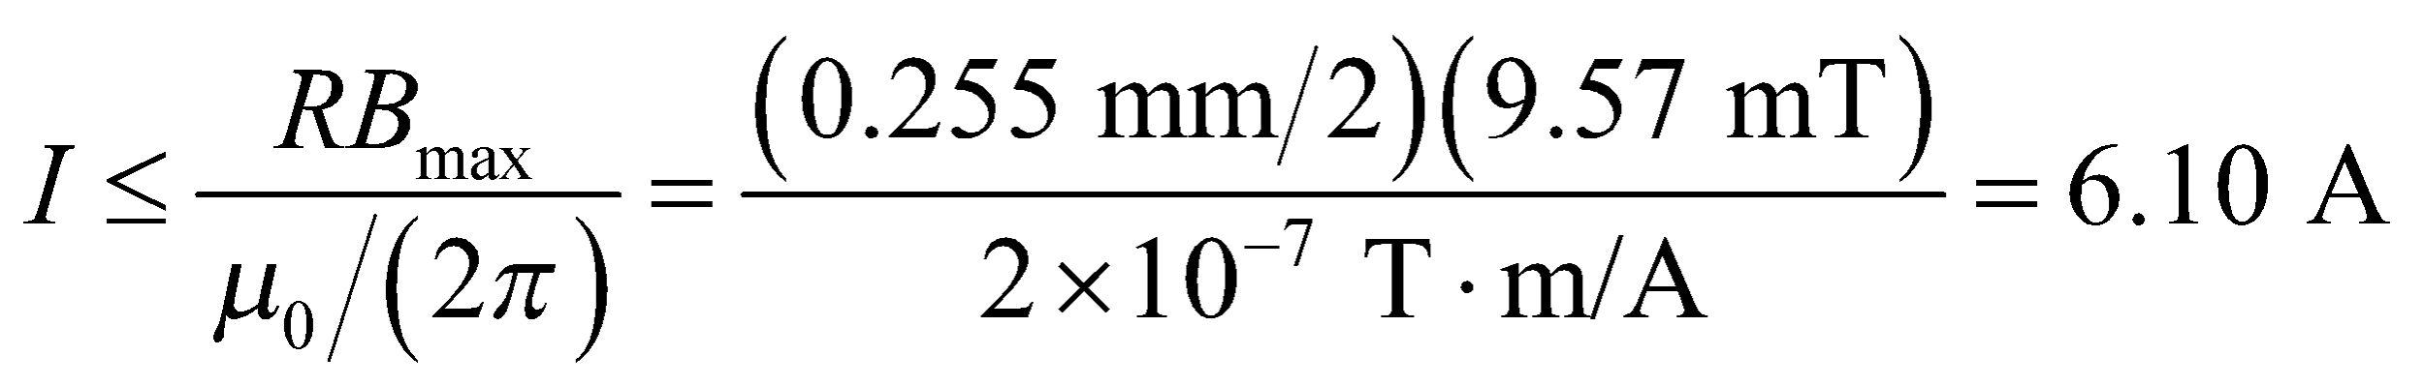

**Assess** This is a very significant current.

**55. Interpret** In this problem, we’re asked about the current required in a solenoid to achieve the critical magnetic field strength of the given superconductor.

**Develop** The magnetic field inside a long thin solenoid is given by Equation 26.21, 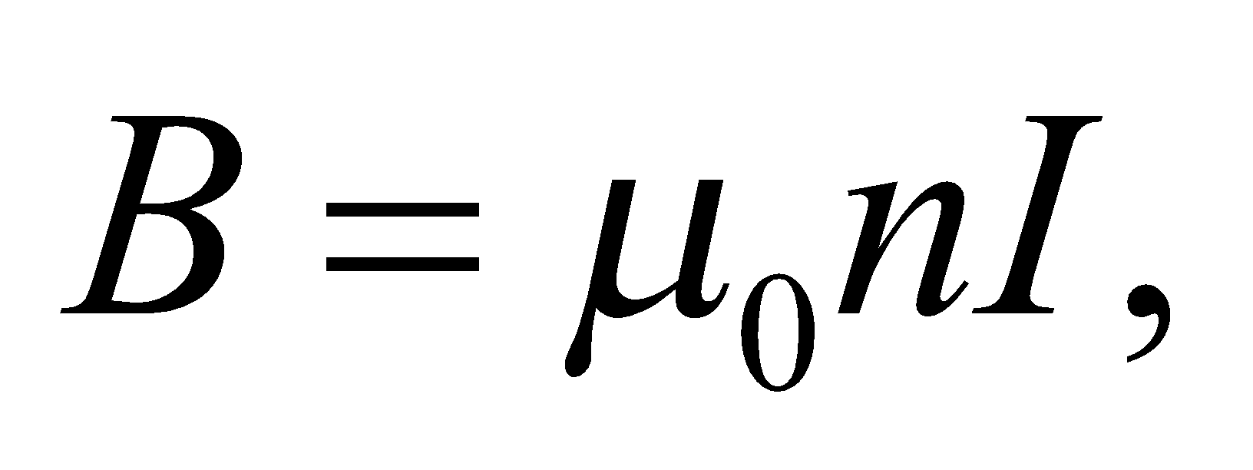 where *n* = 5000/(0.75 m) is the number of turns per unit length in the solenoid.

**Evaluate** Substituting the values given, we find the current is

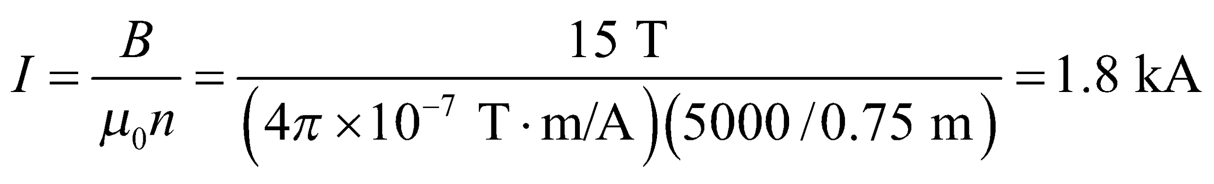

**Assess** The current required is enormous! Note that niobium titanium is a Type-II superconductor with a critical temperature of about 10 K.

**56. Interpret** We are to find the temperature necessary to excite the first rotational state of diatomic oxygen (O2), and determine if this molecule would behave like a monatomic gas at normal pressure.

**Develop** O2 would behave like a monatomic gas if there were insufficient thermal energy to excite the first rotational state. This implies that 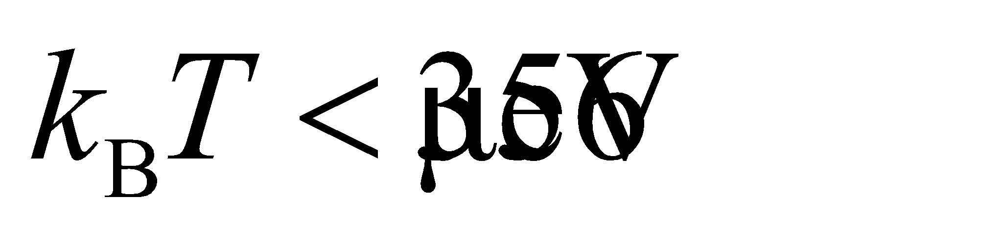.

**Evaluate** Solving for the temperature *T* gives

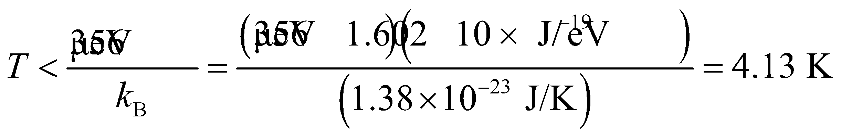

**Assess** Such behavior is not observed, however, since the normal boiling point of oxygen (below which 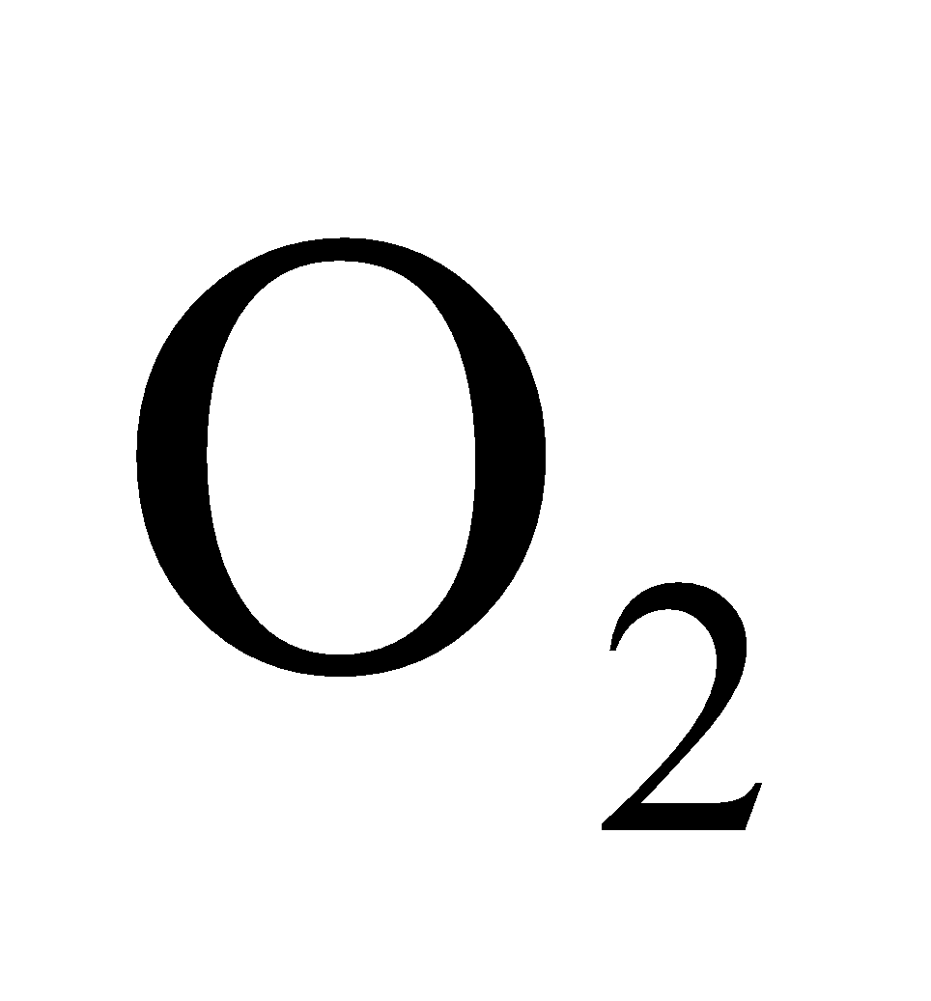 liquefies) is 90.2 K (see Table 17.1).

**57. Interpret** We are asked to find the emission wavelength of a fluorescent protein given the energy separation of its final transition.

**Develop** The relation between transition energy and photon wavelength is given by 

**Evaluate** We're told that the protein absorbs light and then goes through an intermediate transition to an excited state that is 2.44 eV above the ground state. When the protein relaxes to its ground state, it will emit a photon with wavelength

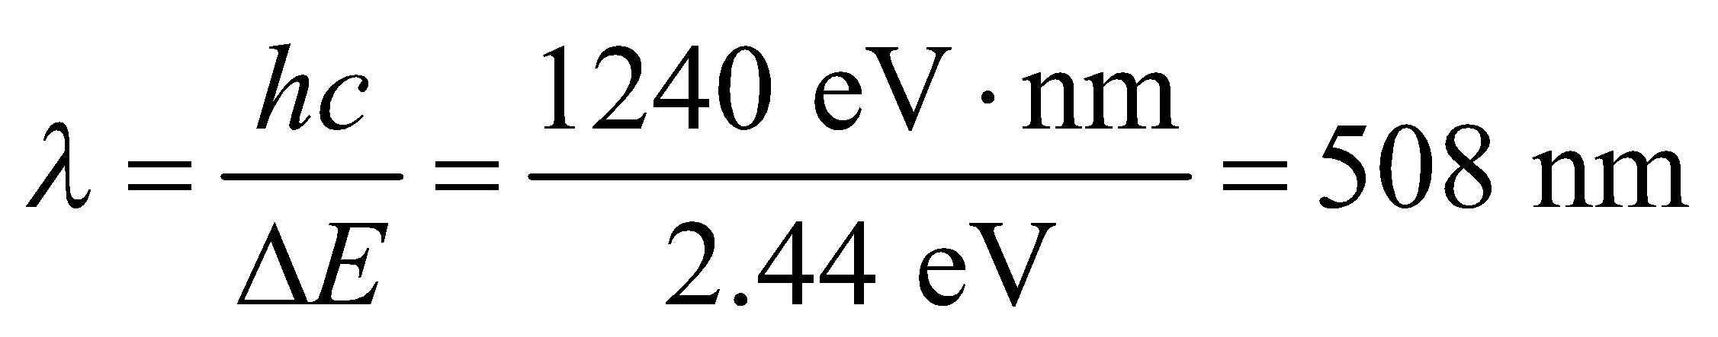

**Assess** This green wavelength is longer than the 395-nm wavelength that the protein absorbs, which implies that the emitted photon has less energy than the absorbed photon. The "missing energy" was expelled when the protein dropped from its initial excited state to the second excited state in the intermediate transition. This is typically how fluorescence works: a molecule absorbs a short wavelength and is excited to a high energy level; it then drops down to a slightly lower energy level before emitting a photon of longer wavelength.

**58. Interpret** We’re given the mass density and ionic cohesive energy of RbI and asked to solve for the equilibrium separation between Rb and I and the constant *n* in Equation 37.4.

**Develop** The equilibrium ionic separation *r*0 can be estimated from the density *ρ*. The constant *n* is given by (see Example 37.3)



**Evaluate**  **(a)** If we assume that the crystal structure of RbI is cubic, like NaCl in Example 37.3, then each cubic volume, 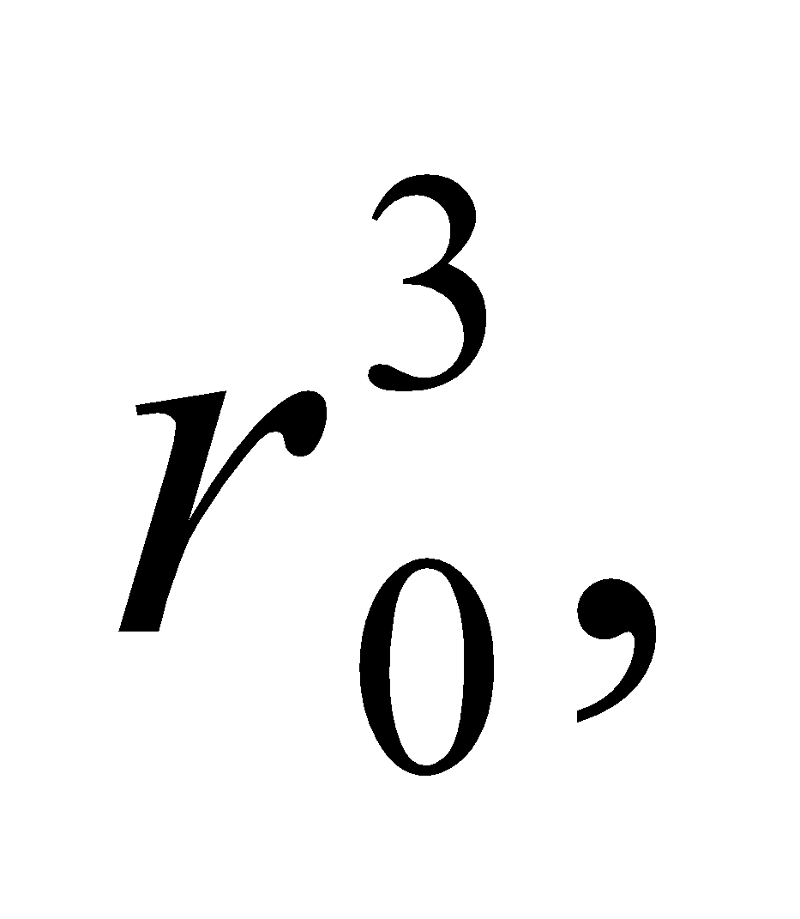 contains one ion of average mass 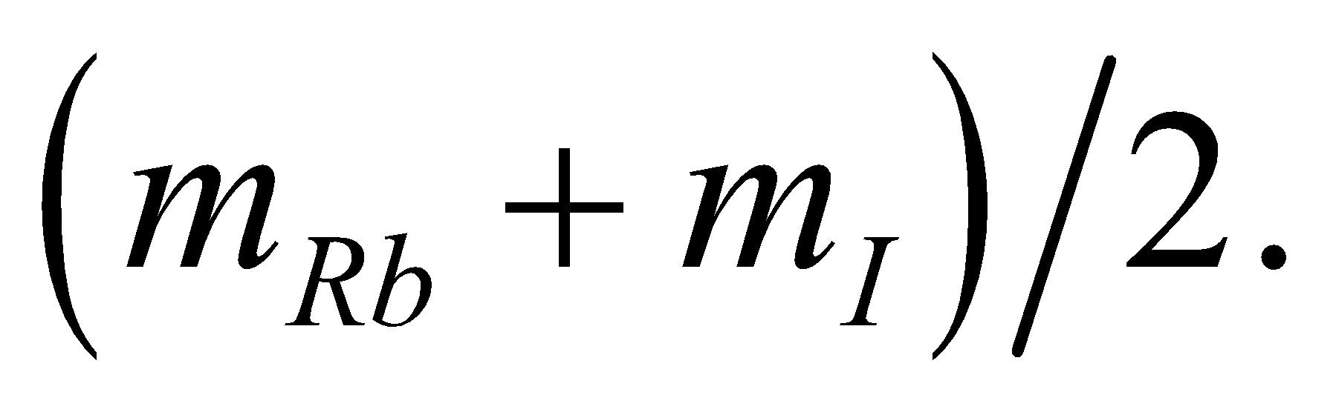 Thus,

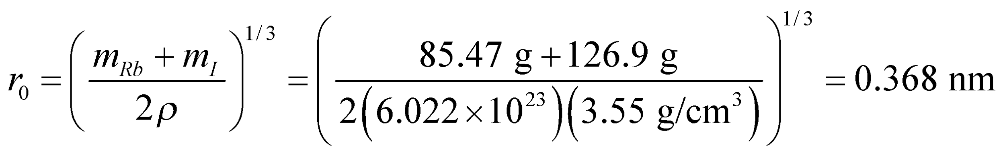

where we used Appendix D for the atomic weights.

**(b)** The ionic cohesive energy per ion pair is,



where we have used the conversion factors given in Appendix C. Equation 37.4 evaluated at *r* = *r*0 can be solved for *n* (as in Example 37.3) with the following result:



**Assess** The results can be compared with n = 8.22 and *r*0 = 0.282 nm for NaCl (see Example 37.3). The large value of the exponent implies that RbI is strongly resistant to compression.

**59. Interpret** You want to find the bond length of a diatomic molecule using the spacing between rotational energy levels inferred from spectral lines. You will use a more accurate model of the moment of inertia.

**Develop** In Example 37.1, the energy spacing between adjacent pairs of rotational energy levels was given for the HCl molecule. Using the quantized rotational energy levels in Equation 37.2: 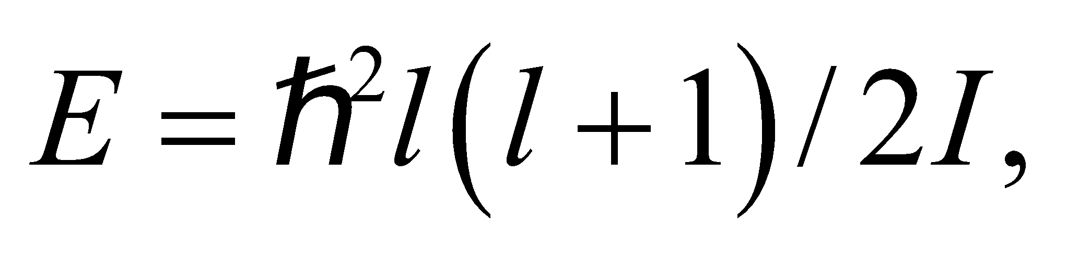an expression for the rotational inertia was found in terms of the energy spacing:

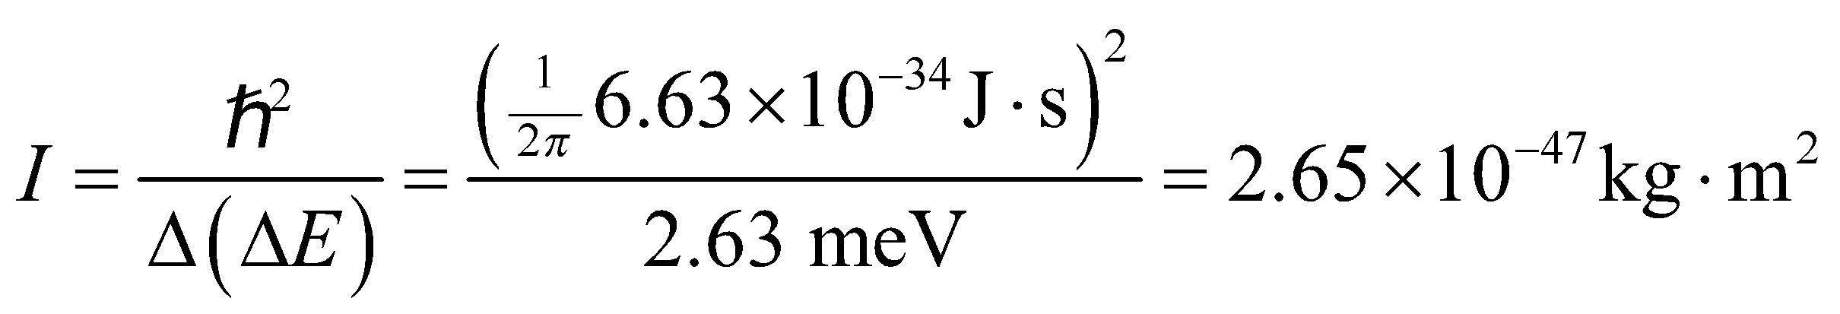

If the HCl molecule is approximated by the hydrogen atom rotating around a fixed chlorine atom, then 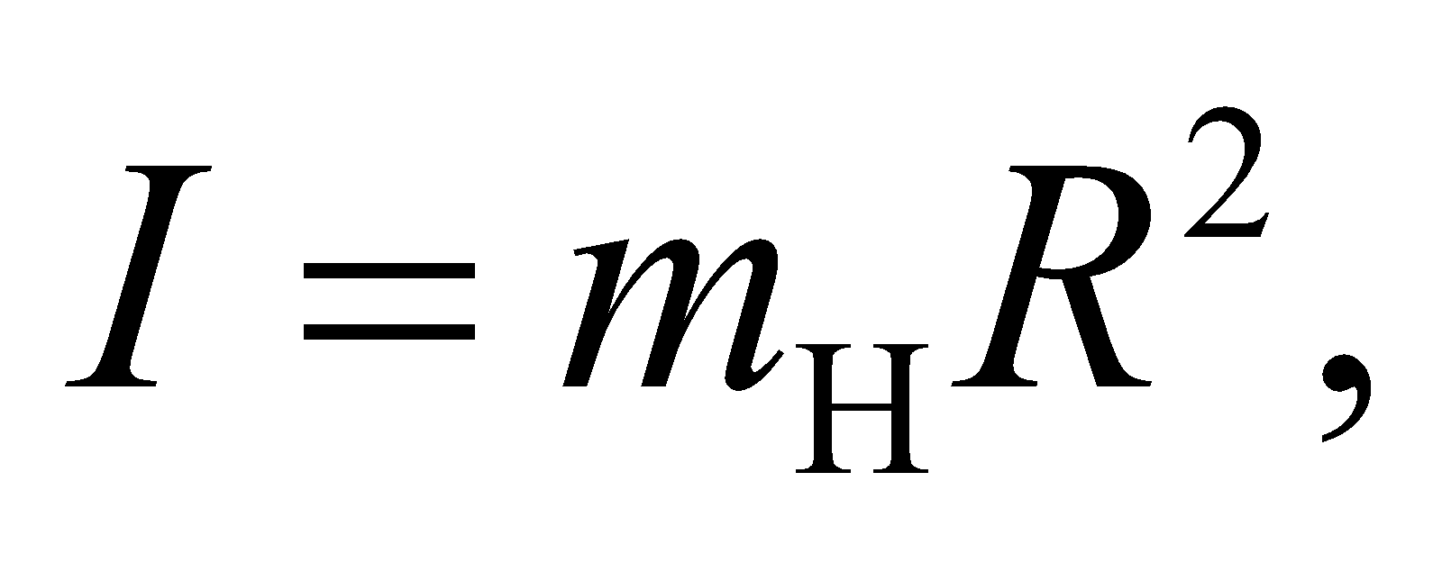and one can solve for the internuclear separation: 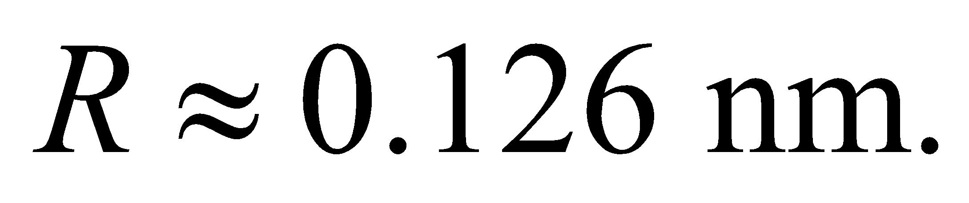 You now want to redo the calculation without assuming the chlorine atom is fixed.

**Evaluate** For a general diatomic molecule, the center of mass is located along the line between the two atoms. Let 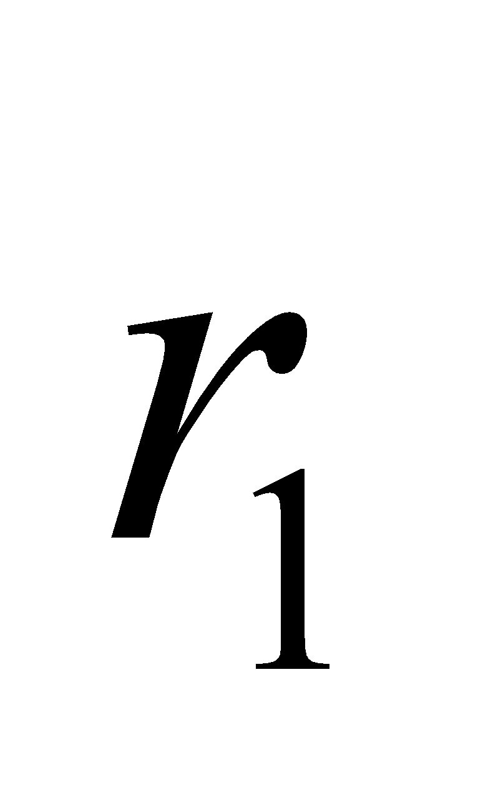 and 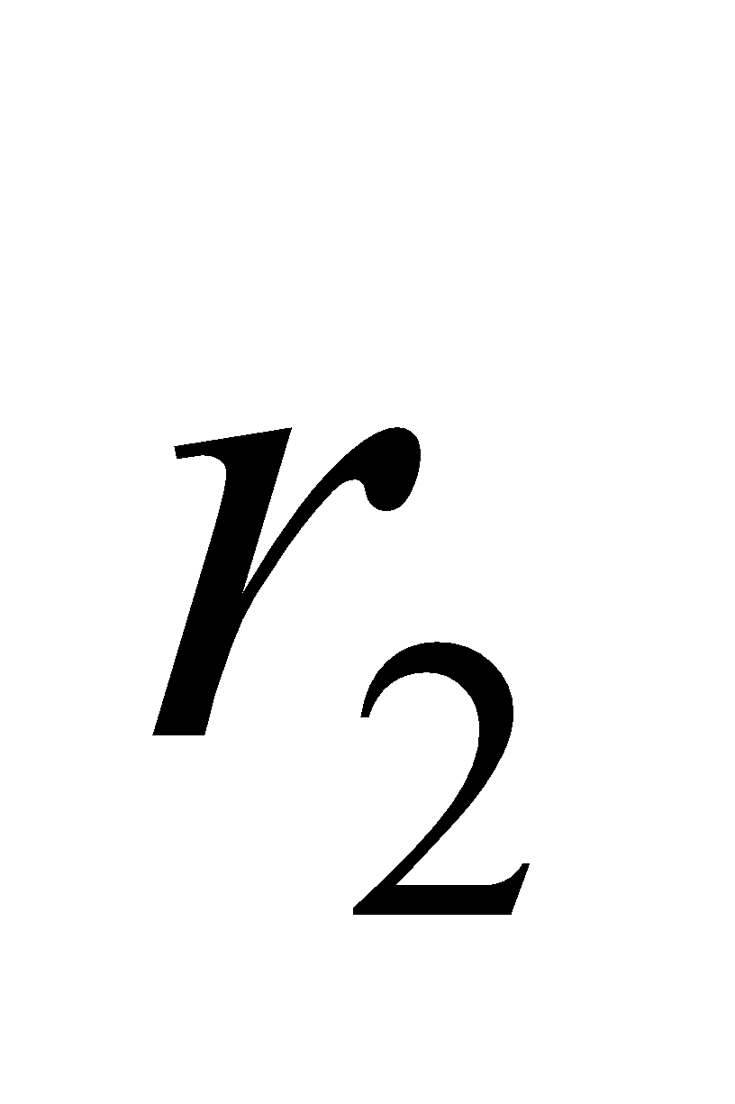 be the distance between the center of mass and the masses 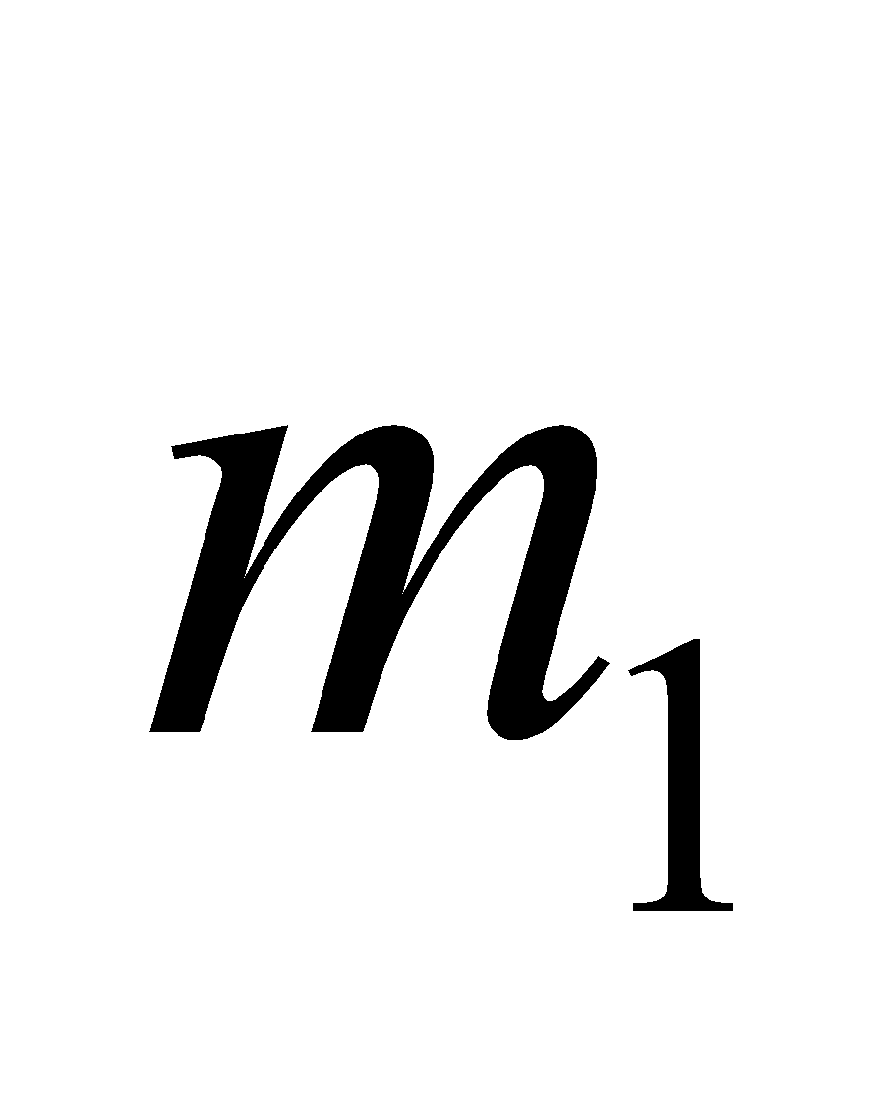 and 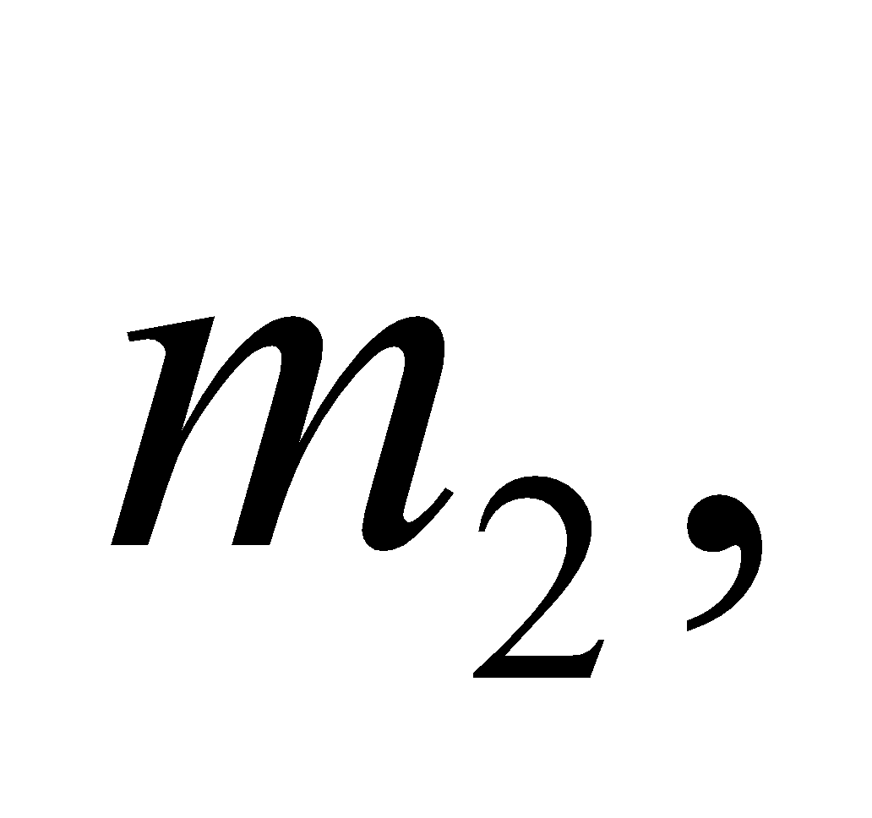respectively. If you choose the origin at the center of mass, then the center of mass equation gives



Combining this with the fact that 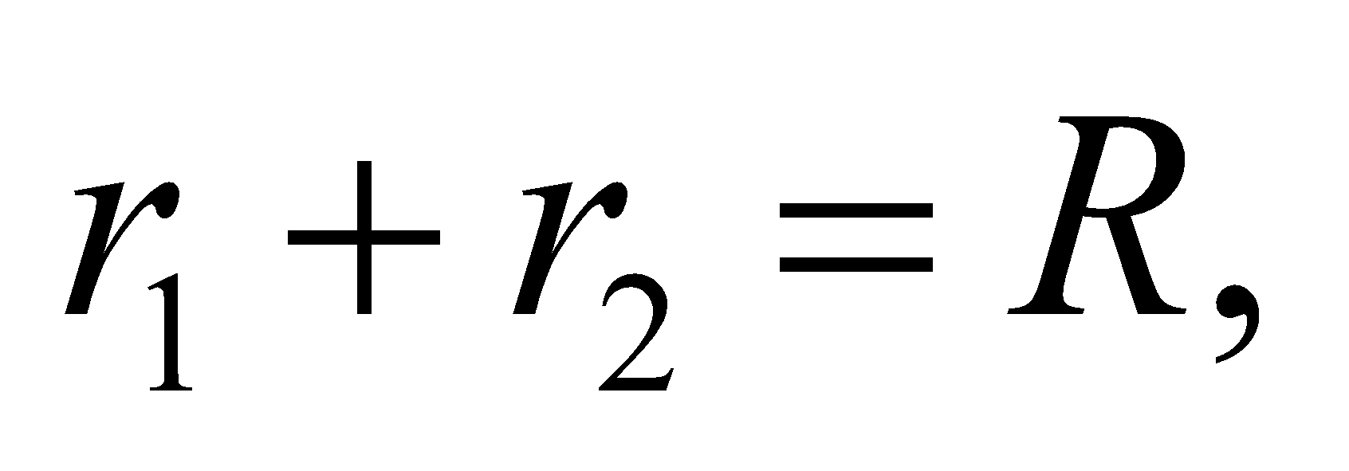you find 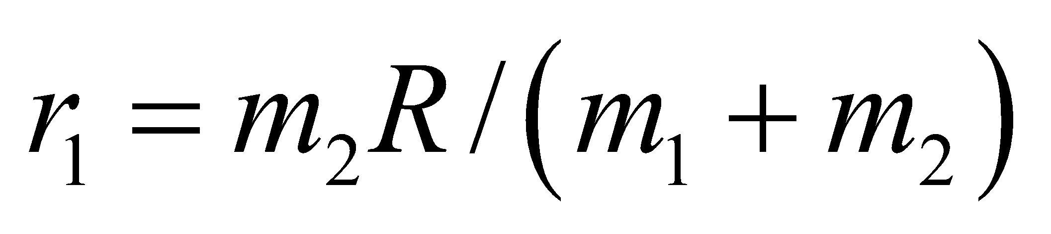 and  Plugging these values into the rotational inertia equation:



With this expression in hand, the internuclear separation in HCl is



Notice that if we neglect the mass of the hydrogen atom (i.e., assumethis equation would reduce to the same solution in Example 37.1, 

**Assess** Neglecting the mass of the hydrogen atom only introduces an error of 1.5% in the calculation of internuclear separation.

**60. Interpret** This problem is about the electron energy distribution at absolute zero (i.e., *T* = 0 K). We are to find the fraction of electrons that have energies below half the Fermi energy.

**Develop** The density of states of electrons in a metal is given by Equation 37.5:



Thus, the number of electrons with 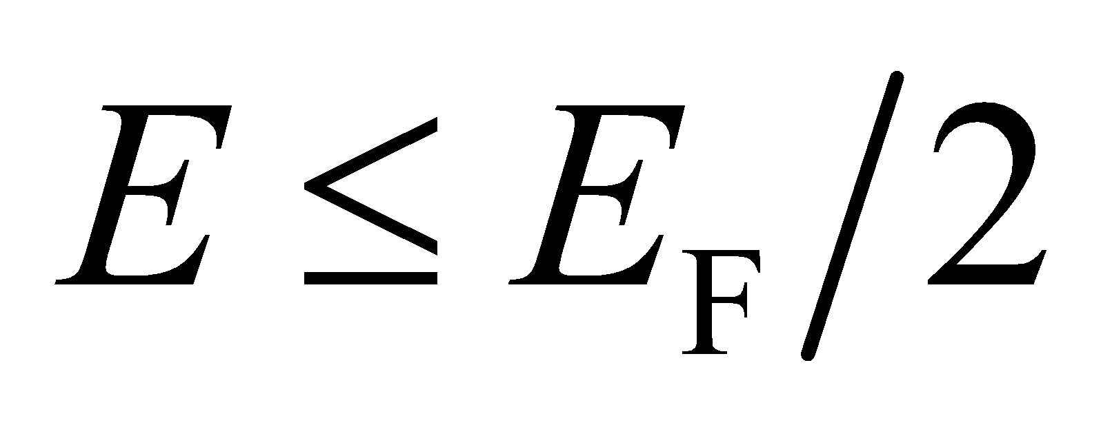 at T = 0 K is simply equal to



**Evaluate** Carrying out the integration, we obtain



where  is the density (number per unit volume) of conduction electrons. Thus, the fraction is 

**Assess** The density of states at *T* = 0 K is plotted in Figure 37.16a. We see that  is less than half

.

**61. Interpret** We are to calculate the Madelung constant for a hypothetical one-dimensional crystal that consists of alternating positive and negative ions.

**Develop** The Madelung constant expresses the magnitude of the electrostatic potential energy of an ion in the crystal (see discussion preceding Equation 37.4). For any ion in the one-dimensional chain shown in Figure 37.24, there are two oppositely charged ions at distances of *r*0, two similarly charged ions at distances of 2*r*0, two opposite ions at 3*r*0, etc. We can find the Madelung constant by summing these terms and using the series expansion of ln(1 + *x*).

**Evaluate** Thus, the electrostatic potential energy of any ion is



The Taylor expansion of ln(1 + *x*) is



When evaluated at *x* = 1, this gives



Comparing this with the series expression above for *U* shows that  for this “crystal.”

**Assess** The convergence of this series, which needs special consideration for *x* = 1, is discussed in many first-year calculus textbooks.

**62. Interpret** This question deals with a model for the potential energy of a diatomic molecule. We are to determine if the model has a minimum and find what that minimum is and the minimum atomic separation.

**Develop** The Morse potential is



We shall use the first and second derivatives to find the minimum. For a minimum, first derivative must be zero and the second must be positive for some value of *r*. Part **(a)** asks for the minimum energy *U*min and part **(b)** asks for the radius *r*min at which this minimum occurs, but in order to find the minimum energy we must know the radius so we’ll do part **(b)** first.

**Evaluate** **(b)** Performing the differentiation gives



There is a local maximum or minimum at *r* = *r*0 and the second derivative of the function at *r* = *r*0 is greater than zero so it must be a minimum.

**(a)** 

**Assess** Unlike the harmonic oscillator potential, the Morse potential is asymmetric. This asymmetry means that the average spacing between the atoms increases with energy level, which leads to a “prediction” that materials would expand with increasing temperature.

**63. Interpret** We are asked to derive the density of states equation for a metallic conductor.

**Develop** Equation 35.8 denotes the energy levels in a three dimensional cube of side *L*:  where  and are integers greater than or equal to zero. Each set of *n*'s corresponds to a unique energy level that can be occupied by at most two electrons, according to the exclusion principle. So there are two electron states for each possible combination of  and 

**Evaluate** We need to count all the electron states that have energy less than some given energy *E*, so let's define an arbitrary vector  Counting electron states will be the same as counting the number of vectors  that have magnitude less than some radius *r*, where *r* is defined by the energy limit:



The number of vectors  satisfying this inequality with integer components is just the volume inside a sphere of radius *r*, see the figure below. We don't consider negative values for the *n*'s, so the relevant volume is that of just one octant of the sphere:  Recalling that there are 2 electron states for each set of *n*'s, the number of states with energy less than or equal to *E* is





(b) Differentiating the above result, we find the density of states:



**Assess** The density of states is the number of states with energy equal to *E*, as opposed to  which is the number of states with energy less than or equal to *E*. Notice that is the integral of :



From this, it is clear why  is the derivative of 

**64. Interpret** We are to find the average energy of a conduction electron at very low temperature, using the metallic density of states (Equation 37.5).

**Develop** We find the average by dividing the total energy  by the number of energy states  At *T* = 0, all states above *E*F are empty, so we can integrate to *E*F rather than to . The density of states for a metallic conductor is



**Evaluate** Performing the integrations and forming the ratio gives



**Assess** It is not actually possible to reach *T* = 0, but the information gained by calculations such as this is applicable at other low temperatures, often including such “low” temperatures as *T* = 300 K.

**65. Interpret** You need to specify the maximum current in a solenoid in order to avoid exposing the superconductors in your device to the critical magnetic field.

**Develop** Recall Equation 26.21, for the magnetic field of a solenoid with *n* turns of wire per unit length. You want the maximum that the current can be in order to keep the magnetic field below half the critical field, i.e.,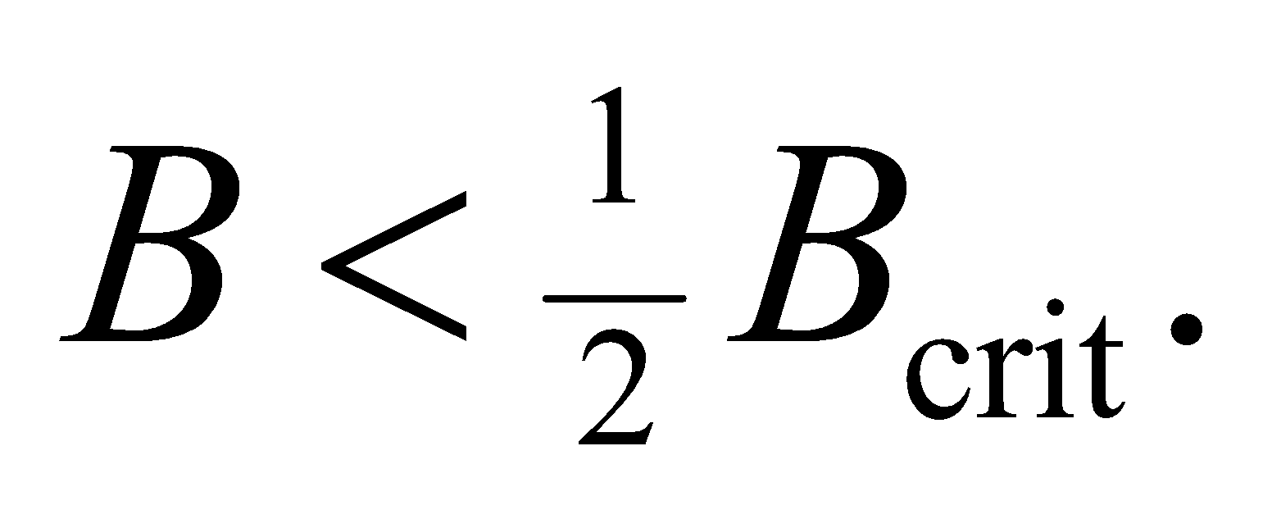

**Evaluate** Solving for the maximum current allowed gives



**Assess** A magnetic field of 6 T is fairly high, so it makes sense that the maximum allowed current is also fairly high.

**66. Interpret** We examine the physics behind photovoltaic cells that use semiconductors to convert sunlight into electricity.

**Develop** We are given the band gap energy of silicon, which corresponds to a photon wavelength of



Silicon can only absorb photons with wavelengths shorter than this.

**Evaluate** The median wavelength of an emitting source is defined such that 50% of the power is emitted at wavelengths above and below this mark. Since the median wavelength of sunlight (700 nm) is less than silicon can absorb at least 50% of sunlight. But is it more than this? In Figure 34.2, we can examine the blackbody spectrum of an object at 6000 K, which is approximately the temperature of the Sun. It is clear that the vast majority of the Sun's energy is emitted at wavelengths less than 1 μm, so we conclude that silicon can absorb about 75% of incident solar energy.

The answer is (c).

**Assess** For a more precise calculation, we can use the radiance, in Equation 34.3 to find the power emitted per unit area of the Sun for wavelengths shorter than :



This integral would be difficult to evaluate, but we can simplify it slightly by changing from wavelengths to photon energy:



The approximation for the exponential term is valid because  for  (note that for the Sun's temperature of 5800 K). The last integral can be found in an integral table:

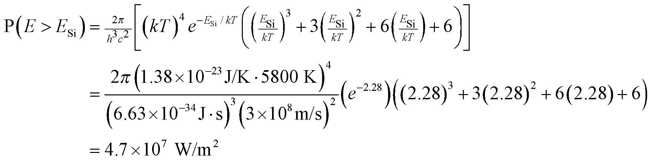

We can compare this with the Stefan-Boltzman law (Equation 34.1) for the total radiance per unit area from a blackbody



Comparing the two results, we see that silicon can absorb approximately 74% of the energy being emitted by the Sun. One might wonder why PV cells aren't more efficient if three-quarters of the solar spectrum is available to them for harvesting energy. As mentioned in the text, photons with more energy than the band gap (i.e., with ) give up their excess energy as heat.

**67. Interpret** We examine the physics behind photovoltaic cells that use semiconductors to convert sunlight into electricity.

**Develop** In the previous problem, we showed how one can calculate the power emitted per unit area of the Sun for energies greater than the band gap energy of silicon:



We can find the number of photons emitted by dividing out one factor of the energy from the integral:



**Evaluate** We could evaluate the integral for but it's not necessary. It should be clear that dividing out one factor of *E* shifts more of the "weight" of the integral to smaller energies below  Therefore, the percentage of solar photons that silicon can absorb is less than the percentage of solar energy that silicon can absorb.

The answer is (a).

**Assess** A simple way to think about this is that there are less photons with wavelengths smaller than the median wavelength (700 nm for the Sun) than there are with larger wavelengths, even though the sum of each set of photons has the same amount of energy. This is because photons at the short-wavelength-end of the spectrum carry more energy per photon.

**68. Interpret** We examine the physics behind photovoltaic cells that use semiconductors to convert sunlight into electricity.

**Develop** A semiconductor with a lower band gap than silicon will be able to absorb photons that silicon cannot. However, for photons with energy right at the silicon band gap, the alternative semiconductor will only be able to use some of the absorbed energy, with the rest being lost as heat.

**Evaluate** Lowering the band gap will both increase the number of photons that are absorbed and increase the amount of absorbed energy lost as heat.

The answer is (b).

**Assess** This demonstrates why the band gap energy of a photovoltaic cell needs to be chosen very carefully. The band gap energy should optimally be very near the energy peak in the solar spectrum.

**69. Interpret** We examine the physics behind photovoltaic cells that use semiconductors to convert sunlight into electricity.

**Develop** Light that is not absorbed by a semiconductor passes through it and therefore can be used by another semiconductor below it. In a multi-layer cell, the first *PN* junction from the top should absorb a small fraction of the solar spectrum, so that there is plenty of light left for the next *PN* junction below. This second junction should only absorb a small fraction of the remainder, so there is still plenty left for the third junction, and so on and so forth. See the figure below, showing a representation of the solar spectrum with the absorption limits of three staggered *PN* junctions.



**Evaluate** A *PN* junction will absorb the light above its band gap energy. Looking at the figure, it's clear then that the first junction (closest to the top) should have the largest energy gap.

The answer is (a).

**Assess** Since the solar spectrum has a median wavelength of 700 nm, the largest band gap should be at a shorter wavelength (higher energy) in the visible or ultraviolet. This shows that answer (c) is false. Similarly, the smallest band gap should be at infrared wavelengths longer than 700 nm, which contradicts answer (d).